Food Hygiene & Safety

Food quality vs food safety – optional activity
As a class you will vote for what different labels mean. Record the class voting in the following 2 tables:
- What does ‘Best before’ mean?
Definition | Number voted | Percentage of total*
- The food will be safe to eat up to this date, but should not be eaten past this date
- The food can be consumed after this date, but it may no longer be at its best quality
- It depends on the type of food
- None of these
- Don’t know

- What does ‘Use by’ mean?
Definition | Number voted | Percentage of total*
- The food will be safe to eat up to this date, but should not be eaten past this date
- The food can be consumed after this date but it may no longer be at its best quality
- It depends on the type of food
- None of these
- Don’t know
Number who voted for this option
Total number in class

X 100
*Work out the total percentage of each option:

Make a pie chart for each definition using the percentages you calculated

Label each pie chart and split it into 5 sections, the size of each section should reflect the size of the percentage of that section. Make sure you label each ‘slice’ of the pie! If any of the sections are 0% then do not include this in your chart

- Describe your pie charts. Did most of you get the correct answer?
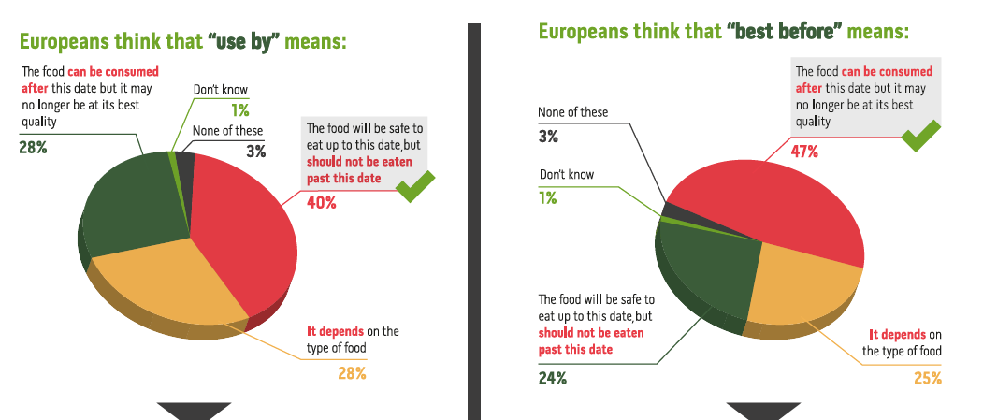
5. Describe the charts showing what the European population believe:

  - Describe what the European population understand by ‘use by’?

  - Describe what the European population understand by ‘best by’?

  - Compare and contrast the European charts with your class charts

  - How does the understanding of your class compare to the European population?

