Amazing Amoxicillin the Antibiotic
Meet Amazing Amoxicillin the Antibiotic! Antibiotics are special medicines, they have superpowers but only when fighting against bacteria! Amazing Amoxicillin’s powers have no effect on fungi or viruses such as the flu…
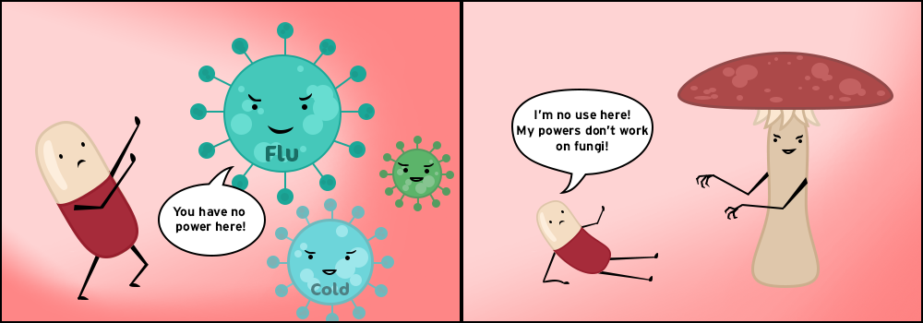
Amazing Amoxicillin has encountered a gang of E. coli trying to invade somewhere they shouldn’t be and he takes them down!

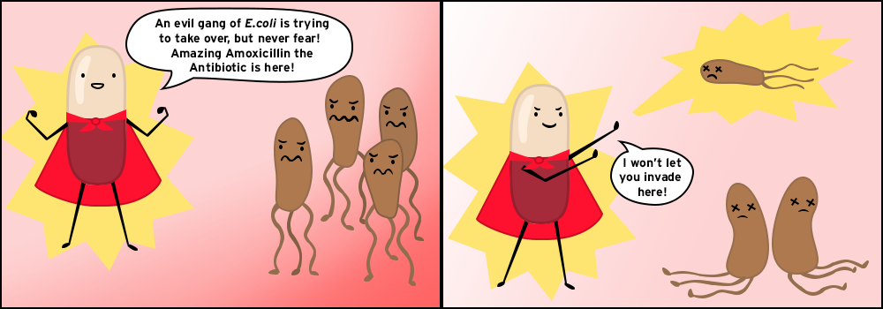
After such a long battle Amazing Amoxicillin the Antibiotic is getting tried, he’s been up against E. coli too many times and now the evil E. coli have learnt how to escape, and Amazing Amoxicillin can’t stop the infection anymore.

