## Resistance balloons

**Difficulty:4 | Ages: 5-16 | Scientific | Time: 10-20 mins**

### Learning objectives

* Antibiotics are special medicine that only work on bacterial infection, not viral infections like most coughs, colds and flu
* Bacteria are becoming resistant to antibiotics.
* We can help prevent more bacteria from becoming resistant to antibiotics by using them responsibly

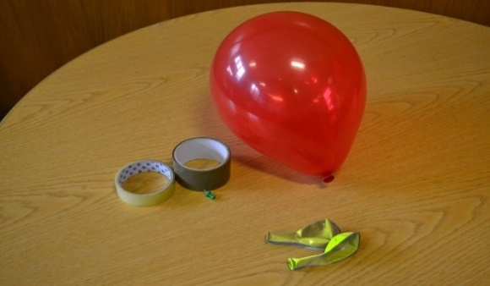 **Pictured: Balloons, sticky tape and a drawing pin**

### Equipment

* Balloons of at least two different colours
* A drawing pin
* Sticky tape or electric tape

### Advanced preparation

1. Blow up balloons of two different colours e.g three x red and 1 x yellow
2. On two of the red balloons and the yellow balloon place several layers of sellotape over the thickest area of the balloon. You should have three balloons with Sellotape and one without

### Activity instructions 1/2

1. Ask the group to sit in front of you for a demonstration. Explain to the group that bacteria that cause infections are continually developing ways to avoid being killed by antibiotics, the medicine used to treat them. This is known as antibiotic resistance. Antibiotic resistant bacteria can be very dangerous.

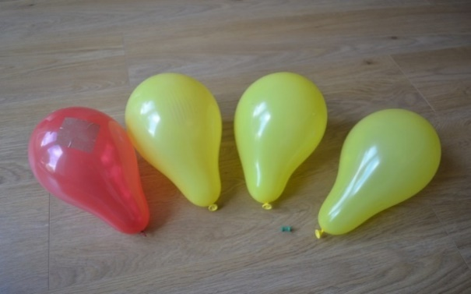

Normal Bacteria

Antibiotic resistant bacteria

Antibiotic

1. Hold up two of the balloons, a red balloon with tape and the red balloon without tape. Tell the group that the balloons represent bacteria. For older children you may wish to make it more advanced by using an example of a bacteria they are familiar with (e.g *E. coli*).
2. Show the pin and tell them that it represents an antibiotic. When we take an antibiotic, usually the antibiotic will help our bodies kill the bacteria. Pop the balloon without tape with the pin.
3. Hold the second balloon but do not bring attention to the Sellotape. Tell the group that this represents the same bacteria (same colour), it causes the same illness however it has become resistant to the antibiotic. Place the pin through the tape and the balloon will not pop. The bacteria can resist the effect of the antibiotic and it will not be killed or cleared from the body.
4. Explain that bacteria are clever and that they can also pass the information on how to resist antibiotics to other bacteria, like passing a secret. Show the remaining red balloon and yellow balloon (representing different bacteria) which each have tape. For older children you can explain that bacteria are able to pass their DNA onto other bacteria to become stronger.

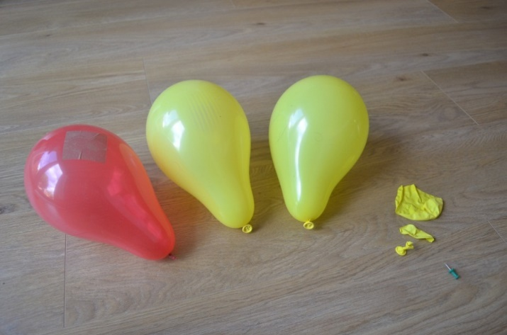

Bacteria killed by antibiotic

Antibiotic resistant bacteria are not killed by antibiotic

### Activity instructions 2/2

1. To help explain antibiotic resistance you can use an analogy such as that the bacteria have developed a super power to either hide from the antibiotic or stop it working. This is why you sometimes hear antibiotic resistant bacteria called ‘Superbugs’. If your group is older you can say that the tape represents a change in the bacteria DNA.
2. Bacteria can become superbugs when they come into contact with an antibiotic, they meet the antibiotic and learn a way to overcome its effect. If you take too many antibiotics or take them when you don’t need to you are increasing the risk of bacteria in your body learning how to resist the antibiotic.
3. Finish by saying that sometimes we have serious infections that need antibiotic treatment. To keep antibiotics working for when we really need them we need to use them correctly and not take them when they are not needed.