Antibiotic storyboard
- Amy went to school not feeling very well. She had a headache and a runny nose. When she arrived in the classroom she took a seat beside Natasha. She soon realised that Natasha was also not well.
Mine too, but I’ve got a runny nose. Don’t forget to cover your mouth when you cough and sneeze.
Not really but my mum said that I must come to school *cough* *cough*
Are you OK Natasha?

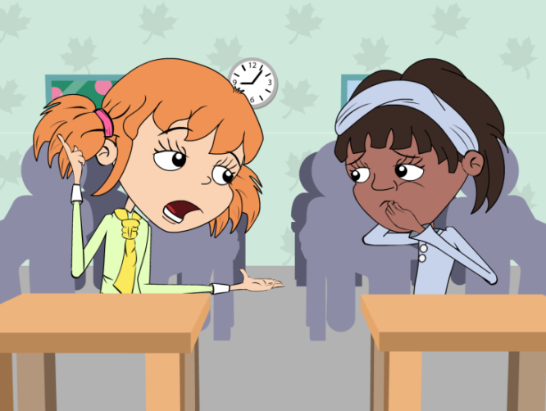
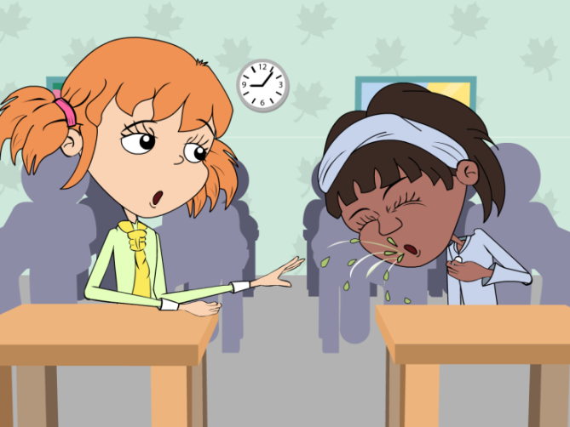
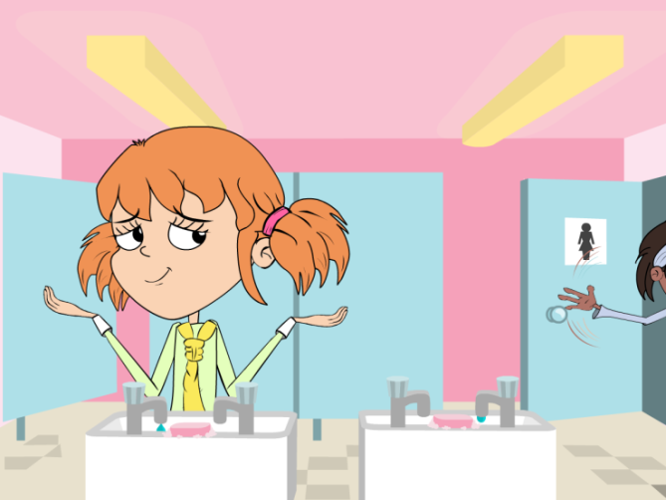
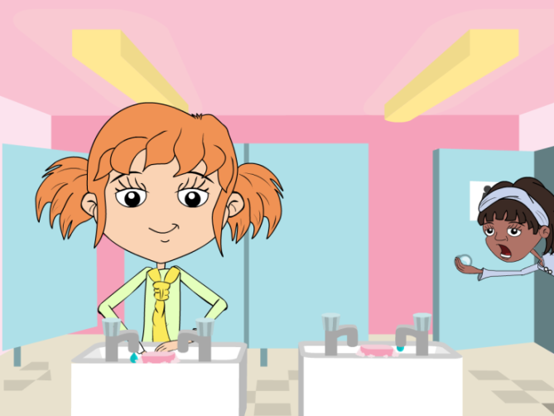
- At lunch time, Amy and Natasha went to the toilet. Natasha was hungry and in a hurry to have her lunch.
Don’t bother. We need to get to lunch before the food runs out!
Hang on, I need to wash my hands.
Come on Amy, I’m Hungry!

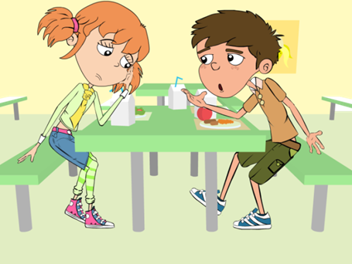
3 During lunch Amy was talking to her friend Harry about her headache and runny nose.
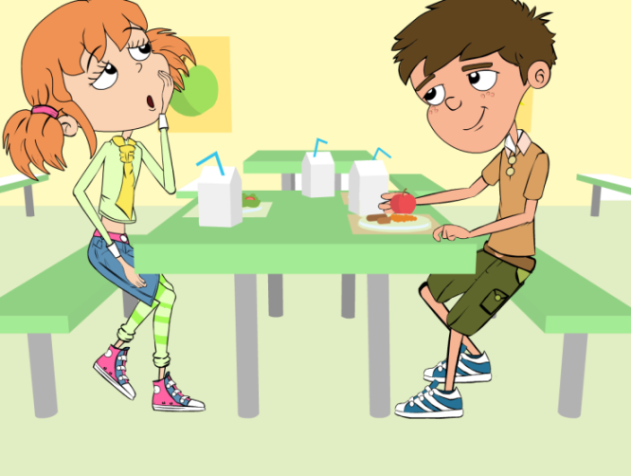
It really hurts, and I think I’m getting a cough.
That’s a good idea. We still have some from when my sister had an ear infection. I’ll ask my mum.
Don’t you have any antibiotics at home you can take?
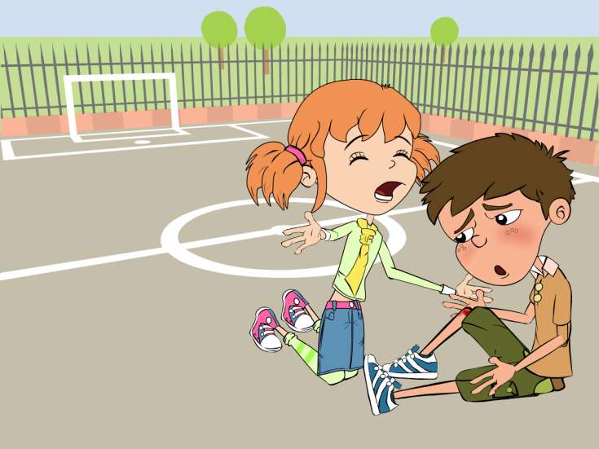
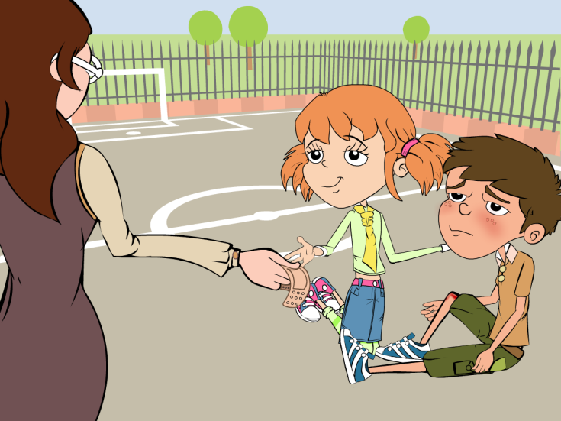
- After they had eaten, the children went out to play. Harry fell over and cut his knee very deeply.
Oh dear. Let me see. It’s not too bad. Let’s just put a plaster on it.
Come on, let’s take you to see Mrs Warren.
Owww my knee is bleeding.

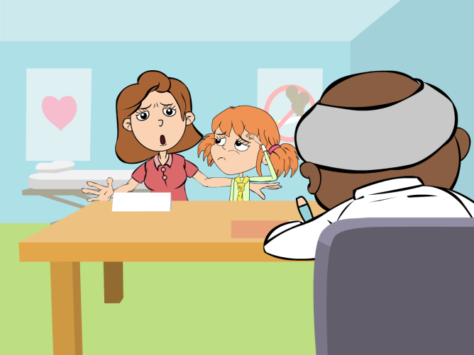
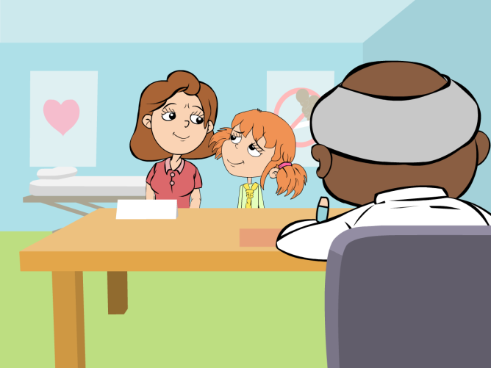
5. When Amy got home, her mother decided to take her to the doctor. He said that she had a bad cold.
There is no need for antibiotics, her body’s natural defences will take care of this cold.

But she’s ill, you have to give her some antibiotics.
Go home and get some bed rest, take some painkillers for the headache if you need to.
6. Harry didn’t come to school the next day so Amy called around to see him on her way home from school.
Oh no, did he give you painkillers?
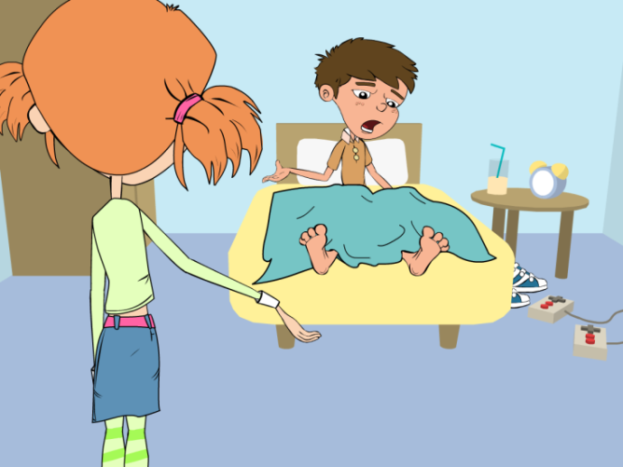
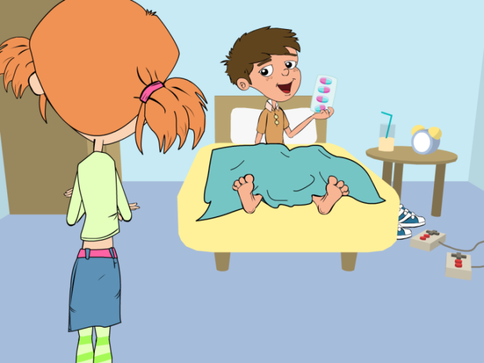
No, he gave me antibiotics to help fight the infection but told me to take them until they were all finished.
No, my knee started to get really painful in the night so my Mum took me to see the doctor. He said that my cut got infected.
You weren’t in school today, are you OK?

