# Discussion Points

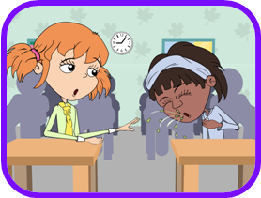

It is important for Harry to take antibiotics as prescribed. Not doing so may result in bacteria becoming resistant to antibiotics in the future. If he would like to stop antibiotics early he should discuss this with his doctor or nurse.

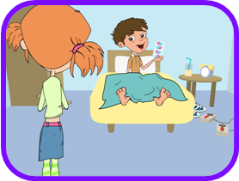

Natasha should cover her mouth whilst coughing. Infection can easily spread from person to person through coughing and sneezing. A sneeze travels at approximately 100 mph and at high force meaning that the microbes carried in a sneeze can travel very far and infect other people.

Mrs Warren should have washed Harry’s cut knee to clean any dirt or microbes which may have been present. Antiseptic cream applied to deeper cuts can also help prevent infection. There is generally no need to cover smaller cuts and grazes with a plaster, fresh air will help the scabbing process.

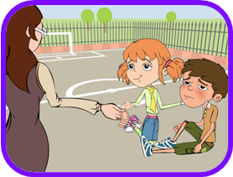

Amy should not use her sister’s antibiotics. There are many different types of antibiotics which treat different bacterial infections. Doctors prescribe specific antibiotics for specific illnesses and at a dose suitable for the patient. Taking someone else’s antibiotics may mean your infection may not get better and increases the chance of bacteria becoming resistant.

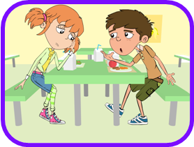

You should always wash your hands after going to the toilet. Many harmful microbes that make you ill are found in toilets. Good personal hygiene is essential to a healthy lifestyle and can greatly reduce the spread of infection. Even if you are in a rush, you must wash your hands after going to the toilet.

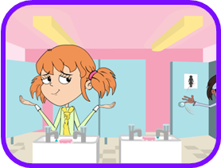

The doctor is right; antibiotics only work on bacterial infections. Coughs and colds are caused by viruses and in many cases the body’s own natural defences will fight these infections. Other medicines from the chemist’s may help with the symptoms of coughs and colds if needed.

