Healthy hands
Difficulty:2 | Ages: 5-16 | Scientific | Physical | Time: 10-20 mins

Learning objectives
- Harmful microbes can spread to others via hands and cause illness
- The best way to stop harmful microbes from spreading is to wash your hands with soap and water.

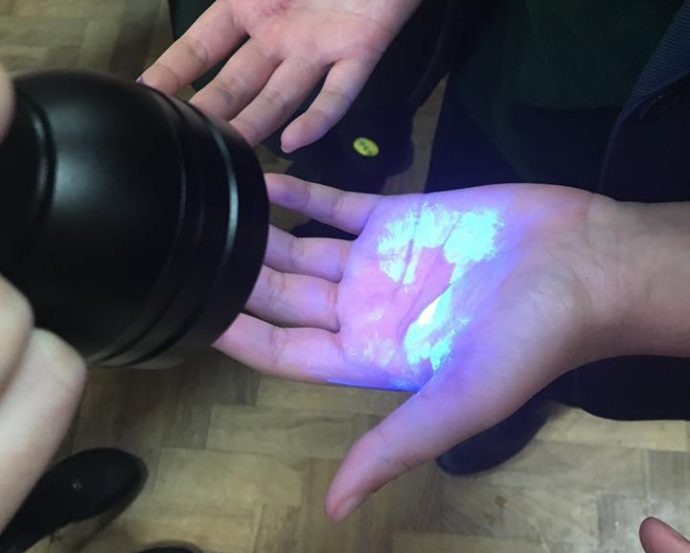
Pictured: UV torch lightling up UV gel, representing the microbes

Equipment
- Ultraviolet (UV) gel or powder and UV torch or lamp
- Alternative to UV is to use eco glitter or glitter substitute such as other pepper or salt
- Access to hand washing facilities with soap and a print out of the ‘Six Steps of Handwashing’

Activity Instructions
- Explain to the group that microbes are everywhere, and they get on to our hands from the things that we touch, or by coughing and sneezing. We then pass these on to other people through touching each other or touching things that others will then touch. Washing our hands is the best way to remove microbes from our hands before they spread to others.
- Ask the group when we should wash our hands e.g. before and after preparing food, after using the toilet, after touching animals and after coughing or sneezing.
- Explain to the group that they are going to demonstrate how microbes spread from person to person. Explain that you will use UV gel/alternative to demonstrate this, ask the group to imagine that the UV is pretend microbes, as microbes themselves are too small to see with the naked eye.
- Ask children to get into lines of 4-5 children. Place UV gel or alternative on the hand of the first child and ask them to shake hands with the person behind them, and so on until all have shaken hands.
- If you used UV gel turn off the lights and show how the gel has spread from child to child. If alternative show how this has spread to each child.
- Demonstrate the proper way to wash hands with soap and ask them to follow your movements: do the six-step technique. Use the torch again to show how well children have washed hands.
- Extension: Ask children to put the six steps of handwashing poster around the venue in handwashing areas. If time allows ask children to make their own version of the poster, or their own song to wash their hands to (this could be done as part of section 2: resource development).

