How big is a microbe?
Difficulty:2 | Ages: 5-11 | Scientific | Time: 10 mins

Learning objectives
- Understand that there are three different types of microbes; bacteria, viruses and fungi which can be found everywhere
- Microbes can come in different shapes and sizes, fungi are the largest, followed by bacteria then viruses
- Some microbes are harmful and can cause infections, but most are harmless, and many are in fact very useful and help us to survive

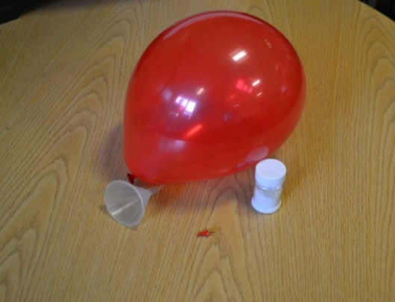 Pictured: Balloon, funnel, glitter and drawing pin.

Advanced preparation
- Fill the balloon with glitter using a funnel and blow the balloon up.
- Prepare as many as needed to demonstrate the activity.

Equipment
- Balloon(s)
- Glitter or sustainable alternative
- Drawing pin

Introduction
- This activity would work well at the start of a meeting as a demonstration.
- Ask the group if they know what a microbe is, explain that there are 3 types of microbes: fungi, bacteria and viruses and they can be both harmful and useful to us.
- Fungi are the largest microbe. Give an example of useful and harmful fungi, for example Penicillium is useful fungi used to create the antibiotic penicillin and mushroom (some!) is a fungi that can be used as food. Harmful fungi causes the condition athlete’s foot.
- Bacteria are the middle-sized microbes. Lactobacillus are useful bacteria found in yoghurts that can aid in our digestion of food. Examples of harmful bacteria are ones that can cause chest infections or food poisoning in spoiled food. Bacteria also come in different shapes: rods, balls or spirals.
- Viruses are the smallest type of microbe; they can cause illnesses such as colds and flu.

Main activity
- Remind the group of the names of the microbes and their sizes. Explain that most microbes are too small to see with the naked eye and that it can be hard to understand their shapes and sizes.
- Ask the group to imagine that if a fungi, the largest of the 3 microbes, was the size of the room they are in, how big do they think a bacteria would be in comparison? Show the group the balloon and explain that this is how big the bacteria would be. Ask how big they think a virus would be in relation to this. Pop the balloon and explain that a virus would be the size of a piece of glitter.

