Illness spreading game
Difficulty:1 | Ages: 5-16 | Scientific | Physical | Time: 10 mins (2 minutes prep.)

Learning objectives
- Infections can spread easily without you knowing
- Hands offer an easy way to spread microbes from one person to another
- Washing our hands is the most effective way to stop infections spreading

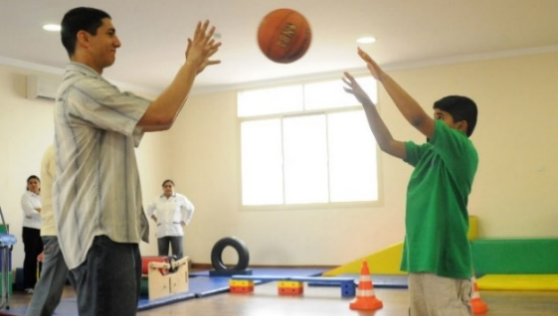 Pictured: Children throwing and catching a ball

Equipment
- Object to pass around the group e.g a ball, cup and saucer, relay baton
- UV gel or powder and UV torch or lamp

Activity Instructions
- Choose a game which involves passing an object around the group, this could be a ball game (such as dodge ball or a catching game), or a cup and saucer game. Choose a game the group is familiar with and enjoys, encouraging engagement.
- Around 30 minutes before playing the game you will need to coat the item(s) with the UV gel or powder. For example – cover the ball in UV gel if you are playing a ball game. White items work better as the gel has a white/opaque colour.
- Play the chosen game and ensure all children join in and touch the object. Once the game has finished ask the children to gather around you in a circle.
- Turn the lights off and use the UV torch on the game item e.g ball. Explain it is covered in germs. You could try and get a reaction by saying that you sneezed or coughed on the item before the game started.
- Tell members to hold their hands out, palms facing upwards. Go around with the UV light to show how the germs have spread onto their hands.
- Ask the group to shout out examples of what other items commonly spread germs. Examples are: door handles, chairs, tables, toilet seats, pens and pencils, mobile phones, tablets, games console controllers, keyboards and mouse.
- We recommend running the next activity ‘healthy hands’ straight after so children have a chance to wash their hands.

