Lucy Lactobacillus



I am a friendly Lactobacillus bacteria found in yoghurt. Please colour me in!

I am a friendly Strep bacteria found in your mouth. Please colour me in!

Sally Strep

(Streptococcus)

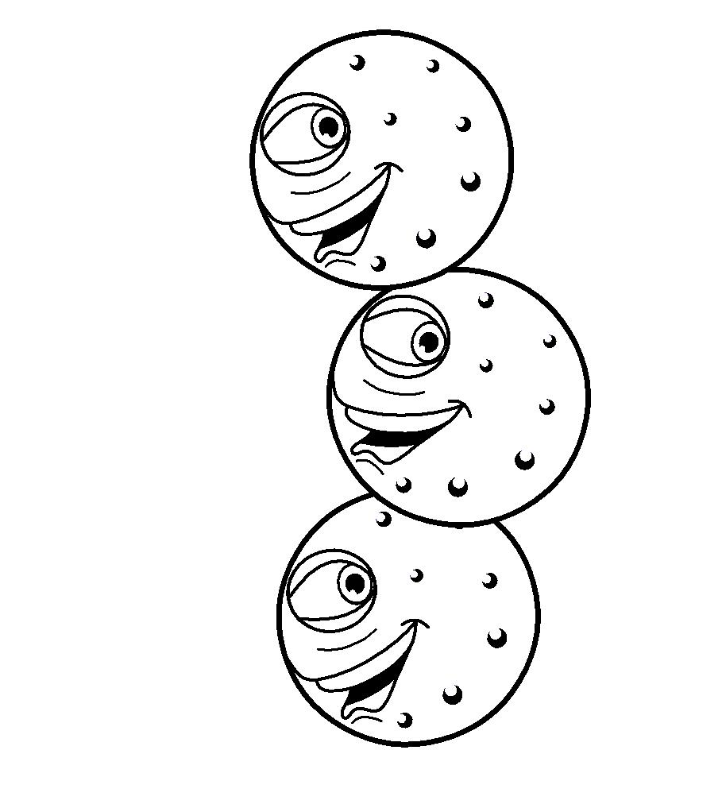

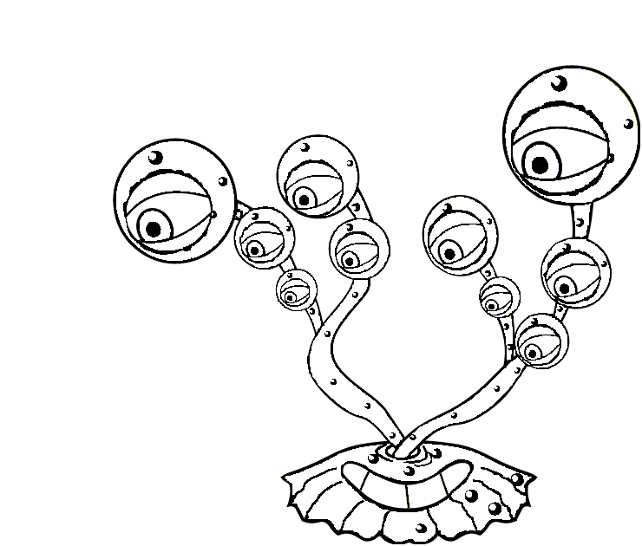

Peter Penicillium

I am fungi used to make antibiotics. Please colour me in!