microscope image of Ebola - E-bowl-A
Microscope image of Influenza virus
In-Floo-en-za
Microscope image of Rhinovirus
Rye-no-vye-rus


# **Ebola**

# **E-bowl-A**

**About**

* Ebola is a very serious **virus** that is **harmful** to humans
* It has been in the news as people living in Africa have caught the virus and many have died
* The virus lives naturally in wild animals in Africa and is not found in the UK

**Symptoms and treatment**

* Ebola virus makes people very unwell and in worst cases causes death
* People with Ebola will need special treatment and hospital care to help get better

# **Influenza virus**

# **In-Floo-en-za**

**About**

* Also known as the **Flu virus**
* It is a **virus** that is **harmful** to humans

**Symptoms and treatment**

* Causes fever (high temperature), runny nose, sore throat, muscle pains, cough, feeling tired
* Spreads from person to person by coughs and sneezes and unwashed hands
* Treatment is bed rest and plenty of fluids to feel better. If very unwell, an antiviral medicine might help.

# **Rhinovirus**

# **Rye-no-vye-rus**

**About**

* Also known as the common cold
* It is a **virus** that is **harmful** to humans

**Symptoms and treatment**

* Causes runny nose, sneezing, sore throat and coughing
* Spread from person to person by coughs and sneezes and unwashed hands
* Treatment is bed rest and plenty of fluids to feel better.

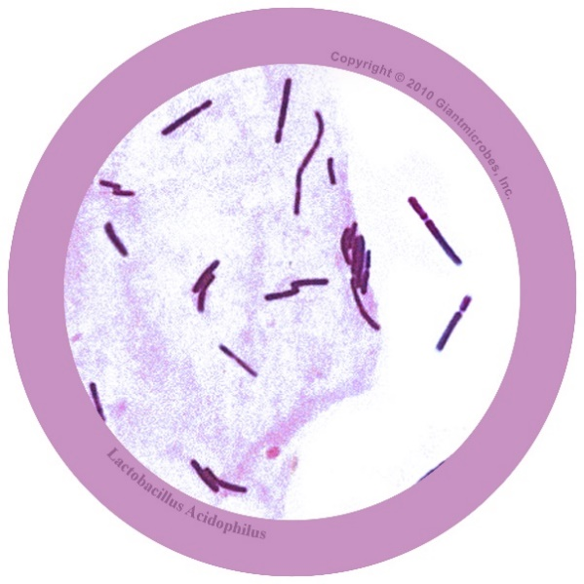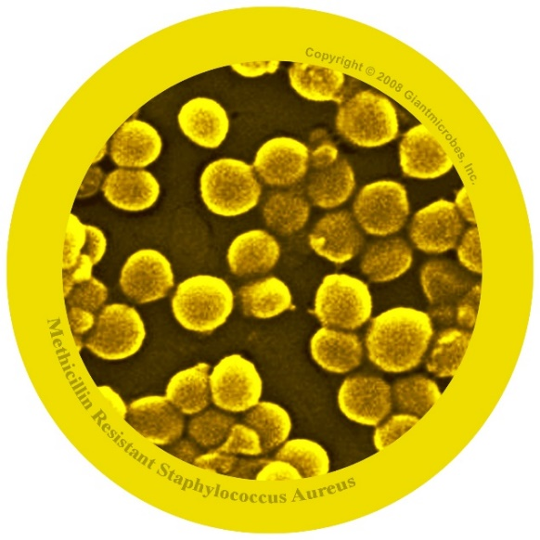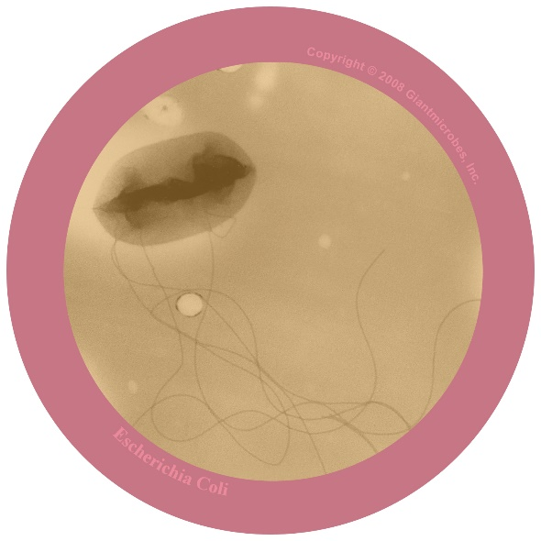

# **Lactobacillus**

# **Lack-toe-ba-sill-us**

**About**

* *Lactobacillus* are **useful** **bacteria** that do not usually cause harm to humans

**What does it do?**

* It lives naturally in our body in our gut
* Lactobacillus can help us to digest food and is good for our health
* It can also be found in dairy foods such as milk and yoghurt
* Lactobacillus may sometimes help people who are sick with diarrhoea

# **Staphylococcus aureus**

# **Staff-ill-O-coccus**

**About**

* *Staphylococcus* are bacteria that normally live in the human nose, throat and skin and can be harmful

**Symptoms and treatment**

* *Staphylococcus* can cause infections of the skin
* In worst cases it can get into the blood and cause very serious illness
* *Staphylococcus* bacteria can be treated with antibiotics
* Some types of *Staphylococcus* are known as ‘Superbugs’ (**antibiotic-resistant bacteria**) and common antibiotics no longer work against them.
* A common type or antibiotic-resistant *Staphylococcus aureus* is called *Methicillin-Resistant Staphylococcus aureus* (known as MRSA) which is resistant to a type of antibiotic called methicillin

# **E. coli**

# **Ee-Cole-eye**

**About**

* *E. coli* are **bacteria** that normally live in the human gut and can be **harmful**
* There are lots of different kinds of *E. coli*

**Symptoms and treatment**

* *E. coli* can sometimes be found in food and when you eat this you can become sick and have diarrhoea
* *E. coli* can also cause water infections
* As a type of bacteria, *E. coli* can be treated with special medicines called antibiotics

Microscope image of Tinea - Tin-Ee-Ah
Microscope image of Sacharomyces
Sack-Ar-O-Mice-ees
Microscope image of Penicillium 
Pen-Ee-Sil-Ee-Um


# **Tinea**

# **Tin-Ee-Ah**

**About**

* Tinea are **fungi** that can be **harmful** to humans

**Symptoms and treatment**

* Tinea can cause athlete’s foot, which causes itchy dry skin between the toes
* Tinea grows well on damp warm feet
* Treatment includes an anti-fungal cream

# **Sacharomyces**

# **Sack-Ar-O-Mice-ees**

**About**

* Sacharomyces is a type of fungi which can be **useful** to humans
* Sacharomyces also known as yeast

**What does it do?**

* Yeasts are used to make certain foods including bread and alcohol such as beer

# **Penicillium**

# **Pen-Ee-Sil-Ee-Um**

**About**

* Penicillium are **useful** **fungi** that do not usually cause harm to humans
* Penicillium are a type of mould

**What does it do?**

* Penicillium was used to create the first antibiotic, Penicillin!
* Some species of penicillium are used to make the blue mould on cheese