Modelling microbes
Difficulty:2 | Ages: 5-16 | Scientific | Creative | Time: 10-15 mins

Learning objectives
- Understand that there are three different types of microbes; bacteria, viruses and fungi which can be found everywhere
- Microbes can come in different shapes and sizes. Fungi are the largest, followed by bacteria then viruses
- Some microbes are harmful and can cause infections, but most are harmless, and many are in fact very useful and help us to survive

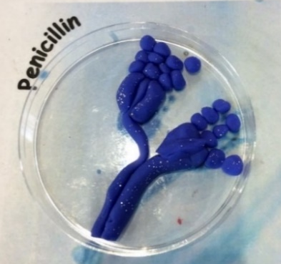 Pictured: Clay model Penicillin in petri dish

Advanced preparation
- Print and laminate the example microbes and place around the activity area
- If running alternative activities, prepare coloured icing and jelly
- For younger children, provide the colour in microbe sheets

Equipment
- Modelling clay in a variety of colours
- Black marker pen, coloured pens and pencils
- Paper plates, plastic dishes or petri dishes
- Alternative activity 1: Small dishes, edible jelly, selection of sweets, coloured icing
- Alternative activity 2: round digestive biscuits, coloured icing
- Worksheets: Microbe example sheets, Microbe colouring in sheets

Introduction
- Explain that microbes are the smallest living creatures on earth and that the word micro-organism refers to micro: small and organism: life. Microbes are so small that they cannot be seen without the use of a microscope.
- Show the group that there are three different types of microbe: bacteria, viruses and fungi. Although they are too small for us to see with the naked eye they can be found everywhere, in the air, the ground and in our bodies!
- Show the children the example microbes and explain that when scientists look at microbes under a microscope they are all different shapes and sizes. Different microbes have different features, which help scientists distinguish them from one another. Encourage children to look at the microbe fact cards and ask if they have heard of any.

Main activity
- Ask each child to recreate one of the example microbes or invent their own within their plates using the modelling clay and coloured pens.

- Ask children to label the plate or dish with their own name, the name and type of microbe, and whether it could be useful or harmful to humans.

Alternative activity
- Alternative 1: provide children with shallow dishes or pots with set coloured jelly. Explain to children that scientists grow microbes on a substance called agar which looks like jelly and provides microbes with the food they need to grow. Children can then decorate the surface of the jelly with coloured icing and sweets to resemble microbes.

- Alternative 2: Provide children with round digestive biscuits, coloured icing and other decorations such as sweets and gummy laces. Ask children to create microbes on their biscuits using the decorations.

