Pepper and water experiment
Difficulty:2 | Ages: 5-14 | Scientific | Time: 10-15 mins

Learning objectives
- Microbes can ‘stick’ to the natural oils on our hands making them hard to remove with water alone
- Soap removes the oil on our hands and helps wash microbes away

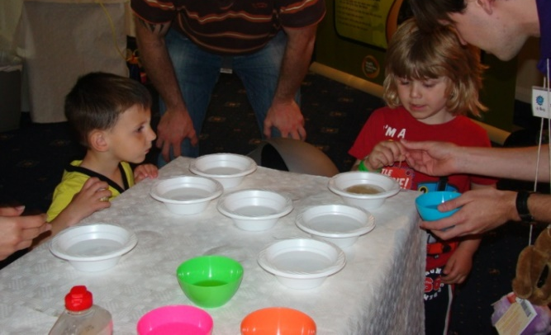
Pictured: Children using soapy cocktail sticks in a bowl of water and pepper to visualise how soap works on our hands

Equipment
- Shallow bowls or dishes
- Access to fresh water and soap
- Ground pepper or other spice such as cinnamon
- Cocktail sticks

Activity Instructions
- Fill the bowl with water and sprinkle the ground pepper or spice across the surface of the water.
- Demonstrate this activity to the group first. Tell children that the surface of the water represents their hands, and that the pepper represents harmful microbes that need to be washed away.
- Dip the end of a cocktail stick into a plain bowl of water and then dip into the pepper water. Nothing happens to the microbes, using water alone to wash your hands only moves the microbes around.
- Dip the cocktail stick into a bowl of soap and then into the pepper water. The pepper ‘microbes’ should move towards the edges of the bowl as the soap hits the surface of the water.
- Tell the children that this shows why using soap when you wash your hands is important, because it breaks up the oils on the surface of your hands that microbes stick to and then they can be rinsed away under running water.
- Split the group into pairs or groups of 3 and ask them to repeat the experiment.
Discuss what happened with the group. The experiment with and without soap should have been different. When the soap was added to the bowl the pepper should have moved towards the edges of the bowl. This is because the soap removes the oils on your hands and the oil pushes the pepper towards the edge of the bowl. Microbes like to stick to the oils on your hands, which is why we should wash our hands with soap.

