Snotgun runway
Difficulty:1 | Ages: 5-16 | Scientific | Time: 10-15 mins

Learning objectives
- Microbes can cause illnesses like colds and flu which make you sneeze and have a runny nose
- Microbes can spread easily between people through snot and sneezes
- We can stop microbes spreading by covering our sneeze with a tissue or our sleeve (not our hands) and washing our hands

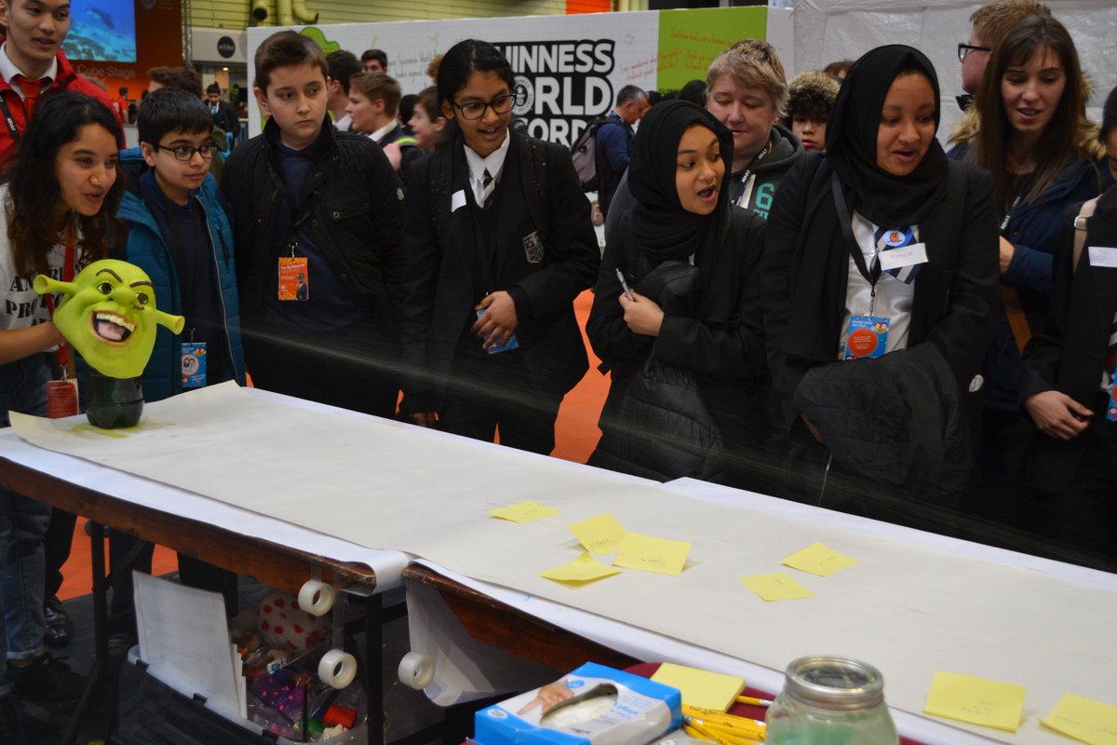 Pictured: Snot gun demonstration

Equipment
- Long roll of paper such as wallpaper
- Measuring tape or 2m ruler
- Pump action spray bottle
- Green food colouring
- Disposable plastic/vinyl gloves
- Kitchen roll
- Pens and sticky notes (optional)
- Optional: a funny mask to cover the spray bottle

Advanced preparation
- Create a sneeze runway using a roll of wallpaper along a long table or on the floor
- Fill the spray bottle with water and green food colouring
- Cover the bottle with a funny mask and place at the end of the runway

Activity instructions
Ask the group “Why we sneeze?” To keep airways clean, to get rid of particles and microbes from the nose. What illnesses are spread through sneezes? What can we do to present spreading illnesses?

- Ask the group to write their name or draw a picture of themselves on a sticky note, or write directly on the runway at the furthest point they think it will reach. Ask the group to imagine that the runway is a party or a bus and the children can place themselves where they think they will avoid the sneeze.

- Hold the bottle at the end of the sneeze runway and simulate a sneeze by squeezing the trigger and work out who was closest to the actual distance. Count down from 3 and encourage the group to shout ACHOO when the snot is launched. You may repeat and allow children to have a go at ‘sneezing’

- Ask a child to measure how far and how wide the sneeze spreads with a meter ruler or tape measure and determine which child guessed the closest.

- Ask the group what you would usually do when sneezing – put a hand over your nose.

- Ask one child to put on a glove and place their hand over the nozzle to demonstrate putting a hand over your nose as you sneeze. Pull the trigger again after predicting what will happen. Ask children if this is an effective way to stop the microbes in the snot spreading to others? The microbes stay on our hands and can spread to anything we touch.

- Ask someone to put a piece of kitchen towel over the nozzle to demonstrate holding a tissue over your nose as you sneeze. Pull the trigger after predicting what will happen. The sneeze is successfully caught in the tissue and won’t infect anyone else if the tissue is thrown in the bin straight away. Ask the sneeze catcher to throw the tissue away.

- Ask the group to recite what they have learned, for example by repeating the phrase ‘catch it, bin it, kill it’. Reinforce that catching a sneeze in a tissue is the best way to prevent the spread of microbes to others.

