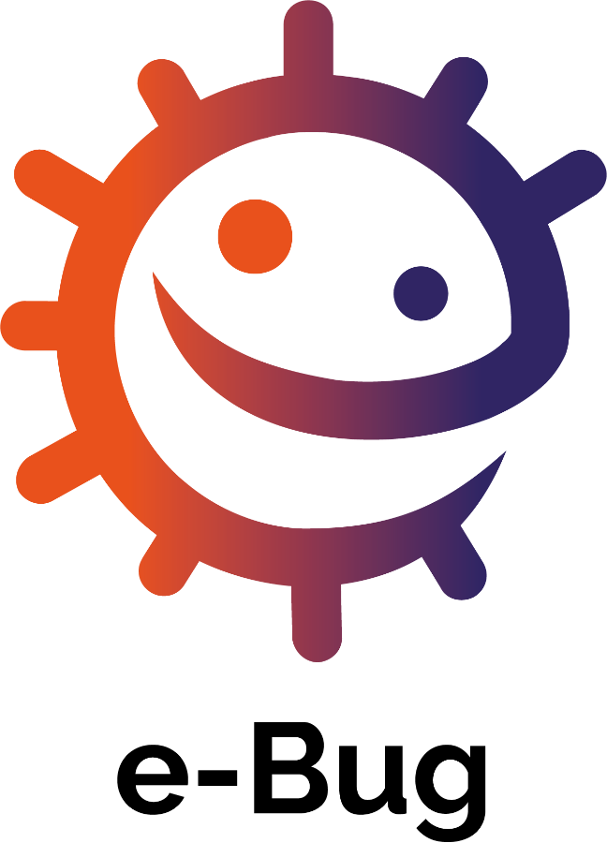
An international educational resource covering the world of microbes and disease.
Lesson plans, worksheets, and activities.

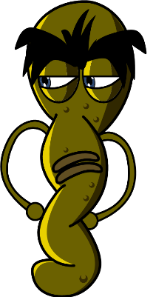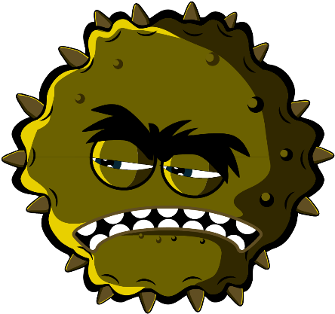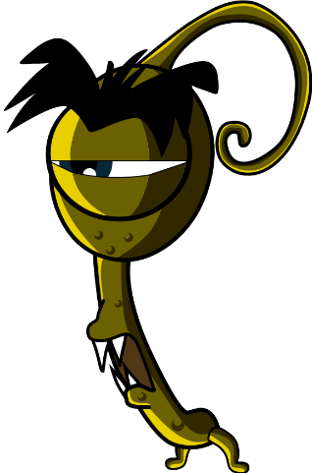

Early Years (3-5 years)

Welcome to e-Bug

e-Bug has been designed to bring the world of microbes and antibiotics to life for children in the school environment. It is a curriculum supplement series (Early Years, Key Stage 1, 2, 3 and 4) that complies with the Department for Education educational standards for junior and senior schools.
This resource has been created by the UK Health Security Agency (formerly Public Health England) in collaboration with 17 EU partner countries to foster an interest in science and to improve young people’s knowledge and understanding about microbes, infection prevention and control, and prudent antibiotic use, thereby empowering them to be proactive in looking after their own health. Lesson plans can be used in sequence or as individual activities designed to fit into 50-minute classroom slots. These tools can be used freely by educators and may be copied for classroom use but may not be sold.
Over 27 international countries are involved in the e-Bug project, and the resources have been evaluated with more than 3000 children in England, France and the Czech Republic. The e-Bug pack is supported by a website from which all the pack resources, videos, images and additional activities can be downloaded (www.e-bug.eu).

We would like to thank everyone involved in the development of this resource which will help the next generation of adults to use antibiotics more wisely. We would especially like to thank the teachers and students across the UK, and Europe who participated in focus groups and the evaluation process and helped ensure that these materials are not only fun and exciting but also effective. We do hope you enjoy using e-Bug and will find this an invaluable addition to your classroom. If you would like to keep up to date with our latest resources, or the research and development that we undertake please register for our quarterly newsletter at: www.e-bug.eu/uk-newsletter

As educators, your feedback is invaluable to us. Your comments will help the e-Bug resource grow and evolve. Please send any comments, queries and suggestions to: Primary Care and Interventions Unit UK Health Security Agency Twyver House, Bruton Way Gloucestershire GL1 1DQ

Or alternatively visit the e-Bug website and contact us at www.e-bug.eu/uk-contact-us

The e-Bug Team

Each section of the pack contains detailed lesson plans, student worksheets and handouts some of which are available in MS PowerPoint format for whiteboard use:
- Creative inquiry based activities to promote active learning
- Highlighted learning outcomes which deepen students’ understanding of the importance of microbes, their spread, treatment and prevention
- Activities that encourage students to take more responsibility for their own health
- Activities that highlight the importance of responsible antibiotic use

Early Years

Teacher Refresher Information
Optional background information for each of the pack topics has been included to help you plan your lessons and introduce the topic to students.

Hand Hygiene
Schools are a haven for potentially harmful microbes that can spread rapidly from child-to-child via touch. Our skin naturally secretes oil which helps to keep our skin moist and stops it getting too dry. This oil, however, is a perfect place for microbes to grow and multiply and helps microbes ‘stick’ to our skin. Although our hands are naturally covered in useful bacteria (also known as flora), our hands can easily pick up harmful microbes from our surroundings (e.g., home, school, garden, animals, pets, food), surfaces and even through the air. These harmful microbes can spread quickly and easily from child-to-child via touch and can make us poorly if swallowed. Washing your hands is one of the best ways to stop harmful microbes from spreading and prevent us from becoming sick.
Washing hands in water alone, even cold water, will eliminate visible dirt and grime. However, soap is required to break up the oil on the surface of the hands which trap microbes. Hand sanitisers can be used where soap and water are not available. When possible, liquid soap should be used instead of bars of soap, especially if used by multiple people. Hands should be washed:
- Before, during and after preparing food
- After using the bathroom - After exposure to animals or animal waste
- After coughing, sneezing, or blowing your nose
- If you’re ill or have been around ill people
- After outdoor play
Hand sanitisers with ingredients like alcohol work by destroying microbes as they dry, but don’t kill all types of harmful microbes and don’t remove visible dirt or other substances from our skin. Therefore, hand sanitisers should not be generally used after using the toilet.

Respiratory Hygiene
Respiratory infections are infections that happen in the lungs, chest, sinuses, nose and throat, for example, coughs and colds, the flu and pneumonia. These infections can spread from person-to-person through the air, through person-to-person contact (touching hands, hugging, kissing) or by touching contaminated surfaces. The microbes can be spread by getting into the non-infected person’s nose or eyes because they touch their face with contaminated hands. The most common mode of spreading infection is through coughs and sneezes. Sneezing is a way in which our body tries to get rid of any harmful microbes and dust particles we might inhale. The harmful microbes and dust get caught on the nose hair and tickle our nose or might irritate the back of our throat or our lungs. The nose sends a message to the brain which then sends a message back to your nose, mouth, lungs and chest telling them to blow the irritation away. In the case of colds and flu, millions of virus particles rush out and contaminate the surface on which they land; this could be our food or hands.
Colds and flu are the most common illnesses in childhood settings and perhaps among the most contagious. COVID-19 is the name of the disease caused by the virus SARSCoV-2. and can be very contagious. As colds, flu and COVID-19 are caused by viruses, they cannot be cured by antibiotics. When we catch a cold or flu rest and drinking plenty of fluids are generally recommended however, if symptoms persist then a visit to the local doctor or pharmacist is required. Symptoms of colds and flu include headache, sore throat and fever. Colds can also cause runny noses. Many sore throats associated with colds and flu are due to the viruses in the throat making it inflamed and feeling raw. Breathing in through the mouth causes the throat to feel dry and continual coughing can aggravate sore throats and contribute to an aching feeling.
Teaching good respiratory hygiene from a young age, such as covering your coughs and sneezes or regularly washing your hands for 20 seconds, can help prevent the spread of these infections. This is especially important in the approach to the winter cold/flu season each year. It is a natural reflex to put our hands towards our faces when we sneeze, but it is important to replace this action with new habits of respiratory hygiene to reduce the spread of infection:
Cover your sneezes, dispose of tissues, and regularly wash your hands.
Catch it: cover your mouth and nose with a tissue. If you don’t have a tissue, cover with your upper sleeve or elbow (not your hands).
- Bin it: throw away the used tissue at once to avoid spreading infection to surfaces, or other people.
- Kill it: wash your hands well with soap and water, or hand sanitiser if soap and water are not available, immediately after throwing the tissue in the bin.
We can help prevent the spread of these infections (like the flu and COVID-19) by getting vaccinations. Check government links on why a different flu vaccine is needed each year.
Learning about respiratory hygiene provides a chance to talk to students about vaccinations, a vaccination they may be familiar with is the annual flu vaccine.

Oral Hygiene
Normally our first teeth come through our gums (erupt) at around 6 months of age, and we will have a full set of 20 baby (primary) teeth by the time we are 2 ½ years old. At around 6 years old our first permanent molars erupt, and the front primary teeth begin to get wobbly and fall out (exfoliate) and are replaced by the permanent (adult) teeth. On average by 12 years old we have lost all our baby teeth and have 32 adult teeth, which if we look after, can last for the rest of our lives.
Bacteria can grow on teeth, clumping together to form a sticky substance called dental plaque. You will see this in your own mouth as a creamy line around your teeth or sometimes feel it as a furry layer with your tongue. If plaque is not brushed away regularly or there is a high frequency of sugar in the diet, the bacteria within the plaque can lead to tooth decay (caries).
When we eat sugary foods and drinks, bacteria in the plaque can use the sugars to make acid. Over time this can dissolve the outer surface of our teeth (the enamel). As more enamel is dissolved, a hole (cavity) appears. As the decay process continues, the bacteria can reach the nerve and cause toothache.
If no dental treatment is given, the tooth decay (caries) can spread and bacteria can penetrate the nerve, leading to inflammation of the bone and surrounding structures of the teeth which can result in an abscess (lump on the gum) that is filled with pus. This can make you very poorly and the tooth will usually need to be removed (extracted).
Dental health is extremely important; over 23% of children in England have tooth decay and it is the main reason for children aged 5 to 9 being admitted to hospital. The good news is that tooth decay can be prevented by limiting the number of times we eat foods and drinks with added sugar, brushing twice a day with fluoride toothpaste and regularly seeing the dentist to check the health of our teeth and gums.
Fluoride in toothpaste can help strengthen our teeth and slow down the decay process. The most important time to brush teeth with fluoride toothpaste is before going to bed at night. To make it easy to remember it is best to add tooth brushing to a twice daily hygiene routine morning and night.

Healthy Eating
In the UK, 34% of primary school children are now overweight and children are now eating three times more sugar than they should. Half of the sugar children eat comes from unhealthy snacks and sugary drinks. Fruit and vegetables are still the healthiest snack choice.

All lesson plans and supporting materials contained in this pack are available to download as modifiable templates from the e-Bug website
Early Years

Spread of Infection: Hand Hygiene

Lesson 1: Hand Hygiene
By taking part in a classroom experiment, children learn why it is important to wash hands properly and learn the best method and order for hand washing.

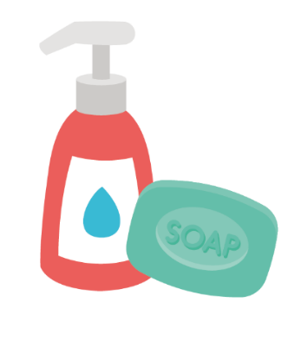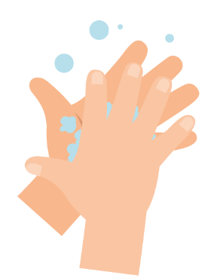

Learning Outcomes

All students will:
- Understand that we wash hands to remove germs (microbes).
- Understand the sequencing of handwashing and nose blowing.
- Understand how to blow their nose to minimise the risk of transmission of infection.

Curriculum Links

Communication and language development
- Listening and attention
- Understanding
- Speaking

Physical development
- Health and self-care

Expressive arts and design
- Exploring and using media and materials

Lesson 1: Hand Hygiene

Resources Required

Activity: Balloon hands

Per child
- Disposable plastic/vinyl gloves

Per group or class
- Basin
- Water
- Hand soap
- Washable black marker

Extension Activity: Hand Washing and Nose Blowing Flashcards

Per class
- TS1 Hand Washing and Nose Blowing Flashcards

Extension activity: Picture Sequencing Activity

Per child/ group
- SW1 Picture Sequencing Activity
- Glue sticks & paper or card

Extension Activity: Hand Washing Chart

Per child
- SW2 e-Bug Healthy Hands Hand Washing Progress Chart

Supporting Materials
- TS1 Hand Washing and Nose Blowing Flashcards
- SW1 Picture Sequencing Activity - place hand washing in the correct order
- SW2 e-bug Healthy Hands Hand Washing Progress Chart

Advanced Preparation
- Fill a basin with soapy water
- Inflate vinyl gloves with air and tie at the bottom to create hand balloons
- Draw circles and dots on the balloon hands with washable marker to resemble germs

Lesson 1: Hand Hygiene

Key Words
Hygiene
Soap
Infection

Health & Safety
Ensure that children have no soap allergies or sensitive skin conditions.
For safe microbiological practices in the classroom consult CLEAPPS
www.cleapps.org.uk

Weblinks
www.e-Bug.eu/eng/EYS/lesson/Hand-Hygiene

Introduction
When introducing students to the concept of microbes, you can refer to the teacher refresher section for more information.
- Begin the lesson by asking how many children have washed their hands today? Ask them why they washed their hands (to wash away any dirt or germs microbes that might be on their hands) and what would happen if they didn’t wash their hands (they might get ill as they ingest harmful microbes on their hands).
- Talk to the children about how we use our hands all the time, and that they pick up millions of microbes every day. Although many of these are harmless, some could be harmful. Explain that we spread our microbes to our friends and others through touch, and that this is why we wash our hands.
- Describe key times we should be washing our hands (especially after using the toilet and before eating).
- Explain to the children that they are going to do an activity to demonstrate how microbes are all over our hands and how best to wash them off.

Activity
- Demonstrate how to wash the marker off the balloon hands with soapy water.
- Provide each child with a balloon hand covered in microbes (washable marker).
- The children should take turns thoroughly scrubbing the marker off the balloon hands in the basin of soapy water.
- Have a conversation with the children about what they saw. How long did it take for all the microbes to disappear? Why do you think it’s important to wash our hands? If we didn’t use soap would it have worked?
Children should notice that it is much easier to wash off the marker pen with soapy water.

Now visit e-bug.eu/eng/EYS/ lesson/Hand-Hygiene to find a NHS demonstration and the UKHSA hand washing song to help make the correct technique more memorable for little hands.

Discussion
- Discuss with the children where the microbes on the balloon hands may have come from. Emphasise to children that not all the microbes on their hands are harmful; there may also be useful microbes there too.
- Emphasise to the children that we also need to wash our hands properly. Highlight that microbes like to hide in between fingers and under the nails. It is important to know both WHEN and HOW to wash our hands properly to prevent spreading microbes and potentially infection. When you must sneeze and you can’t wash your hands, a solution may be to sneeze or cough onto your sleeve/elbow.

Extension Activities

Hand Washing and Nose Blowing Flashcards
TS1 is a useful way to support learning. Cards can be cut and laminated for future use or displayed on a whiteboard. Ask children to name the image, the correct word is shown on the card.

Picture Sequencing Activity
Provide SW1 to a child or group. Supply paper, card and glue sticks and ask children to sort the cards into the correct order and stick them onto the paper or card with glue.

Hand Washing Chart
SW2 is a hand washing chart that allows children to mark and keep track of how often they have washed their hands throughout one school-week. Print the sheet and distribute to each child. This could be a classroom or take-home activity to reinforce hand washing behaviours.

TS1 - Hand Washing and Nose Blowing Flashcards
Bin
Soap

Tissue
Hand sanitiser

Hands
Tap

Sneeze
Water

SW1 - Picture Sequencing Activity – place hand washing in the correct order

Soap
Dry hands

Turn on tap
Rinse hands

Play outside
Scrub hands

SW2 - Healthy Hands Hand Washing Chart
FRI
I washed my hands before school
I washed my hands after breaktime
I washed my hands before lunch
THU
WED
TUE

MON
Healthy Hands Handwashing Chart
Name
Class
Add a picture or star each time you wash your hands!
SW1 – Hand Washing Flashcards
Back
of fingers
20 seconds
Soap
Backs
of hands
Scrub
your hands
Thumbs
Tips
of fingers
Between
fingers
Early Years

Spread of Infection: Respiratory Hygiene

Lesson 2: Respiratory Hygiene
Children learn how easily harmful germs (microbes) spread through sneezing.

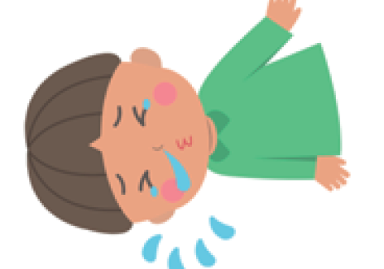

Learning Outcomes

All students will:
- Understand that sneezing into a tissue, or into your sleeve (not your hands), is the best way to stop the spread of colds and flu germs (microbes)
- Understand that there can be harmful germs in your sneezes that can spread over your hands
- Understand the sequencing of hand washing and nose blowing

Curriculum Links

Communication and language development
- Listening and attention
- Understanding
- Speaking

Physical development
- Health and self-care

Expressive arts and design
- Exploring and using media and materials

Lesson 2: Respiratory Hygiene

Resources Required

Activity: Paint Sneezes

Per child
- Paper plate/sheet of paper
- Plastic/vinyl gloves
- Food colouring added to water
- Drinking straw

Extension Activity: Hand Washing and Nose Blowing Flashcards

Per class
- TS1 Hand Washing and Nose Blowing Flashcards

Extension activity: Nose Blowing Writing Activity

Per child
- SW1 Nose Blowing Writing Activity

Supporting Materials
- TS1 Hand Washing and Nose Blowing Flashcards
- SW1 Nose Blowing Writing Activity

Advanced Preparation
- You may wish to use the balloon hands from lesson 1 instead of paper plates for this main activity
- Create a cup of coloured water using a few drops of food colouring
- You may wish to use different colours to indicate different germs

Lesson 2: Respiratory Hygiene

Key Words
Symptom
Sneeze
Vaccinations
Microbe

Health & Safety
Children may require aprons.

Ensure that the food colouring is diluted (to avoid staining). Children may need to wear safety goggles.

For safe microbiological practices in the classroom consult CLEAPPS
http://www.cleapps.org.uk/

Weblinks
wwww.e-Bug.eu/eng/EYS/lesson/Respiratory-Hygiene

Introduction
- Begin by explaining to the children that they are going to learn how harmful microbes can be spread by sneezing and coughing.
- Discuss that colds and flu are caused by harmful microbes (viruses). The viruses can be passed on to other people if we cough or sneeze on them or if we cough and sneeze on to our hands and then touch them.

Activity
- Ask the group to use a pen to draw around their hand onto a paper plate or a sheet of paper.
- Add a few drops of coloured water to each child’s drawn hand.
- Give each child a drinking straw and ask them to blow the germs all over their drawn hand just like they would blow germs out of their nose onto their hands.
- Children may wish to decorate the germs or give them names.
- Discuss with the children what would happen if we cover our mouth with a tissue or our sleeve instead of our hands when sneezing and how this would limit the spread of germs.
Children should notice that the coloured water spreads over their drawn hand more readily when they don’t cover their mouth.

Discussion
Discuss with children what happened. Ask them to look at the hand and notice that the microbes are still on it.

Microbes can still be passed from person to person through touch if we cover our coughs and sneezes with our hands. It is recommended that in the absence of a tissue we sneeze on our sleeve/elbow because we are less likely to transmit harmful microbes to other people by doing this.

Explain that sneezing in your hand can spread the microbes to things that we touch, so it is better to sneeze into the tissue (or our sleeve/elbow) and then throw it away and wash your hands as soon as possible.

Extension Activities
Hand Washing and Nose Blowing Flashcards
TS1 can be used to support learning. Print the sheet and cut out the flashcards or display the sheet on a whiteboard. Ask children to name the image, the correct word is shown on the card.

Nose Blowing Writing Activity
Provide each child with SW1. Ask children to use the picture prompts and words provided to fill in the blanks for the correct steps to take when blowing your nose.

TS1 - Hand Washing and Nose Blowing Flashcards
Bin
Soap

Tissue
Hand sanitiser

Hands
Tap

Sneeze
Water

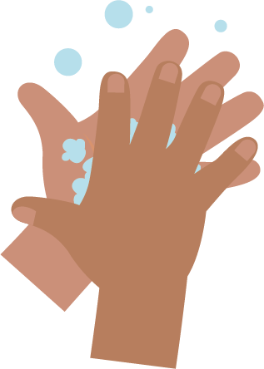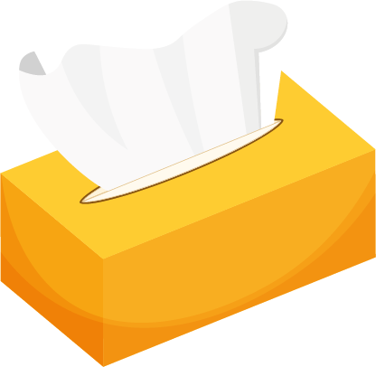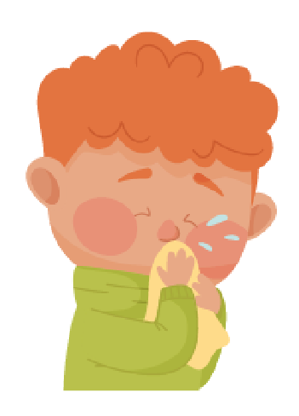
_______________________________

SW1 - Picture Sequencing Activity – place hand washing in the correct order

Blowing Your Nose

Writing Activity
Write instructions for the correct way to blow your nose.
Use the pictures below to help you.
wash hands
bin
tissue
blow
Step 1

_______________________________
Step 2

_______________________________
Step 3

_______________________________
Step 4
SW1 – Hand Washing Flashcards
Back
of fingers
20 seconds
Soap
Backs
of hands
Scrub
your hands
Thumbs
Tips
of fingers
Between
fingers
Early Years

Prevention of Infection: Oral Hygiene

Lesson 3: Oral Hygiene
Children learn how to brush their teeth and understand that we brush our teeth at least twice per day to avoid tooth decay.

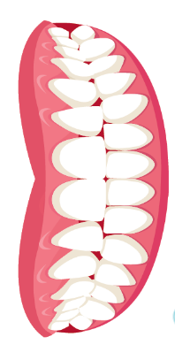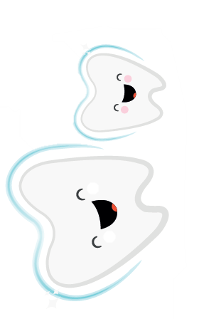

Learning Outcomes

All students will:
- Understand how to brush their own teeth effectively.
- Understand why it is important to brush our teeth.
- Understand the link between sugar and tooth decay

Curriculum Links

Communication and language development
- Listening and attention
- Understanding
- Speaking

Physical development
- Health and self-care

Expressive arts and design
- Exploring and using media and materials

Lesson 3: Oral Hygiene

Resources Required

Introduction

Per Class
- SH1 Picture of teeth

Activity: Mirror Exercise and Teeth Brushing Mime

Per class
- Soft toy / puppet or mouth model with an opening mouth and teeth
- Toothbrush
- Mirror
- A timer / 2-minute egg timer
- If possible, ask children to bring a toothbrush to the session

Extension Activity: Tracking teeth brushing

Per child
- SW1 Teeth Brushing Chart

Supporting Materials
- SH1 Picture of Teeth
- SW1 Teeth Brushing Chart

Lesson 3: Oral Hygiene

Key Words
Bacteria
Germs
Microbes
Plaque
Cavity
Sugar
Tooth brushing

Health & Safety
Younger children must be
supervised when brushing their own teeth at all times.

For safe microbiological practices in the classroom consult CLEAPPS
http://www.cleapps.org.uk/

Weblinks
http://www.e-bug.eu/eng/EYS/lesson/ Oral-Hygiene

Introduction
- Ask the children to use a mirror to look in their mouth. What can they see? How many teeth can they see? What do they look like? Explain to the children that most of their teeth are baby teeth, but some children’s teeth may have started to fall out, these are replaced by bigger adult teeth that they will have for the rest of their lives.
- Show the class SH1 a picture of teeth inside a mouth. SH1 is a picture of adult teeth, which has 28 teeth excluding 4 wisdom teeth. Adults have a total of 32 teeth. Ask the children to help count the number of teeth they see in the picture. Then ask the children to count how many teeth they have (children under 6 generally have 20 baby teeth). Ask the children how many top teeth they have and how many bottom teeth they have.
- Ask the children what we use our teeth for (eating, speaking, smiling). Explain that it is very important to look after our teeth by keeping them clean. Having too many sugary foods and drinks too often is bad for our teeth and could cause holes in our teeth, this is called a cavity. A cavity can hurt and make it painful to eat. Brushing your teeth helps prevent cavities.
- Explain to the children that to keep our teeth healthy we must brush them twice every day; last thing at night and at least one other time during the day, it’s easy to remember if you do it before school and before bed. Tell the children that we should brush our teeth for two minutes each time, using a fluoride toothpaste and be supervised/get help from an adult.

Activity
- Bring out either a soft toy or puppet with an open mouth and teeth and explain to the children that they are going to brush the puppets teeth.
- Using the puppet and a toothbrush, show the children how to brush their teeth, demonstrating the action of moving the toothbrush in small circles on the front and the back of the teeth, and all the way back to the molars.
- If you have extra puppets and toothbrushes let the child try this themselves along with a two-minute timer. If only one puppet/brush is available you can share the puppet and toothbrush among the group, and have each child pass it on after 15 – 30 seconds.
- If children have brought their own toothbrushes to school, supervise the children brushing their own teeth.
This fun activity will help children learn to brush their teeth effectively.

Discussion
Tell the students we brush our teeth to remove germs (microbes) that live in our mouths and like to eat the sugar on our teeth. When this happens and we don’t brush our teeth enough we can get holes in our teeth which might get worse over time and cause toothache or worse and can make you feel unwell.

Ask the children if they can remember the most important steps to keep our teeth clean:
- Brush twice a day - before school and just before bed.
- Using a fluoride toothpaste.
- Brush your teeth in circles and get the front, back and molars.
- Brush for two-minutes.
- Spit out the toothpaste at the end, do not rinse.

Extension Activities

Teeth Brushing Chart
SW2 is a useful way to encourage routine tooth brushing. Provide one sheet per child. Ask children to mark or draw a picture every time they brush their teeth to keep track of how often they have brushed their teeth during one school week. This can be completed in the classroom or at home.

SH1 - Picture of Teeth

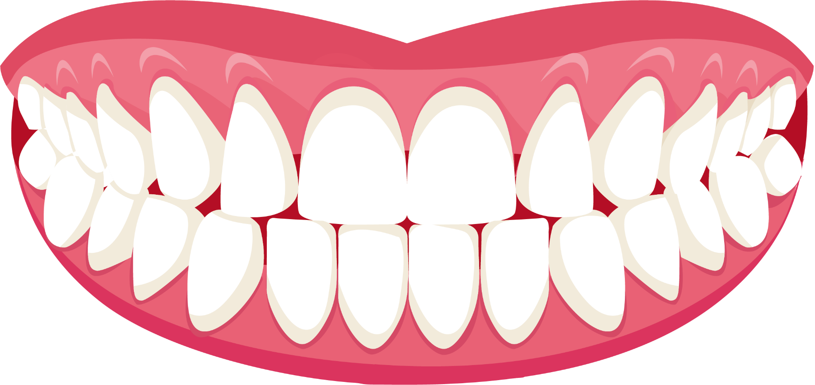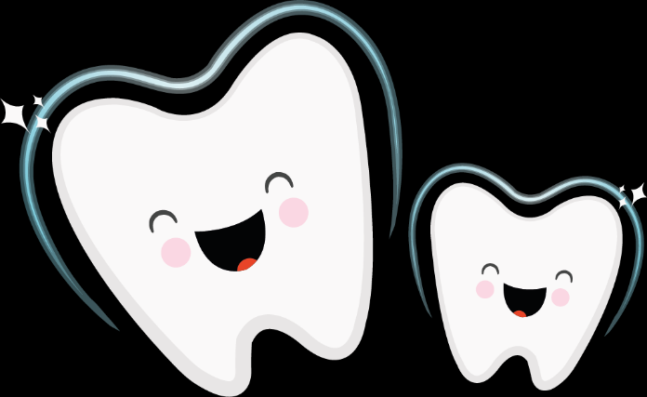

SW1 - e-Bug Healthy Teeth Progress Chart

FRI
I cleaned my teeth in the morning
I cleaned my teeth before bed
I cleaned my teeth for 2 minutes

THU

WED

TUE

MON
Healthy Teeth Brushing Chart
Name
Class
Add a picture or star each time you brush your teeth

