SW1 – Hand Washing Flashcards
Back
of fingers
20 seconds
Soap
Backs
of hands
Scrub
your hands
Thumbs
Tips
of fingers
Between
fingers
Early Years

Spread of Infection: Respiratory Hygiene

Lesson 2: Respiratory Hygiene
Children learn how easily harmful germs (microbes) spread through sneezing.

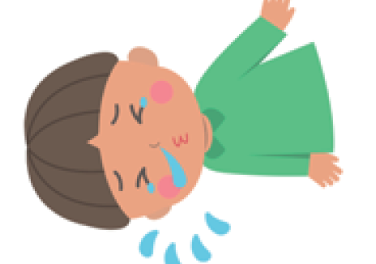

Learning Outcomes

All students will:
- Understand that sneezing into a tissue, or into your sleeve (not your hands), is the best way to stop the spread of colds and flu germs (microbes)
- Understand that there can be harmful germs in your sneezes that can spread over your hands
- Understand the sequencing of hand washing and nose blowing

Curriculum Links

Communication and language development
- Listening and attention
- Understanding
- Speaking

Physical development
- Health and self-care

Expressive arts and design
- Exploring and using media and materials
Lesson 2: Respiratory Hygiene

Resources Required

Activity: Paint Sneezes

Per child
- Paper plate/sheet of paper
- Plastic/vinyl gloves
- Food colouring added to water
- Drinking straw

Extension Activity: Hand Washing and Nose Blowing Flashcards

Per class
- TS1 Hand Washing and Nose Blowing Flashcards

Extension activity: Nose Blowing Writing Activity

Per child
- SW1 Nose Blowing Writing Activity

Supporting Materials
- TS1 Hand Washing and Nose Blowing Flashcards
- SW1 Nose Blowing Writing Activity

Advanced Preparation
- You may wish to use the balloon hands from lesson 1 instead of paper plates for this main activity
- Create a cup of coloured water using a few drops of food colouring
- You may wish to use different colours to indicate different germs

Lesson 2: Respiratory Hygiene

Key Words
Symptom
Sneeze
Vaccinations
Microbe

Health & Safety
Children may require aprons.

Ensure that the food colouring is diluted (to avoid staining). Children may need to wear safety goggles.

For safe microbiological practices in the classroom consult CLEAPPS
http://www.cleapps.org.uk/

Weblinks
wwww.e-Bug.eu/eng/EYS/lesson/Respiratory-Hygiene

Introduction
- Begin by explaining to the children that they are going to learn how harmful microbes can be spread by sneezing and coughing.
- Discuss that colds and flu are caused by harmful microbes (viruses). The viruses can be passed on to other people if we cough or sneeze on them or if we cough and sneeze on to our hands and then touch them.

Activity
- Ask the group to use a pen to draw around their hand onto a paper plate or a sheet of paper.
- Add a few drops of coloured water to each child’s drawn hand.
- Give each child a drinking straw and ask them to blow the germs all over their drawn hand just like they would blow germs out of their nose onto their hands.
- Children may wish to decorate the germs or give them names.
- Discuss with the children what would happen if we cover our mouth with a tissue or our sleeve instead of our hands when sneezing and how this would limit the spread of germs.
Children should notice that the coloured water spreads over their drawn hand more readily when they don’t cover their mouth.

Discussion
Discuss with children what happened. Ask them to look at the hand and notice that the microbes are still on it.

Microbes can still be passed from person to person through touch if we cover our coughs and sneezes with our hands. It is recommended that in the absence of a tissue we sneeze on our sleeve/elbow because we are less likely to transmit harmful microbes to other people by doing this.

Explain that sneezing in your hand can spread the microbes to things that we touch, so it is better to sneeze into the tissue (or our sleeve/elbow) and then throw it away and wash your hands as soon as possible.

Extension Activities
Hand Washing and Nose Blowing Flashcards
TS1 can be used to support learning. Print the sheet and cut out the flashcards or display the sheet on a whiteboard. Ask children to name the image, the correct word is shown on the card.

Nose Blowing Writing Activity
Provide each child with SW1. Ask children to use the picture prompts and words provided to fill in the blanks for the correct steps to take when blowing your nose.

TS1 - Hand Washing and Nose Blowing Flashcards
Bin
Soap

Tissue
Hand sanitiser

Hands
Tap

Sneeze
Water
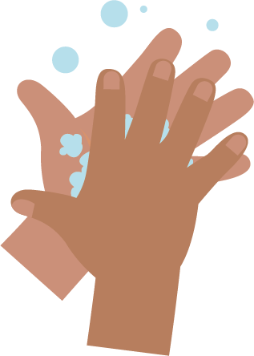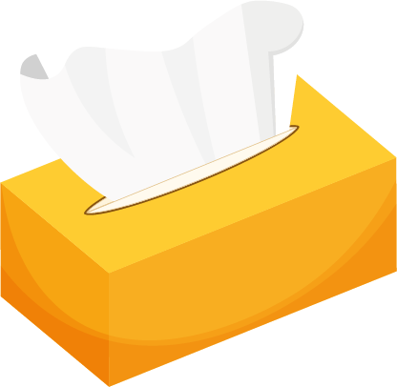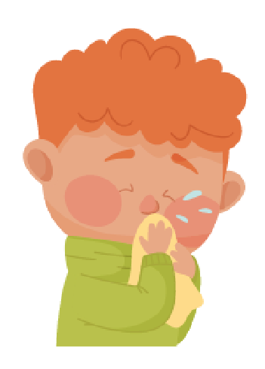
_______________________________

SW1 - Picture Sequencing Activity – place hand washing in the correct order

Blowing Your Nose

Writing Activity
Write instructions for the correct way to blow your nose.
Use the pictures below to help you.
wash hands
bin
tissue
blow
Step 1

_______________________________
Step 2

_______________________________
Step 3

_______________________________
Step 4
SW1 – Hand Washing Flashcards
Back
of fingers
20 seconds
Soap
Backs
of hands
Scrub
your hands
Thumbs
Tips
of fingers
Between
fingers

