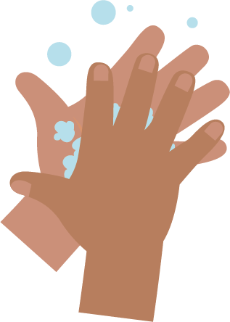  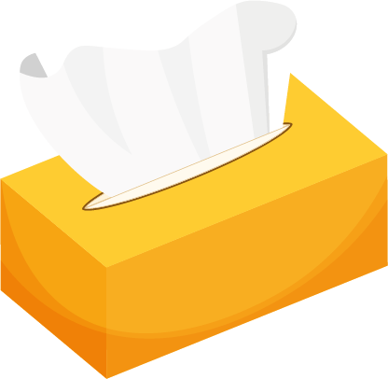 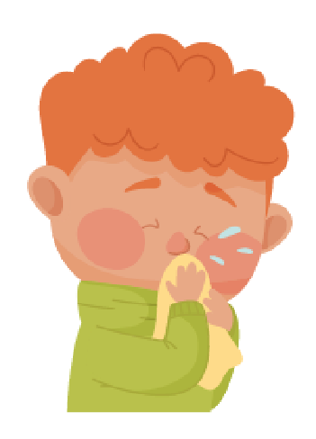



_______________________________

## SW1 - Picture Sequencing Activity – place hand washing in the correct order

### Blowing Your Nose

### Writing Activity

Write instructions for the correct way to blow your nose.

Use the pictures below to help you.

wash hands

bin

tissue

blow

Step 1

_______________________________

Step 2

_______________________________

Step 3

_______________________________

Step 4

**SW1** – Hand Washing Flashcards

**Back**

**of fingers**

**20 seconds**

**Soap**

**Backs**

**of hands**

**Scrub**

**your hands**

**Thumbs**

**Tips**

**of fingers**

**Between**

**fingers**

