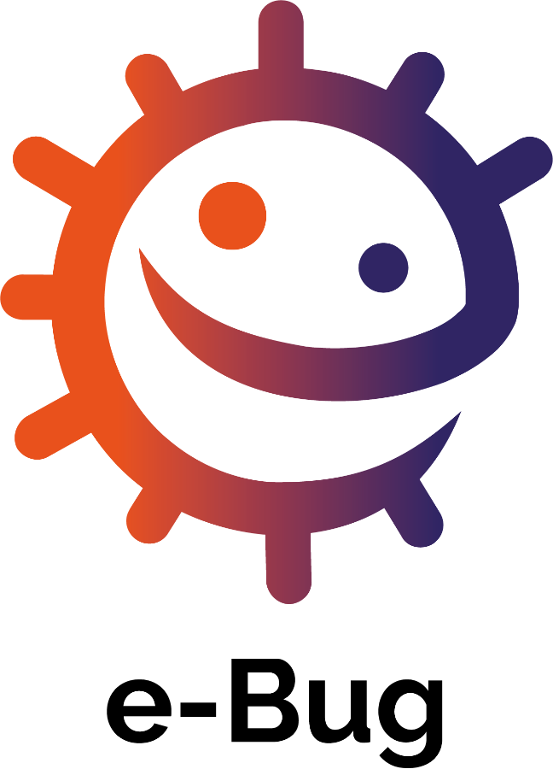

An international educational resource covering the world of microbes and disease.
Lesson plans, worksheets and activities.
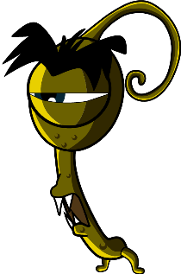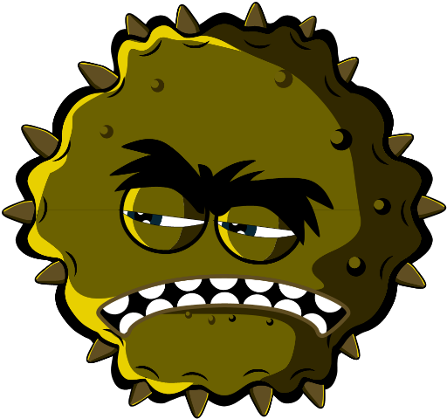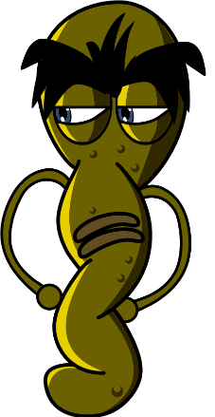

Key Stage 1 (5-7 years)

Welcome to e-Bug

e-Bug has been designed to bring the world of microbes and antibiotics to life for children in the school environment. It is a curriculum supplement series (Early Years, Key Stage 1, 2, 3 and 4) that complies with the Department for Education educational standards for junior and senior schools.
This resource has been created by the UK Health Security Agency (formerly Public Health England) in collaboration with 17 EU partner countries to foster an interest in science and to improve young people’s knowledge and understanding about microbes, infection prevention and control, and prudent antibiotic use, thereby empowering them to be proactive in looking after their own health. Lesson plans can be used in sequence or as individual activities designed to fit into 50-minute classroom slots. These tools can be used freely by educators and may be copied for classroom use but may not be sold.
Over 27 international countries are involved in the e-Bug project, and the resources have been evaluated with more than 3000 children in England, France and the Czech Republic. The e-Bug pack is supported by a website from which all the pack resources, videos, images and additional activities can be downloaded (www.e-bug.eu).

We would like to thank everyone involved in the development of this resource which will help the next generation of adults to use antibiotics more wisely. We would especially like to thank the teachers and students across the UK, and Europe who participated in focus groups and the evaluation process and helped ensure that these materials are not only fun and exciting but also effective. We do hope you enjoy using e-Bug and will find this an invaluable addition to your classroom. If you would like to keep up to date with our latest resources, or the research and development that we undertake please register for our quarterly newsletter at: www.e-bug.eu/uk-newsletter

As educators, your feedback is invaluable to us. Your comments will help the e-Bug resource grow and evolve. Please send any comments, queries and suggestions to: Primary Care and Interventions Unit UK Health Security Agency Twyver House, Bruton Way Gloucestershire GL1 1DQ

Or alternatively visit the e-Bug website and contact us at www.e-bug.eu/uk-contact-us

The e-Bug Team

Each section of the pack contains detailed lesson plans, student worksheets and handouts some of which are available in MS PowerPoint format for whiteboard use:
- Creative inquiry based activities to promote active learning
- Highlighted learning outcomes which deepen students’ understanding of the importance of microbes, their spread, treatment and prevention
- Activities that encourage students to take more responsibility for their own health
- Activities that highlight the importance of responsible antibiotic use

Teacher Refresher Information
Key Stage 1
Optional background information for each of the pack topics has been included to help you plan your lessons and introduce the topic to students.

Introduction to Microbes
Micro-organisms, more commonly known as germs, bugs or microbes, are tiny living things too small to be seen with the naked eye. They are found almost everywhere on Earth. Some microbes are useful, and others can be harmful to humans. It is important to clarify that microbes are not innately useful or harmful. Rather that some microbes can be useful to humans whilst others can be harmful depending on the situation. For example, the mould Aspergillus is used to help make chocolate, however can cause harm to humans if inhaled into the lungs. Although extremely small, microbes come in many different shapes and sizes. The three groups of microbes covered in the resource are viruses, bacteria and fungi.
Viruses often cause illnesses like coughs and colds. Viruses need to live inside a living organism, such as plants and animals, to make more viruses.
Bacteria are single-celled organisms that can grow very quickly and can in some circumstances make substances (toxins) that are harmful to humans. Other bacteria are completely harmless to humans, and some are useful and help us make food like yoghurt and can be good for our health. Bacteria can be divided into three groups based on their shapes – cocci (balls), bacilli (rods) and spirals. Scientists and healthcare workers can use these shapes to identify which infection a patient has.
Fungi are the largest of the three microbes described, they get their food by either decomposing (breaking down) dead plants and animals, or by growing on another living thing. Fungi can be harmful by causing infection or being poisonous to eat; others can be useful or harmless, some fungi like Penicillium help us make medicines.
Spread of Infection
There are many ways our bodies can be exposed to infection and several things that we can do to help prevent this happening. In this teacher refresher section we only cover information for the activities contained in this resource.

Hand Hygiene
Schools are a haven for potentially harmful microbes that can spread rapidly from child-to-child via touch. Our skin naturally secretes oil which helps to keep our skin moist and stops it getting too dry. This oil, however, is a perfect place for microbes to grow and multiply and helps microbes ‘stick’ to our skin. Although our hands are naturally covered in useful bacteria (also known as flora), our hands can easily pick up harmful microbes from our surroundings (e.g. home, school, garden, animals, pets, food), surfaces and even through the air. These harmful microbes can spread quickly and easily from child-to-child via touch and can make us poorly if swallowed. Washing your hands is one of the best ways to stop harmful microbes from spreading and prevent us from becoming sick.
Washing hands in water alone, even cold water, will eliminate visible dirt and grime. However, soap is required to break up the oil on the surface of the hands which trap microbes. Hand sanitisers can be used where soap and water is not available. When possible, liquid soap should be used instead of bars of soap, especially if used by multiple people. Hands should be washed:
- Before, during and after preparing food
- After using the bathroom - After exposure to animals or animal waste
- After coughing, sneezing or blowing your nose
- If you’re ill or have been around ill people
- After outdoor play
Hand sanitisers with ingredients like alcohol work by destroying microbes as they dry, but don’t kill all types of harmful microbes and don’t remove visible dirt or other substances from our skin. Therefore, hand sanitisers should not be generally used after using the toilet.

Respiratory Hygiene
Respiratory infections are infections that happen in the lungs, chest, sinuses, nose and throat, for example, coughs and colds, the flu and pneumonia. These infections can spread from person-to-person through the air, through person-to-person contact (touching hands, hugging, kissing) or by touching contaminated surfaces. The microbes can be spread by getting into the non-infected person’s nose or eyes because they touch their face with contaminated hands. The most common mode of spreading infection is through coughs and sneezes. Sneezing is a way in which our body tries to get rid of any harmful microbes and dust particles we might inhale. The harmful microbes and dust get caught on the nose hair and tickle our nose or might irritate the back of our throat or our lungs. The nose sends a message to the brain which then sends a message back to your nose, mouth, lungs and chest telling them to blow the irritation away. In the case of colds and flu, millions of virus particles rush out and contaminate the surface on which they land; this could be our food or hands.
Colds and flu are the most common illnesses in childhood settings and perhaps among the most contagious. COVID-19 is the name of the disease caused by the virus SARSCoV-2. and can be very contagious. As colds, flu and COVID-19 are caused by viruses, they cannot be cured by antibiotics. When we catch a cold or flu rest and drinking plenty of fluids are generally recommended however, if symptoms persist then a visit to the local doctor or pharmacist is required. Symptoms of colds and flu include headache, sore throat and fever. Colds can also cause runny noses. Many sore throats associated with colds and flu are due to the viruses in the throat making it inflamed and feeling raw. Breathing in through the mouth causes the throat to feel dry and continual coughing can aggravate sore throats and contribute to an aching feeling.
Teaching good respiratory hygiene from a young age, such as covering your coughs and sneezes or regularly washing your hands for 20 seconds, can help prevent the spread of these infections. This is especially important in the approach to the winter cold/flu season each year. It is a natural reflex to put our hands towards our faces when we sneeze, but it is important to replace this action with new habits of respiratory hygiene to reduce the spread of infection:
Cover your sneezes, dispose of tissues and regularly wash your hands.
- Catch it: cover your mouth and nose with a tissue. If you don’t have a tissue, cover with your upper sleeve or elbow (not your hands).
- Bin it: throw away the used tissue at once to avoid spreading infection to surfaces, or other people.
- Kill it: wash your hands well with soap and water, or hand sanitiser if soap and water are not available, immediately after throwing the tissue in the bin.
We can help prevent the spread of these infections (like the flu and COVID-19) by getting vaccinations. Check government links on why a different flu vaccine is needed each year.
Learning about respiratory hygiene provides a chance to talk to students about vaccinations, a vaccination they may be familiar with is the annual flu vaccine.

Oral Hygiene
Normally our first teeth come through our gums (erupt) at around 6 months of age and we will have a full set of 20 baby (primary) teeth by the time we are 2 ½ years old. At around 6 years old our first permanent molars erupt and the front primary teeth begin to get wobbly and fall out (exfoliate) and are replaced by the permanent (adult) teeth. On average by 12 years old we have lost all of the baby teeth and have 32 adult teeth, which if we look after, can last for the rest of our lives.
Bacteria can grow on teeth, clumping together to form a sticky substance called dental plaque. You will see this in your own mouth as a creamy line around your teeth or sometimes feel it as a furry layer with your tongue. If plaque is not brushed away regularly or there is a high frequency of sugar in the diet, the bacteria within the plaque can lead to tooth decay (caries).
When we eat sugary foods and drinks, bacteria in the plaque can use the sugars to make acid. Over time this can dissolve the outer surface of our teeth (the enamel). As more enamel is dissolved, a hole (cavity) appears. As the decay process continues, the bacteria can reach the nerve and cause toothache.
If no dental treatment is given, the tooth decay (caries) can spread and bacteria can penetrate the nerve, leading to inflammation of the bone and surrounding structures of the teeth which can result in an abscess (lump on the gum) that is filled with pus. This can make you very poorly and the tooth will usually need to be removed (extracted).
Dental health is extremely important; over 23% of children in England have tooth decay and it is the main reason for children aged 5 to 9 being admitted to hospital. The good news is that tooth decay can be prevented by limiting the number of times we eat foods and drinks with added sugar, brushing twice a day with fluoride toothpaste and regularly seeing the dentist to check the health of our teeth and gums.
Fluoride in toothpaste can help strengthen our teeth and slow down the decay process. The most important time to brush teeth with fluoride toothpaste is before going to bed at night. To make it easy to remember it is best to add tooth brushing to a twice daily hygiene routine morning and night.

Healthy Eating
In the UK, 34% of primary school children are now overweight and children are now eating three times more sugar than they should. Half of the sugar children eat comes from unhealthy snacks and sugary drinks. Fruit and vegetables are still the healthiest snack choice.

All lesson plans and supporting materials contained in this pack are available to download as modifiable templates from the e-Bug website. Answers are provided at the end of this pack.

Key Stage 1

Introduction to Micro-organisms

Lesson 1: Introduction to Micro-organisms
This lesson is designed to introduce students to viruses, bacteria and fungi. The introductory activity allows students to combine their observational and creative skills to make a microbe of their own choice, exploring various microbial types and shapes.

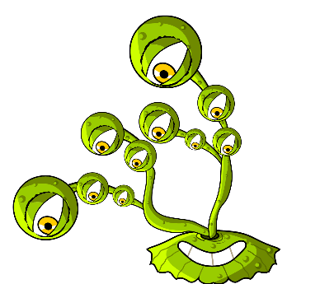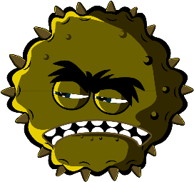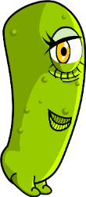

Learning Outcomes

All students will:
- Understand there are three different types of microbes: viruses, bacteria and fungi.
- Understand microbes are all different shapes and sizes.
- Understand some microbes are useful but some can be harmful

Most students will:
- Understand microbes are found everywhere.
- Understand most microbes are too small to be seen with the naked eye.

Curriculum Links

PHSE/RHSE
- Health and prevention

Science
- Working scientifically
- Living things and their habitats

English
- Reading & comprehension
- Writing

Lesson 1: Introduction to
Micro-organisms

Resources Required

Activity: Modelling Microbes

Per group
- Coloured modelling clay (follow
- TS1 for a home-made recipe)
- Permanent black marker
- SH1 Making Microbes Guide
- SH2 Microbes Fun Fact Sheet
- SH3-5 Microbe Example Sheets

Per student
- Petri dishes (optional)

Extension Activity: Yes or No Cards

Per class/group
- SW1 Yes or No Cards
- TS2 Yes or No Answers

Extension Activity: Microbe Flashcards

Per class/student
- SW2 Microbes Flashcards

Extension Activity: Fill in the Blanks Worksheet

Per group
- SW3 Microbe Mania Fill in the Blanks Worksheet
The modelling clay activity can be carried out using arts and craft materials you may already have in your classroom, or by drawing the microbes.

Supporting Materials
- TS1 Home-made Modelling Clay Recipe
- SH1 Making Microbes Guide
- SH2 Microbe Mania Fun Fact Sheet
- SH3 Microbe Example Sheets (SH4-5 available online)
- SW1 “Yes” and “No” cards
- SW2 Microbes Flashcards
- SW3 Microbes Mania Fill in the Blank Worksheet

Advanced Preparation
For the main activity students will be making microbes out of modelling clay. Use the Making Microbes Guide (SH1), Microbe Mania Fun Fact Sheet (SH2) and Microbe Example Sheets (SH3-5) for inspiration. Provide each student group with modelling clay, Petri dishes (if using), images and information about microbe

. Lesson 1: Introduction to
Micro-organisms

Key Words
Fungi
Bacteria
Viruses
Cocci
Bacilli
Spiral
Penicillium
Lactobacilli

Health & Safety
Take care that modelling clay is non-toxic and suitable for students.

Take care that students do not eat the modelling clay.

For safe microbiological practices in the classroom consult CLEAPPS
www.cleapps.org.uk

Weblinks
e-bug.eu/eng/KS1/lesson/ Introduction-to-Microbe

Introduction
- Begin the lesson by asking students if they know what microbes are. Explain that they are tiny living things that are all around us. Most of these are too small to be seen with our eyes.
- Ask the students if they, or anyone in their family, has ever been poorly with a cough, cold or a temperature? What do they think caused it? Explain to the students that some illnesses called infections, are caused by these tiny living things called microbes. Explain that there are three different types of microbes: viruses, bacteria and fungi.
- Emphasise that although some microbes make us ill, there are also useful microbes. Tell the students that bacteria help to make foods like yoghurt, and fungi like yeast help make bread while other fungi are used as medicines.
- Highlight to the class that microbes can be found EVERYWHERE: floating around in the air we breathe, on the food we eat, on the surface of our bodies, in our mouth, nose and gut/tummy, most of these are not harmful and some are good for us.

Activity
This activity aims to introduce students to different types of microbes and microbe shapes by allowing them to make a microbe out of modelling clay. This activity also introduces students to terms associated with microbes that they may come across day-to-day e.g. germs, bugs.
- Remind the students that there are three different types of microbes (viruses, bacteria and fungi) and how these are different.
- Encourage students to make microbes using modelling clay and to place them in a Petri dish (if using). They can use the images from SH1 and SH3-5, and information about microbes on SH2 as inspiration.
- Point out common forms of microbes that they might have heard of to get them started.
- Ask them which microbe they are making and to describe it e.g. is it a virus, fungi or bacteria and is it useful or harmful?
- When they have finished, ask students to write what they have made on the Petri dish with the permanent black marker. Students can take the dish home.

Discussion
Discuss the microbes the students made highlighting the differences between viruses, bacteria and fungi.

If you have used the extension activity, SW1 Yes and No cards, discuss the answers with the students. Explain that not all microbes make us poorly.

Fascinating Fact
Micro-organisms first appeared on earth about 3.5 billion years ago and are essential to sustain life on our planet

Extension Activities

Yes or No cards
As a class activity or in groups of 3 or 4 provide SW1 Yes or No cards or display them on a whiteboard. Ask students to answer yes or no to the questions provided. Answers can be found in TS2 on the e-Bug website.

Microbe Flashcards
SW2 can be used to support learning. Print the sheet and cut out the flashcards or display on a whiteboard. Ask students to name the image, the correct word is shown on the card.

Fill in the Blanks Worksheet
SW3 requires students to fill in the blanks using the correct words provided. Provide one worksheet per student to help test their knowledge of microbes.

Learning Consolidation
At the end of the lesson, ask the class the following questions as a fact checking exercise.
- What are the three different types of microbes?
- Answer: Viruses, bacteria and fungi
- Microbes can be beneficial to us e.g. yeast, can be used to make bread rise. What type of microbe is yeast?
- Answer: Fungus
- True or false? Microbes are invisible to the naked eye and come in different shapes and sizes.
- Answer: True

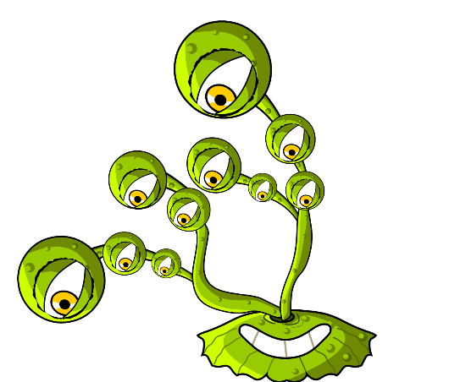
Ingredients
- 1 cup of plain flour
- 1 cup of water
- ½ cup of salt
- 2 teaspoons of cream of tartar
- 1 tablespoon of vegetable oil
- Food colouring

For Parents and Teachers
Modelling clay is a soft, pliable material that can be used to make microbe shapes. Modelling clay can be purchased but it may be cost effective to make your own. Home-made modelling clay has the added advantage that you can choose your preferred palate of colours. The home-made modelling clay is non-toxic and easily sculpted, making it an ideal material for this activity.

Method
- Mix together the dry ingredients
- Add the water and mix until smooth
- Add the food colouring, followed by the vegetable oil
- Cook on a medium heat, stirring constantly, until the dough leaves the side of the pan in a ball. Alternatively, microwave the mixture on a high setting for four minutes, stirring every 30 seconds.
- Allow to cool before use
- Store in a plastic bag or wrapped in cling film to prevent the modelling clay from drying out.

Microbe Mania

Home-made modelling clay recipe

TS1 Home-made Modelling Clay Recipe

SH1 – Making Microbes Guide

Microbe Mania

Make your own microbes
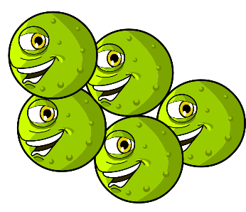
Use modelling clay to create your own microbes.
Decide what type of microbes you have made:
Virus, bacteria, or fungi, and whether it is a useful or harmful microbe.
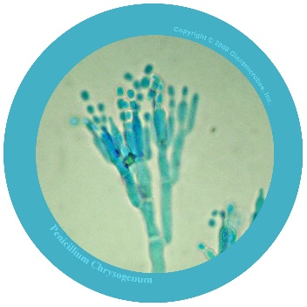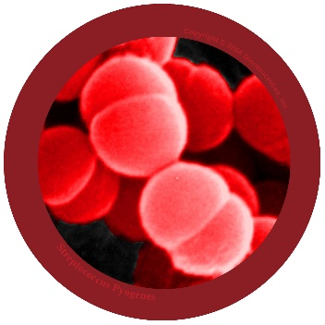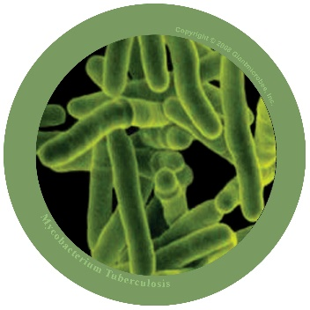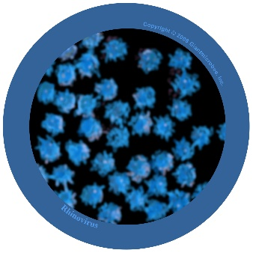
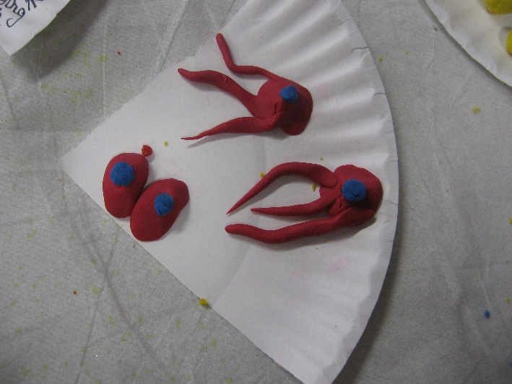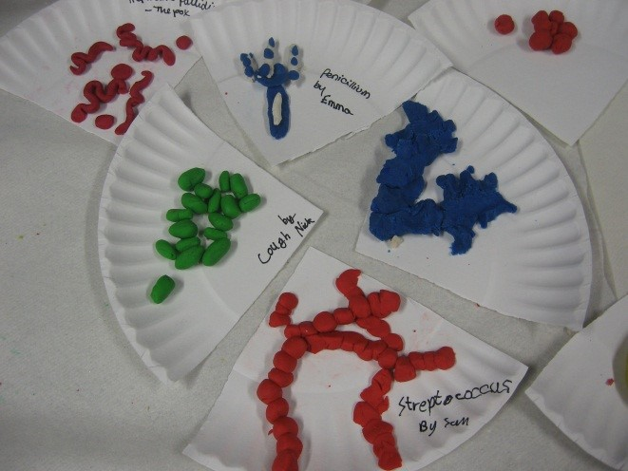
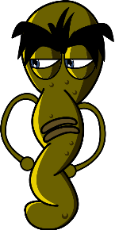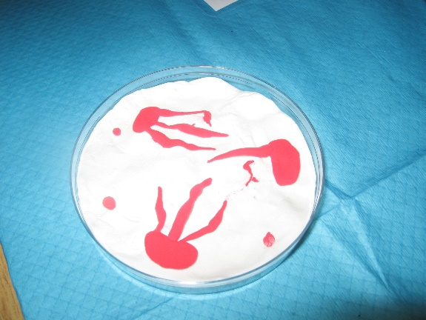
Photos copyright 2008 Giantmicrobes, inc.

SH2 - Microbe Mania Fun Fact Sheet

Microbe Mania
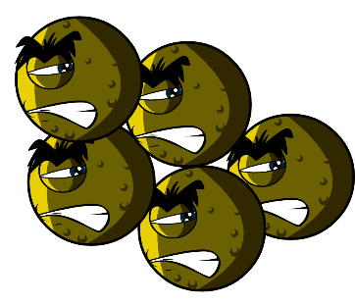

Fact Sheet

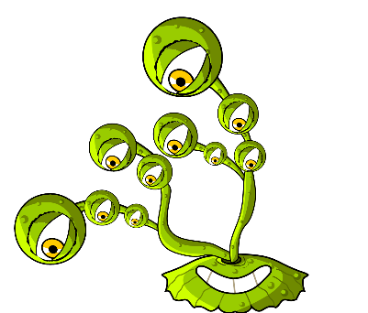
- There are more microbes on the planet than any other type of living thing.
- Microbes are the oldest form of life on Earth. They’ve been here for four billion years!
- Microbes are found everywhere on Earth, even inside volcanoes.
- Some microbes can glow in the dark. People once used glowing pieces of fungi growing on wood to light the way.
- Humans would not be able to live without microbes. Some microbes produce oxygen which we need to breathe, and others help plants to grow which we eat.

What is a microbe?
Microbes are also called germs or bugs. There are three types of microbes: bacteria, viruses and fungi. Some microbes can make us ill, but most are very useful to us.

Where are microbes found and what do they look like?
Microbes are found everywhere. They come in all shapes and sizes.

Make your own microbes
Use modelling clay to create your own microbes.
Decide what type of microbes you have made:
Virus, bacteria, or fungi, and whether it is useful or harmful. For ideas, download pictures of microbes from
www.e-bug.eu. Ask an adult to help you make your own modelling clay – see TS1 for the recipe.
Surprise your friends and family with these fun facts…!

SH3 - Microbe Example Sheet 1
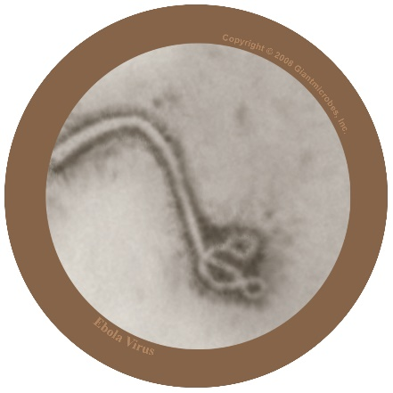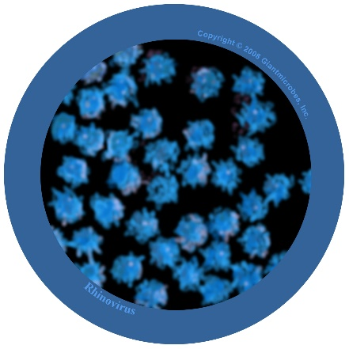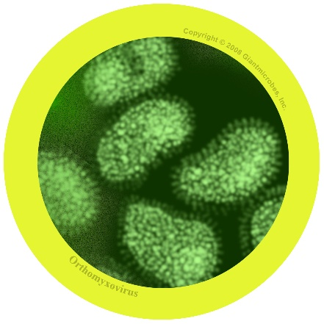

Filovirus
File-o-vi-rus

About
- Filovirus is harmful to humans and causes a disease called Ebola.
- It has been in the news as people living in Africa have caught the virus and many have died.
- The virus lives naturally in wild animals in Africa and is not found in other continents.

Symptoms and treatment
- Ebola virus makes people very unwell and in worst cases, death.
- People with Ebola will need special treatment and hospital care to help get better.

Rhinovirus
Rye-no-vye-rus

About
- Also known as the common cold
- It is a virus that is harmful to humans

Symptoms and treatment
- Causes runny nose, sneezing, sore throat, and coughing
- Spreads from person to person by coughs and sneezes and unwashed hands
- Treatment is rest and plenty of fluids to feel better.

Influenza virus
In-floo-en-za

About
- Also known as the flu virus
- It is a virus that is harmful to humans

Symptoms and treatment
- Causes fever (high temperature), runny nose, sore throat, muscle pains, cough, feeling tired
- Spreads from person to person by coughs and sneezes and unwashed hands
- Treatment is rest and plenty of fluids to feel better. If very unwell, an antiviral medicine may help.

SW1 - Yes and No Cards

Most microbes can be seen with the naked eye
Yes or No
Microbes always make us poorly
Yes or No
Microbe is another name for bugs and germs
Yes or No
Most colds are caused by viruses
Yes or No

SW2 - Microbes Flashcards
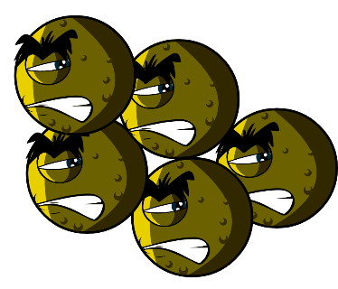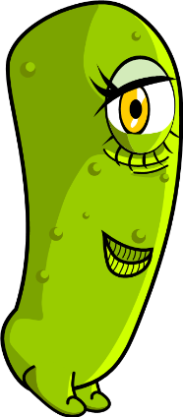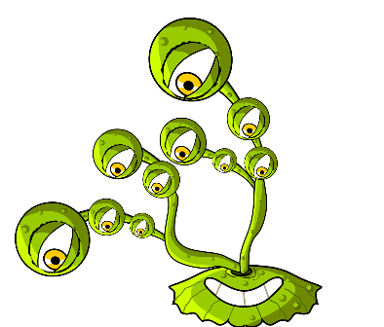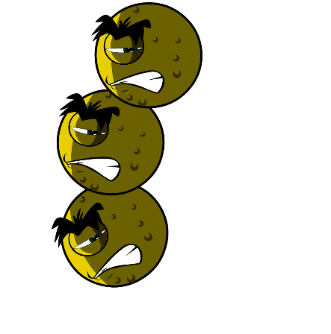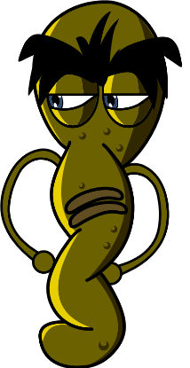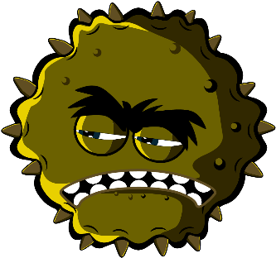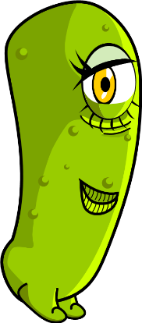
Balls (Cocci)
Lactobacilli
Fungi
Penicillium
Bacteria
Spiral
Virus
Rod

SW3 - Microbe Mania Fill in the Blank Worksheet

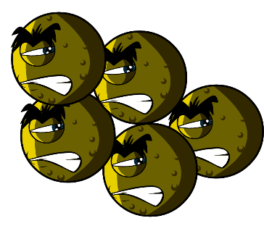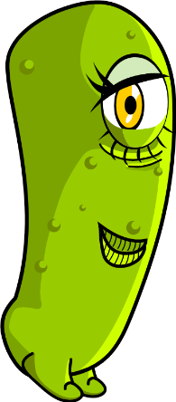

Microbes Worksheet
What have you learnt about microbes?
Complete the sentences below
Germs and bugs are also called _ _ _ _ _ _ _ _
and there are three main types.
The smallest microbe is a _ _ _ _ _ and they can make us poorly with a cough or a cold.
The largest microbe is a _ _ _ _ _ _. We use this to make bread.
Balls, rods and spirals are the three main
shapes of _ _ _ _ _ _ _ _.
Microbes are found _ _ _ _ _ _ _ _ _ _ and even in volcanoes!
Key Stage 1
Spread of Infection: Hand Hygiene

Lesson 2: Hand Hygiene
By taking part in a classroom experiment, students will understand how soap or sanitisers work and that hand washing is the best way to remove microbes.

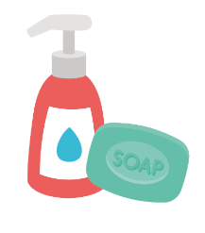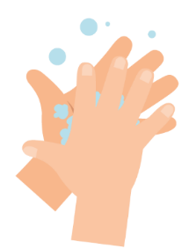

Learning Outcomes

All students will:
- Understand washing hands can help remove microbes.
- Understand washing hands is one of the best ways to prevent the spread of microbes.
- Understand washing hands with soap and water is better than washing hands with water alone.

Curriculum Links

PHSE/RHSE
- Health and prevention

Science
- Working scientifically
- Living things and their habitats

English
- Reading & comprehension
- Writing

Lesson 2: Hand Hygiene

Resources Required

Activity: Pepper and Water Experiment

Per group
- Small plastic bowls
- Water
- Washing up liquid
- Pepper
- Cocktail sticks

Extension Activity: Healthy Hands Fact Sheet

Per student
- SH1 Healthy Hands Fact Sheet

Extension Activity: Hand Washing Flashcards

Per class
- SW1 Hand Washing Flashcards

Extension Activity: Fill in the Blank Worksheet

Per student
- SW2 Healthy Hands Fill in the Blank Worksheet
Supporting Materials
- SH1 Healthy Hands Fact Sheet
- SW1 Hand Washing Flashcards
- SW2 Healthy Hands Fill in the Blank Worksheet

Advanced Preparation
Set up a few bowls of water with pepper sprinkled on the surface, a few plain bowls of water, and another bowl with washing up liquid in

Lesson 2: Hand Hygiene

Key Words
Hygiene
Soap
Hand washing
Microbes
Health & Safety
Ensure that the demonstrating students have no soap allergies or sensitive skin conditions

For safe microbiological practices in the classroom consult CLEAPPS
www.cleapps.org.uk

Weblinks
e-bug.eu/eng/KS1/lesson/ Hand-Hygiene

Introduction
- Begin the lesson by asking the students if they know why we wash our hands. Explain that we wash our hands to not only remove any dirt and grime that we can see, but also to remove germs (microbes) that we cannot see.
- Explain to students that because we use our hands all the time, they pick up millions of germs (microbes) every day. Although many of these are harmless some could be harmful and might make us ill.
- Explain that our skin is naturally covered in oils and that this oil helps microbes ‘stick’ to our skin. This means we need to wash our hands properly with both soap and water to be able to wash away the germs from our hands. If no soap is available, hand sanitiser gels can also remove germs from our hands.
- Explain to the students that they are now going to complete an activity to show them why soap is important when we wash our hands

Activity
This activity shows how washing with soap and water is better than using water alone. Demonstrators should help students with cocktail sticks to ensure safety. The bowls must be rinsed after each group for this activity to be effective.
- Explain to the class that the surface of the water in the bowls represents their hands, and that the pepper represents harmful microbes that need to be washed away.
- Dip the end of a cocktail stick into the plain bowl of water and then into the pepper water. Gently swirl the cocktail stick around and explain that using water to wash your hands only moves the microbes around.
- Dip the cocktail stick into the bowl of washing up liquid and then into the pepper water.
- The pepper (microbes) will move towards the edges of the bowl as the soap hits the surface of the water.
- Explain to the class that the soap breaks up the oil on our hands. The microbes can then be washed away when we rinse the soap off hands with water.
Now visit e-bug.eu/eng/ks1/ lesson/Hand-Hygiene to find a NHS demonstration and UKHSA hand washing song to help make the correct technique more memorable for little hands.

Discussion
Can the students answer the question: Why do we use soap to wash our hands?
Discuss where germs (microbes) on their hands may have come from. Emphasise to students here that not all the germs on their hands are harmful; there may also be useful microbes there too.
Discuss where germs (microbes) on their hands may have come from. Emphasise to students here that not all the germs on their hands are harmful; there may also be useful microbes there too.
Emphasise to students that we also need to wash hands properly. Highlight that microbes like to hide in between fingers and under the nails. It is important to know both WHEN and HOW to wash hands properly to prevent harmful microbes and potentially infection.

Extension Activities

Healthy Hands Fact Sheet
Provide each student with a copy of SH1 to consolidate the session. Students can learn and share Healthy Hands facts with family and friends.

Hand Washing Flashcards
SW1 can be used to support learning. Print the sheet and cut out the flashcards, or display on a whiteboard. Ask children to explain the image, the correct words are shown on the card.

Fill in the Blank Worksheet
Provide each student with SW2. Ask students to name the image to complete the sentence. Students can re-write the completed sentence or read it out loud.

Learning Consolidation
At the end of the lesson, ask the class to complete the following sentences with their own answers.
- A song to use when washing my hands is: ___________________________
- I will wash my hands at key moments during the day, for example: ______________
- There are how many steps to wash every part of my hands?
- If I am not able to wash my hands with soap and water, I will use ___________

SH1 - Healthy Hands Fact Sheet

Healthy Hands

Fact Sheet
What makes our hands dirty?

We get microbes on our hands from everything that we touch like door handles, school desks, the floor, or our pets. We also get microbes on our hands when we hold hands, pick our nose or sneeze into our hands.

Why should we wash our hands?

We wash our hands to get rid of harmful microbes that might make us poorly. It is important that we wash our hands after using the toilet, before eating or cooking, after stroking animals or after coughing or sneezing.
Surprise your friends and family with these fun facts.
• Most microbes on our hands are under our fingernails.

• Nearly everyone says they wash their hands after using the toilet, but more than half don’t. Just think what may be on their hands.

• Most toilet handles have 400 times more microbes than the toilet seat.

• There are more microbes on one person’s hand than people on the planet.

• Hand washing is the best way to stop microbes spreading.

• Some microbes can stay alive on our hands for up to three hours

SW1 - Hand Washing Flashcards
Back
of fingers
Back
of fingers
20 seconds
Between fingers
Soap
Backs
of hands
Backs
of hands
Tips of fingers
Scrub
your hands
Scrub
your hands
Thumbs

SW2 - Healthy Hands Fill in the Blank Worksheet
Turn the
to run the
Put
on your
together
Rub your
Rinse your
with
Turn off the
Your hands
Throw the paper towel in the
Key Stage 1

Spread of Infection: Respiratory Hygiene

Lesson 3: Respiratory Hygiene
In this fun experiment students learn how easily microbes can be spread through coughs and sneezes and recreate a sneeze.

Learning Outcomes

All students will:
- Understand there can be harmful microbes in our coughs and sneezes.
- Understand that infection can be spread through coughs and sneezes.
- Understand that good respiratory hygiene can reduce the spread of infection.

Most students will:
- Understand that we can spread infection through touching surfaces after touching/wiping our nose or holding a cough/ sneeze.
- Understand how to develop best practice respiratory hygiene behaviours in everyday life to reduce the spread of infection.

Curriculum Links

PHSE/RHSE
- Health and prevention

Science
- Working scientifically
- Living things and their habitats

English
- Reading & comprehension
- Spoken language

Mathematics
- Comparing measurements

Lesson 3: Respiratory Hygiene

Resources Required

Activity: Snot Runway

Per group
- Long roll of paper such as wallpaper
- Measuring tape or 2m ruler
- Pump action spray bottle/s
- Green food colouring
- Disposable plastic/vinyl gloves
- Kitchen roll
- Pens and sticky notes (optional)
- A funny mask to cover the spray bottle (optional)
- Cardboard

Extension Activity: Fact Sheet

Per student
- SH1 Super Sneezes Fact Sheet

Extension Activity: Super Slimy Snot Activity

Per student
- SH2 Super Slimy Snot Activity

Extension Activity: Super Sneezes Wordsearch

Per student
- SW1 Super Sneezes Wordsearch Extension

Activity: Fill in the Blank Worksheet

Per student
- SW2 Super Sneezes Fill in the Blank Worksheet

Supporting Materials
- SH1 Super Sneezes Fact Sheet
- SH2 Super Slimy Snot Activity
- SW1 Super Sneezes Wordsearch
- SW2 Super Sneezes Fill in the Blank Worksheet

Advanced Preparation
1. Create a paper runway on the floor or by placing 3 – 4 desks in a row and
covering them with white paper (lining wallpaper is a cheap alternative).
2. Fill one spray bottle per group with water and food colouring

Lesson 3: Respiratory Hygiene

Key Words
Bacteria
Hygiene
Micro-organism
Sneeze
Cough
Hand wash
Hand sanitiser

Health & Safety
Students may require aprons.
Ensure that the food colouring is dilute (to avoid staining).
Ensure that all spray bottles have been thoroughly cleaned and rinsed prior to use.
Students may need to wear safety goggles.

For safe microbiological practices in the classroom consult CLEAPPS
www.cleapps.org.uk

Weblinks
e-bug.eu/eng/KS1/lesson/ Respiratory-Hygiene

Introduction
- Begin the lesson by explaining to students that they are going to learn how harmful microbes (germs) can make us poorly and are passed from person to person through coughing and sneezing.
- Explain to students that many harmful microbes can travel in tiny droplets of mucus/snot and water coughed and sneezed into the air by people. If you are carrying out the Super Slimy Snot Activity (SH2) it is useful to refer to that here. You can use examples like the common cold or flu.
- Continue to discuss a cold, or flu, explaining that they are caused by very small microbes called viruses.
- Explain that it is very important for everyone’s health that people cover their mouth and nose with a tissue when they cough and sneeze, or with their sleeve/into the crook of their elbow if they have no tissue. They should then wash their hands or use hand gel.

Activity
- Ask the group to write their name or draw a picture of themselves on a sticky note (or write directly on the runway). Ask the group to imagine that the runway is a bus and the students can place themselves where they think they will avoid the germs from the cough/sneeze.
- Hold the bottle at the end of the sneeze runway and simulate a sneeze/cough by squeezing the trigger. You can then work out who was closest to the actual distance by measuring the distance between the spay droplets and the student’s name or picture of themselves. You may wish to repeat to allow all students to have a go.
- Ask a student to measure how far and how wide the cough/sneeze spreads with a meter ruler or tape measure and determine which student guessed the closest.
- Ask the group what you would usually do when sneezing or coughing – put a hand over your nose.
- Ask one student to put on a glove and place their hand over the nozzle to demonstrate putting a hand over your nose as you cough/sneeze. Pull the trigger again after predicting what will happen. Ask students if this is an effective way to stop the microbes in the snot spreading to others? The microbes stay on our hands and can spread to anything we touch. Explain that students should wash their hands immediately if they cough or sneeze into their hands.
- Ask someone to put a piece of kitchen towel over the nozzle to demonstrate holding a tissue over your nose as you cough/sneeze. Pull the trigger after predicting what will happen. The cough/sneeze is successfully caught in the tissue and won’t infect anyone else if the tissue is thrown in the bin straight away. Ask the catcher to throw the tissue away.
- Ask the group to recite what they have learned, for example by repeating the phrase ‘catch it, bin it, kill it’. Reinforce that catching a cough/sneeze in a tissue is the best way to prevent the spread of microbes to others.
Students will notice that the spray travels furthest when it isn’t covered

Discussion
Explain that sneezing in your hand can spread the microbes to things that we touch, so it is better to sneeze into the tissue and then throw it away and wash your hands or use hand sanitiser as soon as possible.

Discuss with the class what happened. You may want to show the glove or hand that covered the cough/sneeze and notice that the spray germs (microbes) are still on it. Show the students that when they place the hand on the paper, sprayed side down, the microbes transfer to the paper.

As was observed from the activity, microbes can still be passed from person to person through touch if we cover our coughs and sneezes with our hands. Recent guidance recommends we sneeze or cough into our elbow or sleeve because we are less likely to transmit harmful microbes to other people by doing this.

Extension Activities

Fact Sheet
SH1 contains fun facts about sneezes. You can read and discuss this sheet with students at the end of the snot runway activity, or provide it as a home reading activity for students.

Super Slimy Snot Activity
Provide each student with the SH2 guide for students to make their own gooey snot. The activity demonstrates how snot sticks to germs and prevents them from entering our bodies.

Super Sneezes Wordsearch
Provide each student with a copy of SW1 and ask them to find hidden key respiratory hygiene words, this can be completed in class or as a homework activity.

Fill in the Blank Worksheet
Provide each student with SW2. Ask students to name the image to complete the sentence. Students can re-write the completed sentence or read it out loud.

Learning Consolidation
At the end of the lesson, ask the class to create some simple rules or messages to reduce the spread of coughs, colds and flu in their school, for example:
- Coughs and sneezes spread diseases.
- Catch it, bin it, kill it.

SH1 – Super Sneezes Fact Sheet

Super Sneezes

Fact Sheet

Why do we sneeze?
Sneezing is a way in which our body tries to get rid of harmful microbes. Germs and dust get stuck in our nose hair and so we sneeze to blow them away.

What is in a sneeze?
Sneezes contain snot and harmful microbes. That is why it’s important to cover our sneezes with a tissue or our sleeve (but never our hand), so we don’t pass the harmful microbes onto someone else.

Surprise your friends and family with these fun facts:
• Sneezes can travel at a speed of 100 miles per hour.
• Sneezes can spread microbes 2-3 meters.
• The longest sneezing spree was 978 days, a record set by Donna Griffiths of Worcestershire, England.
• It is impossible to sneeze without closing your eyes.
• It is illegal to burp or sneeze in a church in Nebraska.

SH2 – Super Slimy Snot Activity

Super Slimy Snot

Activity

Make your own snot!
Sticky, slimy snot in our noses traps microbes. This helps to stop harmful microbes getting into our bodies and making us poorly. Ask an adult to help you make your own snot using the recipe below.
To make your own snot, you will need:

Ingredients
- PVA Glue
- Laundry starch and warm water
- Green food colouring
- Water
- 2 disposable cups, labelled A and B
- A plastic spoon or stirrer
- A tablespoon
- Rubber gloves

Method
1. Put the gloves on. Fill cup A with water and ask an adult to add a spoonful of laundry starch to the cup. Stir to mix the powder and water.
2. In cup B, add 2.5cm of PVA glue to the bottom of the cup, and mix with about three tablespoons of water. Stir to mix.
3. Add a few drops of green colouring to cup B and stir to mix.
4. Finally, add a tablespoon of the starch solution (from cup A) to cup B, and watch the green slimy snot form! After about 30 seconds you can play with it!
You can play with the snot, but do not eat it!
Wash your hands when you have finished playing with the snot. It will last a few days if you keep it wrapped up in cling film.

SW1 – Super Sneezes Wordsearch

Super Sneezes Wordsearch
Can you find all the sneezy words in the wordsearch below? Remember that words can be horizontal (across), vertical (down) or diagonal (top left to bottom right).
G | E | R | M | S | N | Y | Y | K | O
M | C | O | L | D | J | Z | W | T | S
B | N | O | H | C | D | E | I | W | P
A | P | I | G | S | U | B | U | G | S
C | B | Z | J | C | N | C | O | K | S
T | F | L | U | P | M | O | J | A | N
E | B | V | K | A | S | D | T | T | E
R | F | C | O | U | G | H | S | B | E
I | I | W | F | R | S | V | H | B | Z
A | V | I | R | U | S | B | C | D | E

Snot, Bugs, Virus, Cough, Cold,
Sneeze, Flu, Bacteria, Germs,

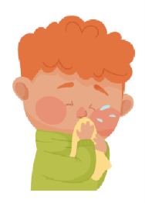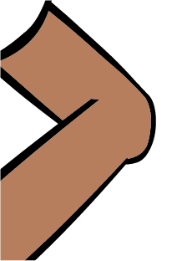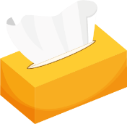

SW2 - Super Sneezes Fill in the Blank Worksheet
Into a
or
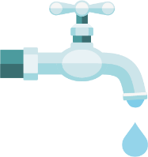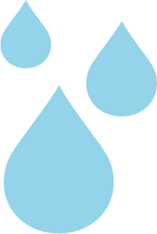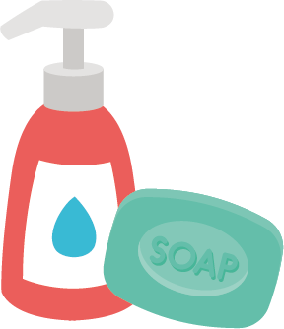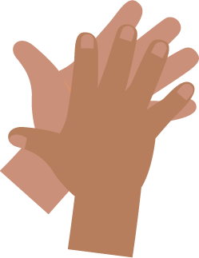
Throw the paper towel in the
Turn the
to run the
Put
on your
Rub your
together
Rinse your
with
Turn off the
Key Stage 1

Prevention of Infection: Oral Hygiene

Lesson 4: Oral Hygiene
Students learn how plaque forms and why and how sugary food and drink can damage your teeth.

Learning Outcomes

All students will:
- Understand what dental plaque is and how it forms
- Understand the consequences of tooth decay
- Understand that limiting sugary foods and drinks can reduce tooth decay
- Understand the importance of eating healthier snacks

Curriculum Links

PHSE/RHSE
- Health and prevention

Science
- Working scientifically
- Living things and their habitats

English
- Reading & comprehension
- Writing

Lesson 4: Oral Hygiene

Resources Required

Activity: Eggshell Experiment

Per group
- Egg shells – cracked and then cleaned out
- Clear cups
- High sugar cola
- Semi-skimmed milk or water
- High sugar juice drink
- Labels for cups

Extension Activity: Tooth Brushing Chart

Per student
- SW1 e-Bug Healthy Teeth Progress Chart

Extension Activity: Healthy Food Swaps

Per class
- TS1 Oral Hygiene True/False Quiz

Per student
- SH1 Healthy Food Choice Fact Sheet
- SH2 Oral Hygiene True or False cards
- SW2 Healthy Food Choice

Supporting Materials
- TS1 Oral Hygiene True/False Quiz
- SH1 Healthy Food Choice Fact Sheet
- SH2 Oral Hygiene True or False Cards
- SW1 e-Bug Healthy Teeth Progress Chart
- SW2 Healthy Food Choice

Advanced Preparation
- Set out 3 cups per 3-4 students and label these as 1 to 3.
- Divide up the eggshells so that each cup has one eggshell half

Lesson 4: Oral Hygiene

Key Words
Bacteria
Plaque
Cavity
Sugar
Acid
Tooth brushing
Decay
Health & Safety
Ensure students do not drink the cola, especially those who may have diabetes. Students with egg or milk allergies or intolerances must not directly handle these components.

See the e-Bug website for alternative activities.

For safe microbiological practices in the classroom consult CLEAPPS
www.cleapps.org.uk

Weblinks
e-bug.eu/eng/KS1/lesson/ Oral-Hygiene

Introduction
- Ask the students to think about their teeth; ask them what are they like (they are hard and white and shiny). Ask the students why they think their teeth are like that (so that they are strong and can chew and bite food).
- Pass around the eggshells, have the students (carefully) examine them. Ask them if they think they are like any parts of their body? The students should be able to identify that they are like their teeth. Tell the students that teeth are made of layers. The eggshell is similar to the hard layer on our teeth called the enamel.
- Explain to the students that throughout the day, germs called bacteria grow on teeth to form a sticky substance called plaque and when we eat sugary foods and drinks the bacteria uses the sugar to attack our teeth (especially the hard outer enamel layer).

Activity
- Explain to the students you will be using the eggshells to show what sugar can do to our teeth.
- Divide the class into groups of 3-4 and give them 3 cups labelled 1-3. Assist them placing one eggshell half into each cup and pouring the three drinks you’ve chosen into the cup.
  - Cola
  - Water (or milk)
  - Juice
- To see the effects, you will need to wait one day. Now, ask the students: What will happen to the egg if you leave it in the drink for a long time? Which liquid will change the egg most? Which liquid will change the egg least? You can record their guesses for tomorrow.
After one day, students will notice a discoloured and partly dissolved eggshell from the cola, an unchanged eggshell from the water (or milk), and a slightly dissolved eggshell from the juice. This demonstrates that high sugar content foods and drinks can damage the enamel.

Discussion
The next day, have the student check on their eggs. What changes can they see? Why do they think that has happened?
Tell the students that the sugar in the drinks has damaged the eggshells and made the shell discolour – remind the students that the eggshell is like the enamel on their teeth, and a lot of sugar can cause damage to their teeth.
Ask the students what they think they should do to keep their teeth healthy? Answers should include:
- Have sugary food and drinks less often and in small amounts
- Brush your teeth twice a day (before school and before bed)
- Using a fluoride toothpaste
- Spit don’t rinse
- Visit your dentist regularly

Extension Activities

Tooth Brushing Chart
SW1 is a useful way to encourage routine tooth brushing. Provide one sheet per student. Ask students to mark or draw a picture every time they brush their teeth to keep track of how often they have brushed their teeth during one school week. This can be completed in the classroom or at home.

Healthy food swaps
Begin by reminding students how the sugar in the cola effected the eggshell. Eating too much sugar is bad for you and can cause tooth decay. Around half the sugar we consume comes from unhealthy snacks and sugary drinks. That is why it is important to choose healthier snacks.
- Fruit and vegetables are a good snack choice; you can eat them on their own or with a healthy dip.
- Dried fruits have a high sugar content and they should be kept to mealtimes only.
Ask the class what their favourite fruit and vegetable snacks are. Tell students that they can swap their unhealthier foods (e.g. sugary breakfast cereals) and drinks (e.g. sugary fizzy drinks, fruit juice and smoothies, full sugar squash) for lower sugar alternatives such as low sugar yoghurt with fruit, lower fat milks, plain waters, or no-added sugar/sugar free squash.
We don’t need to worry about the sugar in whole fruits and vegetable and plain milk and plain yoghurts because this isn’t added sugar.
What other swaps can they think of? Provide students with SH1 Healthy Food Choice Factsheet to help them complete SW2 and ask students to draw their favourite food swaps on SW2.
Food items with the most green labels are considered the healthiest choices and the ideal swap.

Oral Hygiene True of False Quiz
Hand out SH2 to groups of 3 or 4 students. Ask students to cut out the cards and hold them up to answer True or False quiz contained in TS1. Answers are provided on the sheet.

Learning Consolidation
At the end of the lesson, ask the class the series of questions below as a fact checker.
- What is the sticky substance made up of bacteria that clump together on our teeth called?
Answer: Plaque
- Complete the sentence; When we consume sugary foods and drinks, this leads to an attack on our teeth that can lead to?
Answer: Tooth decay
- How many times a day should you brush your teeth with toothpaste.
Answer: At least twice
- After brushing, should you; a) spit out the toothpaste and rinse; b) spit out the toothpaste and don’t rinse?
Answer: you should spit out the toothpaste but don’t rinse (this will allow the fluoride to stay on the teeth for longer).

TS1 - Oral Hygiene True or False Quiz

Healthy Eating

What do you remember?

Are these True or False?
Dried fruits should be
eaten at mealtimes not
as a snack
True
Chocolate biscuits are
a healthier snack than
plain yoghurt and fruit
False
Biscuits contain a lot of added sugar
Lower-fat milk is a
healthier drink choice
than a sports drink
True
Sports drink can contain lots of sugar. Water or lower-fat milk are better choice
Eating too much sugar
can cause tooth decay
True

SH1 - Healthy Food Choice Fact Sheet

Healthy Food Choice Fact Sheet

Breakfast
Wheat biscuit cereal
Porridge
Jam on toast
High sugar cereal
sugar
fat
salt
sugar
fat
salt
sugar
fat
salt
sugar
fat
salt

Drink
No-added sugar/ sugar free squash and water
Chocolate milk
Orange juice
Full sugar cola
sugar
fat
salt
sugar
fat
salt
sugar
fat
salt
sugar
fat
salt

Snack
Malt loaf
Low sugar yoghurt
Regular yoghurt
Chocolate bar
sugar
fat
salt
sugar
fat
salt
sugar
fat
salt
sugar
fat
salt

SH2 Oral Hygiene True or False Cards
False
False
False
True
True
True

SW1 - e-Bug Healthy Teeth Progress Chart
FRI
I cleaned my teeth in the morning
I cleaned my teeth before bed
I cleaned my teeth for 2 minutes
THU
WED
TUE
MON

Healthy Teeth Brushing Chart
Name

Class

Add a picture or star each time you brush your teeth

SW2 - Healthy Food Choice Exercise

What breakfast, drink and snack would you drink to keep your teeth healthy?
Write your choice
Draw your choice

Breakfast

Drink

Snack

e-Bug Key Stage One Teacher Answer Booklet

Lesson One: Micro-organisms: Introduction

SW1 Yes and No Cards
- Microbe is another name for bugs and germs
Answer: Yes
- Most microbes can be seen with the naked eye
Answer: No
- Most colds are caused by viruses
Answer: Yes
- Microbes always make us poorly
Answer: No
- Bacteria are used to make yoghurt
Answer: Yes
- If you become poorly because of a microbe, this is called an infection
Answer: Yes
- Most microbes do not affect us in any way
Answer: Yes
- You only find microbes on things that are dirty, like the toilet
Answer: No

SW3 Microbe Mania Fill in the Blank
- Microbes
- Virus
- Fungi
- Bacteria
- Everywhere

Lesson Three: Spread of Infection: Respiratory Hygiene

SW1 Super Sneezes Wordsearch

Super Sneezes Wordsearch
Can you find all the sneezy words in the wordsearch below? Remember that words can be horizontal (across), vertical (down) or diagonal (top left to bottom right).

G | E | R | M | S | N | Y | Y | K | O
M | C | O | L | D | J | Z | W | T | S
B | N | O | H | C | D | E | I | W | P
A | P | I | G | S | U | B | U | G | S
C | B | Z | J | C | N | C | O | K | S
T | F | L | U | P | M | O | J | A | N
E | B | V | K | A | S | D | T | T | E
R | F | C | O | U | G | H | S | B | E
I | I | W | F | R | S | V | H | B | Z
A | V | I | R | U | S | B | C | D | E

Snot, Bugs, Virus, Cough, Cold,
Sneeze, Flu, Bacteria, Germs

SW2 Super Sneezes Fill in the Blanks
- Sneeze into a tissue or the crook of the elbow
- Throw the paper towel in the bin
- Turn the tap to run the water
- Put the soap on your hands
- Rub your hands together
- Rinse your hands with water
- Turn off the taps

Lesson Four: Prevention of Infection: Oral Hygiene

SH2 Oral Hygiene True / False Quiz
- Dried fruits should be eaten at mealtimes and not as a snack – True; dried fruits contain lots of natural sugars
- Chocolate biscuits are a healthier snack option than plain yoghurt and fruit – False; biscuits contain a lot of added sugar
- Lower-fat milk is a healthier drink choice than a sports drink – True; sports drinks can contain lots of sugar. Water or lower-fat milk are better choices
- Eating too much sugar can cause tooth decay – True; bacteria on our teeth feed on the sugar which creates acid and dissolves our teeth

