## SW1 - Hand Washing Flashcards

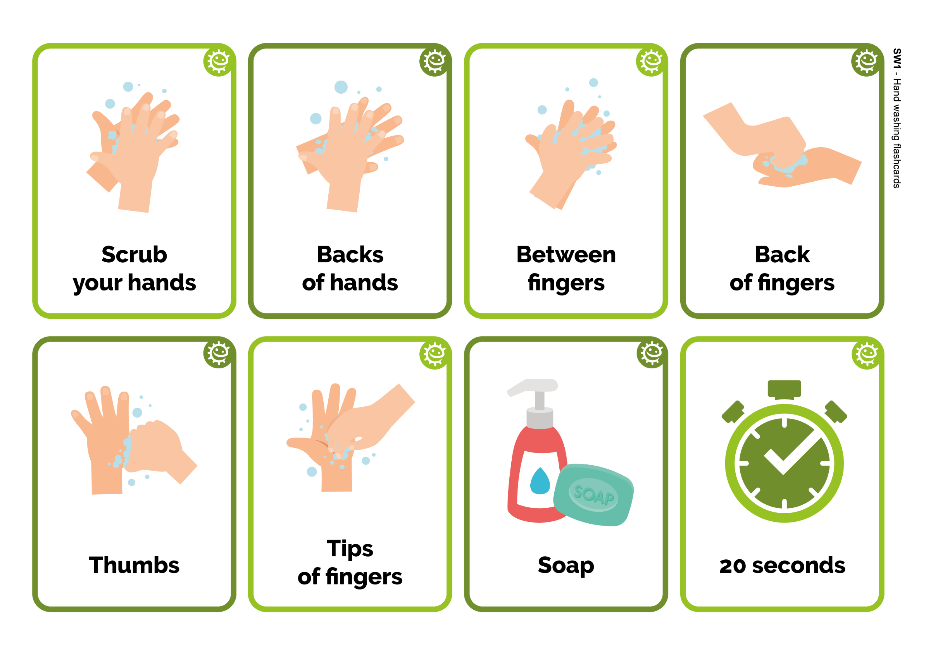

**Back**

**of fingers**

Back

of fingers



20 seconds



Between fingers



Soap

**Backs**

**of hands**



Backs

of hands



Tips of fingers

**Scrub**

**your hands**



Scrub

your hands



Thumbs