## SW2 - Healthy Hands Fill in the Blank Worksheet



Turn the

to run the

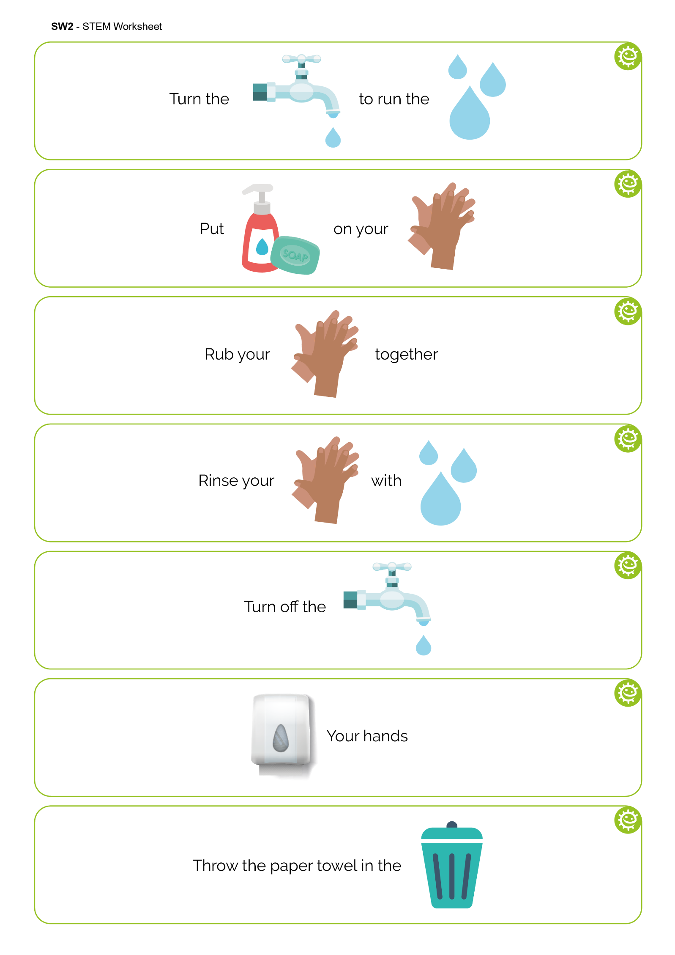

Put

on your



together

Rub your



Rinse your

with



Turn off the



Your hands



Throw the paper towel in the