Key Stage 1

Introduction to Micro-organisms Teacher Guidance

Background Information
Micro-organisms, more commonly known as germs, bugs or microbes, are tiny living things too small to be seen with the naked eye. They are found almost everywhere on Earth. Some microbes are useful, and others can be harmful to humans. It is important to clarify that microbes are not innately useful or harmful. Rather that some microbes can be useful to humans whilst others can be harmful depending on the situation. For example, the mould Aspergillus is used to help make chocolate, however can cause harm to humans if inhaled into the lungs. Although extremely small, microbes come in many different shapes and sizes. The three groups of microbes covered in the resource are viruses, bacteria and fungi.
Viruses often cause illnesses like coughs and colds. Viruses need to live inside a living organism, such as plants and animals, to make more viruses.
Bacteria are single-celled organisms that can grow very quickly and can in some circumstances make substances (toxins) that are harmful to humans. Other bacteria are completely harmless to humans, and some are useful and help us make food like yoghurt and can be good for our health. Bacteria can be divided into three groups based on their shapes – cocci (balls), bacilli (rods) and spirals. Scientists and healthcare workers can use these shapes to identify which infection a patient has.
Fungi are the largest of the three microbes described, they get their food by either decomposing (breaking down) dead plants and animals, or by growing on another living thing. Fungi can be harmful by causing infection or being poisonous to eat; others can be useful or harmless, some fungi like Penicillium help us make medicines.
Spread of Infection
There are many ways our bodies can be exposed to infection and several things that we can do to help prevent this happening. In this teacher refresher section we only cover information for the activities contained in this resource.
Key Stage 1

Introduction to Micro-organisms

Lesson 1: Introduction to Micro-organisms
This lesson is designed to introduce students to viruses, bacteria and fungi. The introductory activity allows students to combine their observational and creative skills to make a microbe of their own choice, exploring various microbial types and shapes.

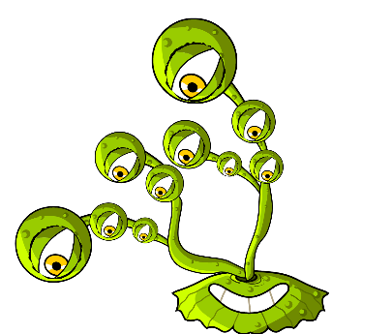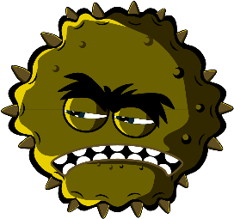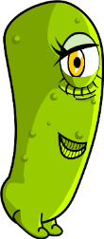

Learning Outcomes

All students will:
- Understand there are three different types of microbes: viruses, bacteria and fungi.
- Understand microbes are all different shapes and sizes.
- Understand some microbes are useful but some can be harmful

Most students will:
- Understand microbes are found everywhere.
- Understand most microbes are too small to be seen with the naked eye.

Curriculum Links

PHSE/RHSE
- Health and prevention

Science
- Working scientifically
- Living things and their habitats

English
- Reading & comprehension
- Writing

Lesson 1: Introduction to
Micro-organisms

Resources Required

Activity: Modelling Microbes

Per group
- Coloured modelling clay (follow
- TS1 for a home-made recipe)
- Permanent black marker
- SH1 Making Microbes Guide
- SH2 Microbes Fun Fact Sheet
- SH3-5 Microbe Example Sheets

Per student
- Petri dishes (optional)

Extension Activity: Yes or No Cards

Per class/group
- SW1 Yes or No Cards
- TS2 Yes or No Answers

Extension Activity: Microbe Flashcards

Per class/student
- SW2 Microbes Flashcards

Extension Activity: Fill in the Blanks Worksheet

Per group
- SW3 Microbe Mania Fill in the Blanks Worksheet
The modelling clay activity can be carried out using arts and craft materials you may already have in your classroom, or by drawing the microbes.

Supporting Materials
- TS1 Home-made Modelling Clay Recipe
- SH1 Making Microbes Guide
- SH2 Microbe Mania Fun Fact Sheet
- SH3 Microbe Example Sheets (SH4-5 available online)
- SW1 “Yes” and “No” cards
- SW2 Microbes Flashcards
- SW3 Microbes Mania Fill in the Blank Worksheet

Advanced Preparation
For the main activity students will be making microbes out of modelling clay. Use the Making Microbes Guide (SH1), Microbe Mania Fun Fact Sheet (SH2) and Microbe Example Sheets (SH3-5) for inspiration. Provide each student group with modelling clay, Petri dishes (if using), images and information about microbe

. Lesson 1: Introduction to
Micro-organisms

Key Words
Fungi
Bacteria
Viruses
Cocci
Bacilli
Spiral
Penicillium
Lactobacilli

Health & Safety
Take care that modelling clay is non-toxic and suitable for students.

Take care that students do not eat the modelling clay.

For safe microbiological practices in the classroom consult CLEAPPS
www.cleapps.org.uk

Weblinks
e-bug.eu/eng/KS1/lesson/ Introduction-to-Microbe

Introduction
- Begin the lesson by asking students if they know what microbes are. Explain that they are tiny living things that are all around us. Most of these are too small to be seen with our eyes.
- Ask the students if they, or anyone in their family, has ever been poorly with a cough, cold or a temperature? What do they think caused it? Explain to the students that some illnesses called infections, are caused by these tiny living things called microbes. Explain that there are three different types of microbes: viruses, bacteria and fungi.
- Emphasise that although some microbes make us ill, there are also useful microbes. Tell the students that bacteria help to make foods like yoghurt, and fungi like yeast help make bread while other fungi are used as medicines.
- Highlight to the class that microbes can be found EVERYWHERE: floating around in the air we breathe, on the food we eat, on the surface of our bodies, in our mouth, nose and gut/tummy, most of these are not harmful and some are good for us.

Activity
This activity aims to introduce students to different types of microbes and microbe shapes by allowing them to make a microbe out of modelling clay. This activity also introduces students to terms associated with microbes that they may come across day-to-day e.g. germs, bugs.
- Remind the students that there are three different types of microbes (viruses, bacteria and fungi) and how these are different.
- Encourage students to make microbes using modelling clay and to place them in a Petri dish (if using). They can use the images from SH1 and SH3-5, and information about microbes on SH2 as inspiration.
- Point out common forms of microbes that they might have heard of to get them started.
- Ask them which microbe they are making and to describe it e.g. is it a virus, fungi or bacteria and is it useful or harmful?
- When they have finished, ask students to write what they have made on the Petri dish with the permanent black marker. Students can take the dish home.

Discussion
Discuss the microbes the students made highlighting the differences between viruses, bacteria and fungi.

If you have used the extension activity, SW1 Yes and No cards, discuss the answers with the students. Explain that not all microbes make us poorly.

Fascinating Fact
Micro-organisms first appeared on earth about 3.5 billion years ago and are essential to sustain life on our planet

Extension Activities

Yes or No cards
As a class activity or in groups of 3 or 4 provide SW1 Yes or No cards or display them on a whiteboard. Ask students to answer yes or no to the questions provided. Answers can be found in TS2 on the e-Bug website.

Microbe Flashcards
SW2 can be used to support learning. Print the sheet and cut out the flashcards or display on a whiteboard. Ask students to name the image, the correct word is shown on the card.

Fill in the Blanks Worksheet
SW3 requires students to fill in the blanks using the correct words provided. Provide one worksheet per student to help test their knowledge of microbes.

Learning Consolidation
At the end of the lesson, ask the class the following questions as a fact checking exercise.
- What are the three different types of microbes?
- Answer: Viruses, bacteria and fungi
- Microbes can be beneficial to us e.g. yeast, can be used to make bread rise. What type of microbe is yeast?
- Answer: Fungus
- True or false? Microbes are invisible to the naked eye and come in different shapes and sizes.
- Answer: True

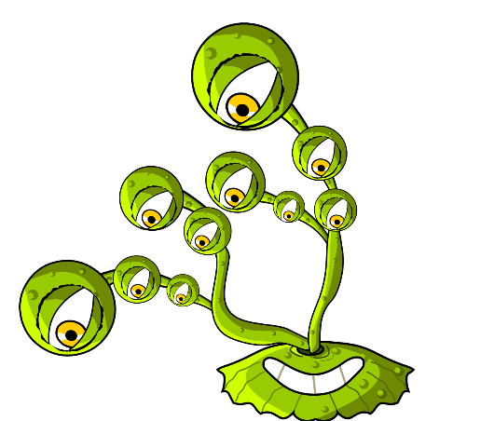
Ingredients
- 1 cup of plain flour
- 1 cup of water
- ½ cup of salt
- 2 teaspoons of cream of tartar
- 1 tablespoon of vegetable oil
- Food colouring

For Parents and Teachers
Modelling clay is a soft, pliable material that can be used to make microbe shapes. Modelling clay can be purchased but it may be cost effective to make your own. Home-made modelling clay has the added advantage that you can choose your preferred palate of colours. The home-made modelling clay is non-toxic and easily sculpted, making it an ideal material for this activity.

Method
- Mix together the dry ingredients
- Add the water and mix until smooth
- Add the food colouring, followed by the vegetable oil
- Cook on a medium heat, stirring constantly, until the dough leaves the side of the pan in a ball. Alternatively, microwave the mixture on a high setting for four minutes, stirring every 30 seconds.
- Allow to cool before use
- Store in a plastic bag or wrapped in cling film to prevent the modelling clay from drying out.

Microbe Mania

Home-made modelling clay recipe

TS1 Home-made Modelling Clay Recipe

SH1 – Making Microbes Guide

Microbe Mania

Make your own microbes
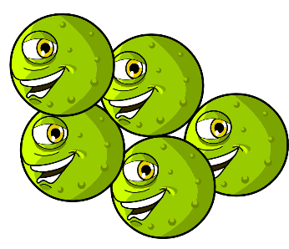
Use modelling clay to create your own microbes.
Decide what type of microbes you have made:
Virus, bacteria, or fungi, and whether it is a useful or harmful microbe.
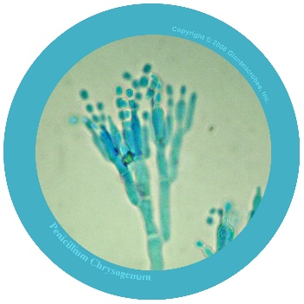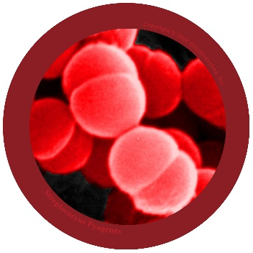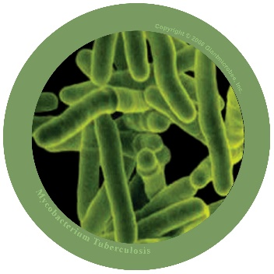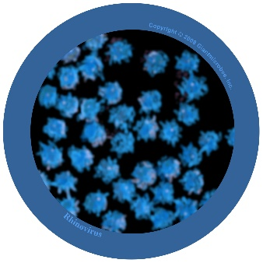
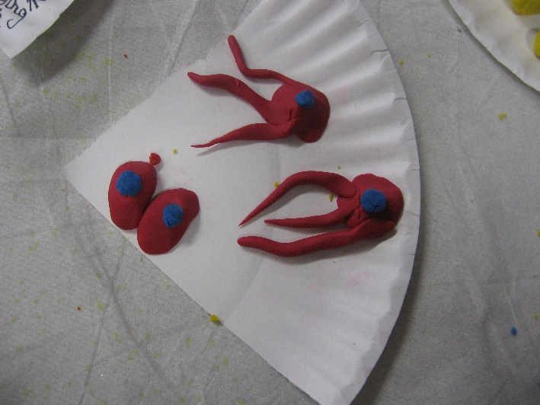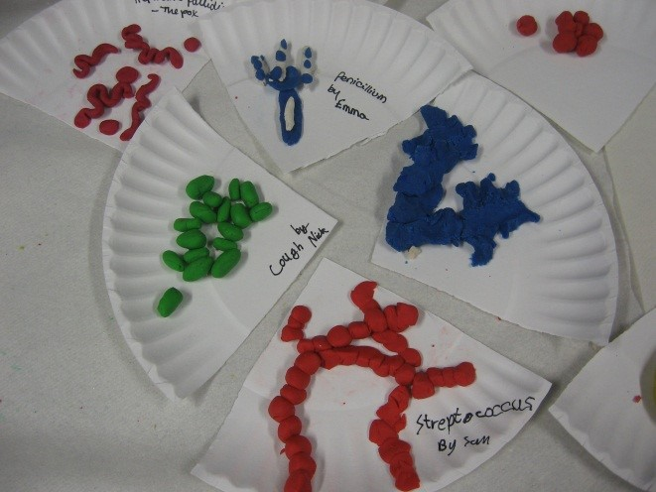
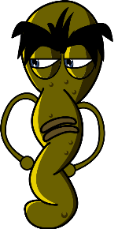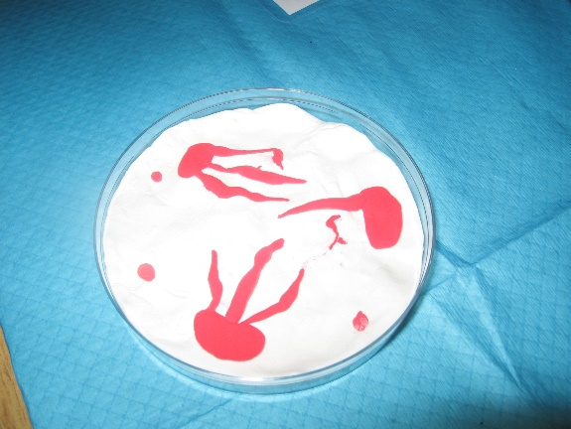
Photos copyright 2008 Giantmicrobes, inc.

SH2 - Microbe Mania Fun Fact Sheet

Microbe Mania
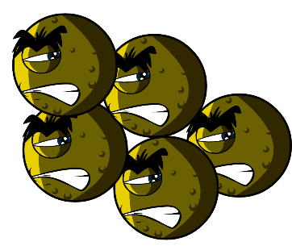

Fact Sheet

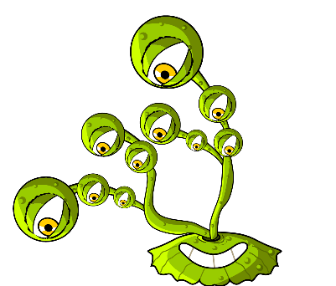
- There are more microbes on the planet than any other type of living thing.
- Microbes are the oldest form of life on Earth. They’ve been here for four billion years!
- Microbes are found everywhere on Earth, even inside volcanoes.
- Some microbes can glow in the dark. People once used glowing pieces of fungi growing on wood to light the way.
- Humans would not be able to live without microbes. Some microbes produce oxygen which we need to breathe, and others help plants to grow which we eat.

What is a microbe?
Microbes are also called germs or bugs. There are three types of microbes: bacteria, viruses and fungi. Some microbes can make us ill, but most are very useful to us.

Where are microbes found and what do they look like?
Microbes are found everywhere. They come in all shapes and sizes.

Make your own microbes
Use modelling clay to create your own microbes.
Decide what type of microbes you have made:
Virus, bacteria, or fungi, and whether it is useful or harmful. For ideas, download pictures of microbes from
www.e-bug.eu. Ask an adult to help you make your own modelling clay – see TS1 for the recipe.
Surprise your friends and family with these fun facts…!

SH3 - Microbe Example Sheet 1
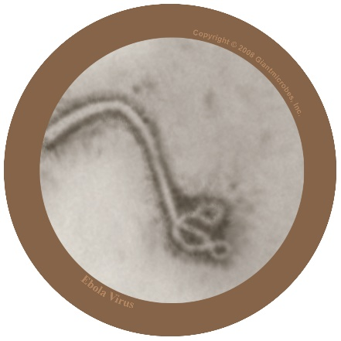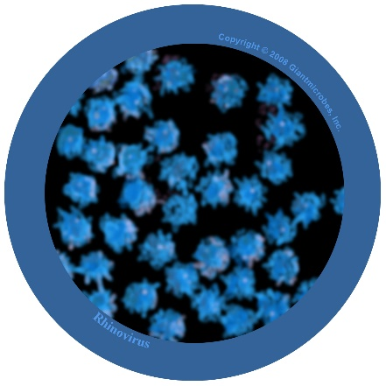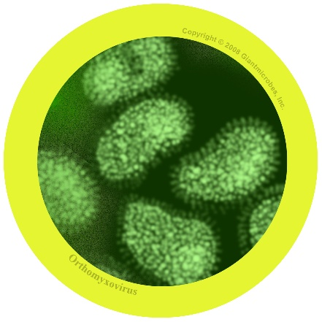

Filovirus
File-o-vi-rus

About
- Filovirus is harmful to humans and causes a disease called Ebola.
- It has been in the news as people living in Africa have caught the virus and many have died.
- The virus lives naturally in wild animals in Africa and is not found in other continents.

Symptoms and treatment
- Ebola virus makes people very unwell and in worst cases, death.
- People with Ebola will need special treatment and hospital care to help get better.

Rhinovirus
Rye-no-vye-rus

About
- Also known as the common cold
- It is a virus that is harmful to humans

Symptoms and treatment
- Causes runny nose, sneezing, sore throat, and coughing
- Spreads from person to person by coughs and sneezes and unwashed hands
- Treatment is rest and plenty of fluids to feel better.

Influenza virus
In-floo-en-za

About
- Also known as the flu virus
- It is a virus that is harmful to humans

Symptoms and treatment
- Causes fever (high temperature), runny nose, sore throat, muscle pains, cough, feeling tired
- Spreads from person to person by coughs and sneezes and unwashed hands
- Treatment is rest and plenty of fluids to feel better. If very unwell, an antiviral medicine may help.

SW1 - Yes and No Cards

Most microbes can be seen with the naked eye
Yes or No
Microbes always make us poorly
Yes or No
Microbe is another name for bugs and germs
Yes or No
Most colds are caused by viruses
Yes or No

SW2 - Microbes Flashcards
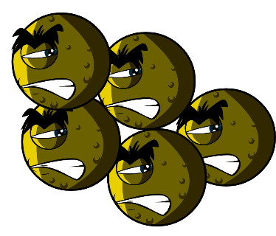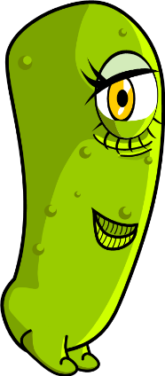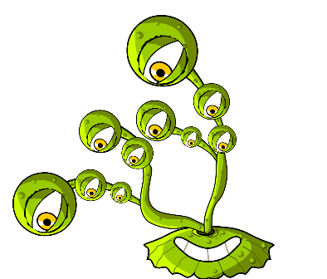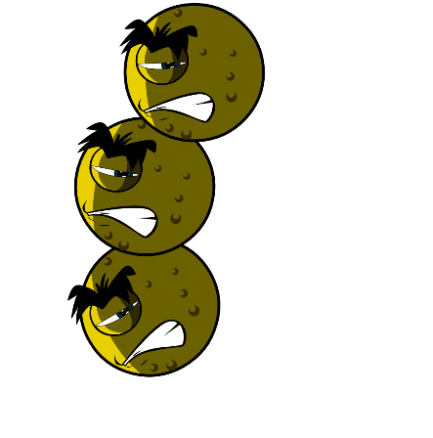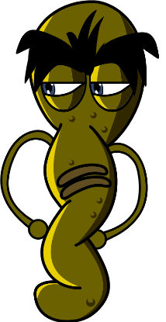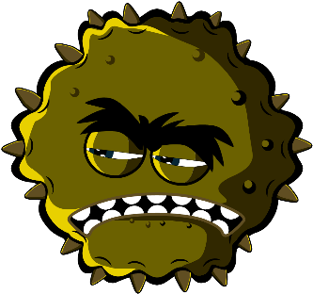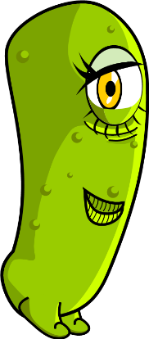
Balls (Cocci)
Lactobacilli
Fungi
Penicillium
Bacteria
Spiral
Virus
Rod

SW3 - Microbe Mania Fill in the Blank Worksheet

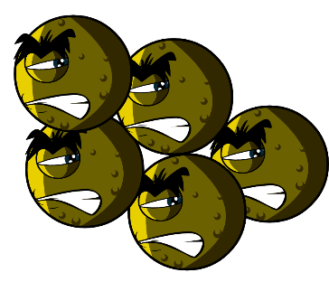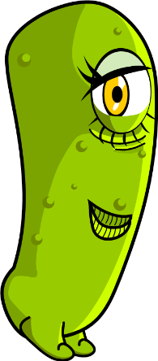

Microbes Worksheet
What have you learnt about microbes?
Complete the sentences below
Germs and bugs are also called _ _ _ _ _ _ _ _
and there are three main types.
The smallest microbe is a _ _ _ _ _ and they can make us poorly with a cough or a cold.
The largest microbe is a _ _ _ _ _ _. We use this to make bread.
Balls, rods and spirals are the three main
shapes of _ _ _ _ _ _ _ _.
Microbes are found _ _ _ _ _ _ _ _ _ _ and even in volcanoes!

