Key Stage 1

Introduction to Micro-organisms Teacher Guidance

Background Information
Micro-organisms, more commonly known as germs, bugs or microbes, are tiny living things too small to be seen with the naked eye. They are found almost everywhere on Earth. Some microbes are useful, and others can be harmful to humans. It is important to clarify that microbes are not innately useful or harmful. Rather that some microbes can be useful to humans whilst others can be harmful depending on the situation. For example, the mould Aspergillus is used to help make chocolate, however can cause harm to humans if inhaled into the lungs. Although extremely small, microbes come in many different shapes and sizes. The three groups of microbes covered in the resource are viruses, bacteria and fungi.
Viruses often cause illnesses like coughs and colds. Viruses need to live inside a living organism, such as plants and animals, to make more viruses.
Bacteria are single-celled organisms that can grow very quickly and can in some circumstances make substances (toxins) that are harmful to humans. Other bacteria are completely harmless to humans, and some are useful and help us make food like yoghurt and can be good for our health. Bacteria can be divided into three groups based on their shapes – cocci (balls), bacilli (rods) and spirals. Scientists and healthcare workers can use these shapes to identify which infection a patient has.
Fungi are the largest of the three microbes described, they get their food by either decomposing (breaking down) dead plants and animals, or by growing on another living thing. Fungi can be harmful by causing infection or being poisonous to eat; others can be useful or harmless, some fungi like Penicillium help us make medicines.
Spread of Infection
There are many ways our bodies can be exposed to infection and several things that we can do to help prevent this happening. In this teacher refresher section we only cover information for the activities contained in this resource.

TS1 Home-made Modelling Clay Recipe
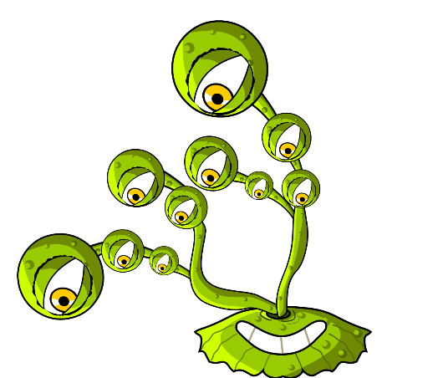

Microbe Mania

Home-made modelling clay recipe

For Parents and Teachers
Modelling clay is a soft, pliable material that can be used to make microbe shapes. Modelling clay can be purchased but it may be cost effective to make your own. Home-made modelling clay has the added advantage that you can choose your preferred palate of colours. The home-made modelling clay is non-toxic and easily sculpted, making it an ideal material for this activity.
Ingredients
- 1 cup of plain flour
- 1 cup of water
- ½ cup of salt
- 2 teaspoons of cream of tartar
- 1 tablespoon of vegetable oil
- Food colouring

Method
- Mix together the dry ingredients
- Add the water and mix until smooth
- Add the food colouring, followed by the vegetable oil
- Cook on a medium heat, stirring constantly, until the dough leaves the side of the pan in a ball. Alternatively, microwave the mixture on a high setting for four minutes, stirring every 30 seconds.
- Allow to cool before use
- Store in a plastic bag or wrapped in cling film to prevent the modelling clay from drying out.

