## SH2 - Microbe Mania Fun Fact Sheet



## Microbe Mania

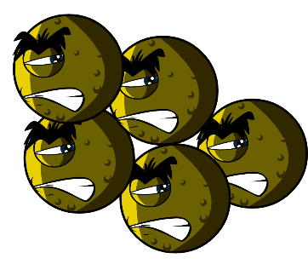

### Fact Sheet

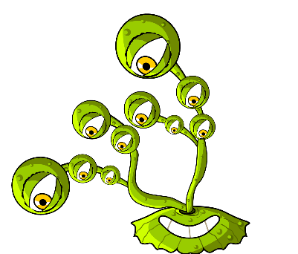

* There are more microbes on the planet than any other type of living thing.
* Microbes are the oldest form of life on Earth. They’ve been here for four billion years!
* Microbes are found everywhere on Earth, even inside volcanoes.
* Some microbes can glow in the dark. People once used glowing pieces of fungi growing on wood to light the way.
* Humans would not be able to live without microbes. Some microbes produce oxygen which we need to breathe, and others help plants to grow which we eat.

#### What is a microbe?

Microbes are also called germs or bugs. There are three types of microbes: bacteria, viruses and fungi. Some microbes can make us ill, but most are very useful to us.

#### Where are microbes found and what do they look like?

Microbes are found everywhere. They come in all shapes and sizes.

#### Make your own microbes

Use modelling clay to create your own microbes.

Decide what type of microbes you have made:

Virus, bacteria, or fungi, and whether it is useful or harmful. For ideas, download pictures of microbes from

[www.e-bug.eu](http://www.e-bug.eu/). Ask an adult to help you make your own modelling clay – see TS1 for the recipe.   
  
Surprise your friends and family with these fun facts…!