

## SH3 - Microbe Example Sheet 1

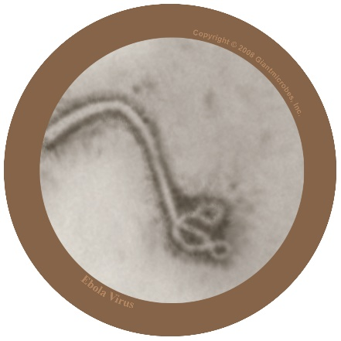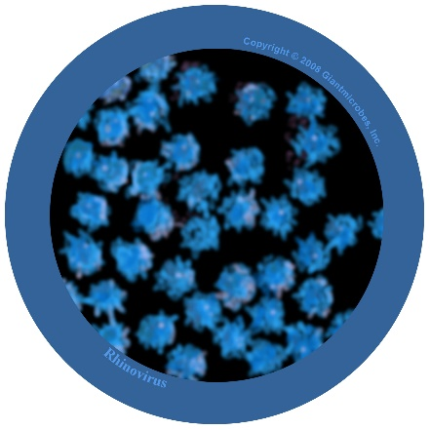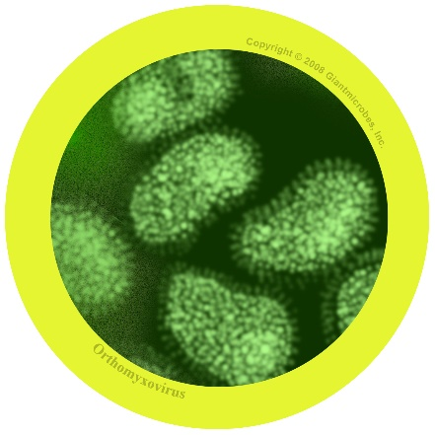

### *Filovirus*

File-o-vi-rus

#### About

* *Filovirus* is **harmful** to humans and causes a disease called Ebola.
* It has been in the news as people living in Africa have caught the virus and many have died.
* The virus lives naturally in wild animals in Africa and is not found in other continents.

#### Symptoms and treatment

* Ebola virus makes people very unwell and in worst cases, death.
* People with Ebola will need special treatment and hospital care to help get better.

### *Rhinovirus*

Rye-no-vye-rus

#### About

* Also known as the common cold
* It is a virus that is **harmful** to humans

#### Symptoms and treatment

* Causes runny nose, sneezing, sore throat, and coughing
* Spreads from person to person by coughs and sneezes and unwashed hands
* Treatment is rest and plenty of fluids to feel better.

### *Influenza virus*

In-floo-en-za

#### About

* Also known as the flu virus
* It is a virus that is **harmful** to humans

#### Symptoms and treatment

* Causes fever (high temperature), runny nose, sore throat, muscle pains, cough, feeling tired
* Spreads from person to person by coughs and sneezes and unwashed hands
* Treatment is rest and plenty of fluids to feel better. If very unwell, an antiviral medicine may help.