

## SH1 - Healthy Food Choice Fact Sheet

### Healthy Food Choice Fact Sheet

#### Breakfast

Wheat biscuit cereal

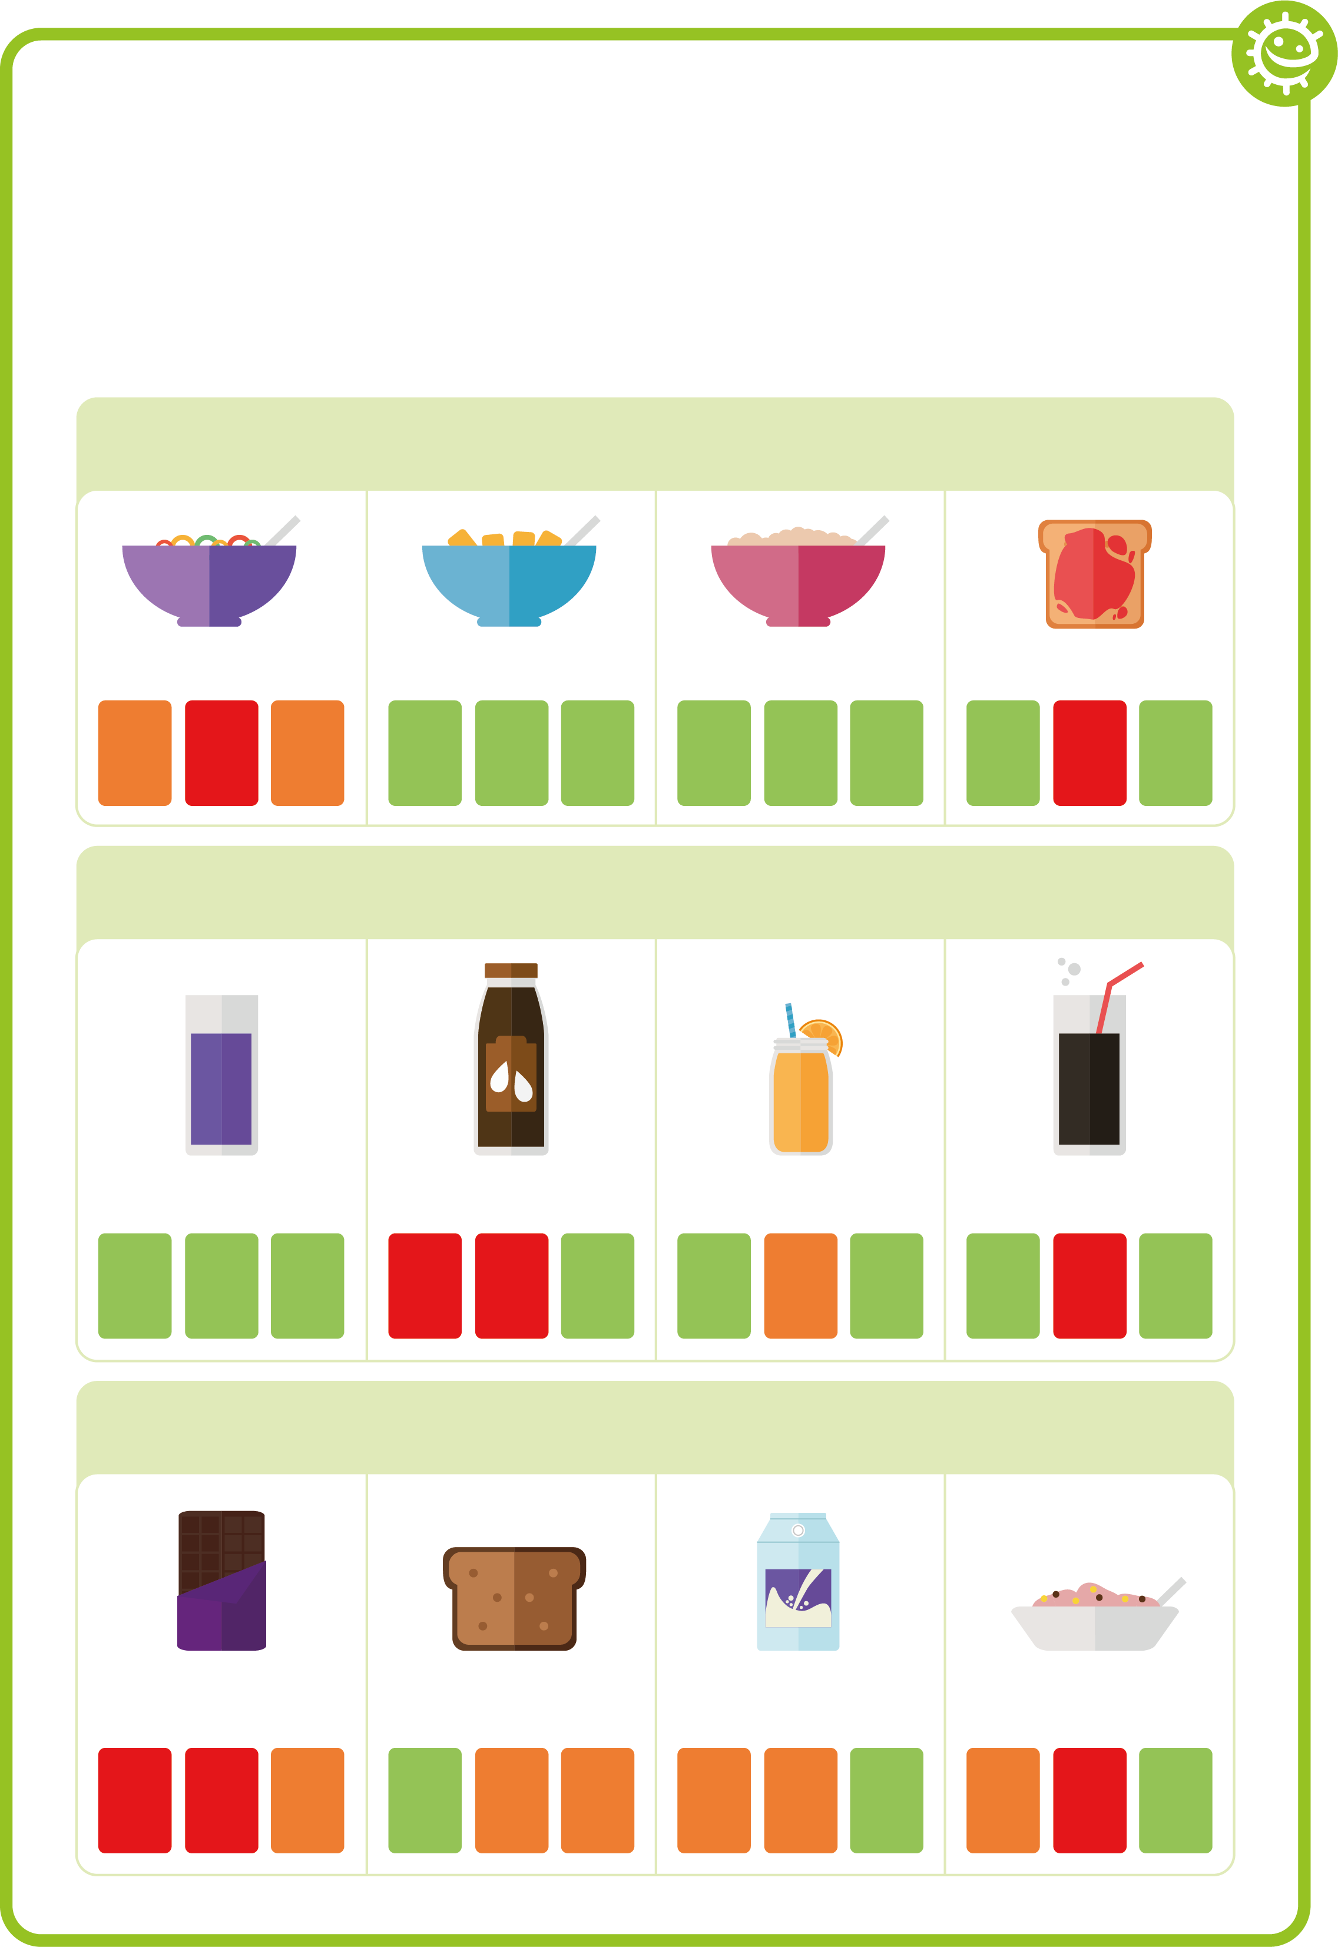

Porridge



Jam on toast



High sugar cereal

sugar

fat

salt

sugar

fat

salt

sugar

fat

salt

sugar

fat

salt

#### Drink

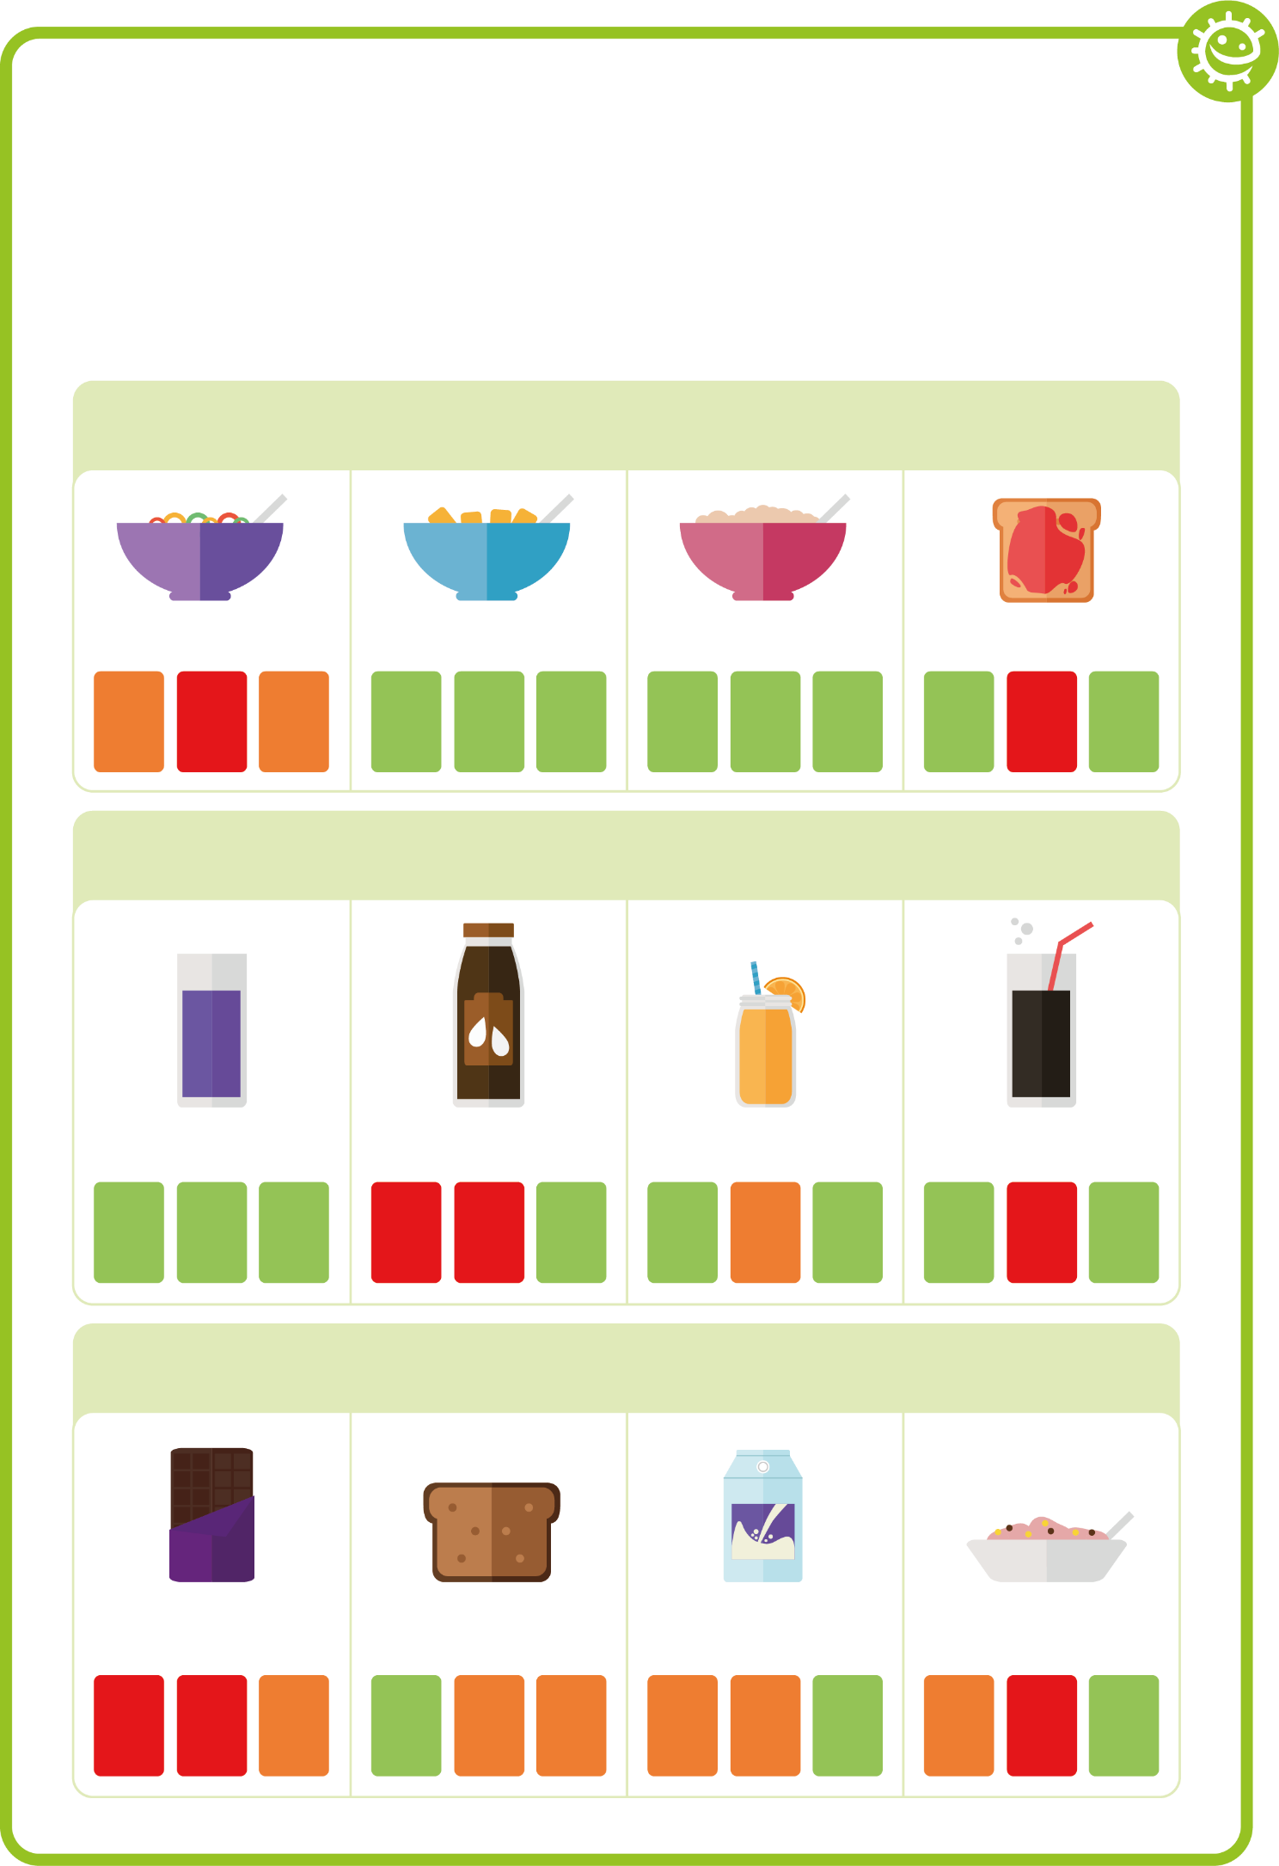

No-added sugar/ sugar free squash and water

Chocolate milk



Orange juice



Full sugar cola



sugar

fat

salt

sugar

fat

salt

sugar

fat

salt

sugar

fat

salt

#### Snack

Malt loaf



Low sugar yoghurt



Regular yoghurt



Chocolate bar

sugar

fat

salt

sugar

fat

salt

sugar

fat

salt

sugar

fat

salt