Treatment of Infection: Antibiotics
Key Stage 2

Lesson 10: Antibiotics
Through teacher-led discussion and debate, students learn the importance of using antibiotics and other medicines appropriately.

Learning Outcomes

All students will:
- Understand that most common infections get better on their own through time, bed rest, hydration and healthy living.
- Understand that if antibiotics are taken, it is important to finish the course.
- Understand that antibiotics treat bacterial infections only.
- Understand that they should not share antibiotics or other medicines that are prescribed by a doctor or healthcare professional.

Curriculum Links

PHSE/RHSE
- Health and prevention

Science
- Working scientifically
- Animals, including humans

English
- Reading & comprehension

Lesson 10: Antibiotics

Resources Required

Main Activity: Comic Strip Scenarios

Per group
- Copy of SH1
- Copy of SH2
- Copy of TS1

Extension Activity 1: Antibiotics Flash Cards

Per group
- Copy of SH3

Extension Activity 2: Word Mix Up

Per student
- Copy of SW1

Supporting Materials
- TS1 Teacher Discussion Points
- SH1-2 Antibiotics Comic Strip
- SH3 Antibiotics Flashcards
- SW1 Word Mix Up Game Sheet

Lesson 10: Antibiotics

Key Words
Antibiotic
Disease
Immune system
Infection
Medicine
Natural defences
Vaccine

Health & Safety
For safe microbiological practices in the classroom consult CLEAPPS
www.cleapps.org.uk

Weblinks
e-bug.eu/eng/KS2/lesson/ Antibiotics

Introduction
- Begin the lesson by explaining to the students that they are going to learn about some common infections and when antibiotics should and should not be used. Remind students that harmful microbes can cause an infection and make us ill. Ask students about their own experiences of being ill, what was the illness, how did they feel and what did they do? Did they think it was caused by a microbe/ infection? If so, why did they think that? Did they stay at home or did they go to the doctor or visit the chemist? Did they get any medicine?
- Tell students that before we get medicine for common infections, we should try and let our bodies fight the harmful microbes. Explain that inside our bodies we have an immune system that fights harmful microbes. If we get plenty of sleep and eat properly we keep our immune system strong and it keeps fighting the harmful microbes.
- Explain however, that sometimes, if a lot of harmful microbes get into the body, the immune system may need help. This is when we need medicine. Explain that different types of medicine are used to treat the symptoms of different infections e.g. cough remedies, painkillers, medicines to bring down temperatures, etc.
- Highlight to students that antibiotics are medicines that are used to treat only bacterial infections. Antibiotics make us better by stopping or killing the harmful bacteria that make us ill. Explain to students that different antibiotics affect different bacteria therefore we should not use other people’s antibiotics because they might not work; we should only take antibiotics given to us by the doctor, nurse or chemist. Explain that antibiotics will not work on infections caused by a virus, for example antibiotics cannot stop or kill COVID-19 or the common cold.
- Explain that if we do get antibiotics from the doctor, nurse or chemist then it is important to finish the course. If not, we may not kill all the harmful bacteria and they could make us ill again or become resistant to the bacteria.
- Students should know that many of the other medicines e.g. pain killers or cough mixtures are used to relieve the symptoms of infection such as headaches, fever, congestion, etc.

Activity

Main Activity: Comic Strip Scenarios and discussion
This activity can be carried out in small groups or as a classroom discussion. The task is presented like a cartoon story.
- Each section of the cartoon has a situation with a decision that needs to be made. The words spoken by the decision maker are in italics to highlight them.
- Show each box to the students (either all together SH1 and SH2, or as individual boxes on the white board) and discuss whether the decision maker has made the right or wrong choice.
- Discussion points can be found in TS1. Students will learn how and when to use antibiotics appropriately.

Extension Activities

Antibiotic flashcards
This activity can be carried out in small groups of 3 or 4 or as part of a class discussion. Provide students with SH3 and ask them to answer either ‘yes’ or ‘no’ to the statements. Answers are available on the e-bug website.

Word mix up game sheet
This fun activity can be carried out either individually or in groups of 2 or 4 students. Provide students with SW1. Students should match the word on the left-hand column with the definition on the right-hand column. Answers are available on the e-bug website.

Learning Consolidation
At the end of the lesson, ask the class if they can name different ways to correctly use antibiotics. For example:
- Only use antibiotics prescribed to me by my doctor
- Always finish the course once started
- Never take somebody else’s antibiotics
- Sign up to become an antibiotic guardian
- Or write your own

TS1 – Comic Strip Discussion Points

Discussion Points
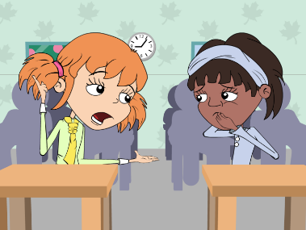
Eva should cover her mouth whist coughing. Infection can easily spread from person to person through coughing and sneezing. A sneeze travels at approximately 100mph and at high force meaning that the microbes carried in a sneeze can travel very far and infect other people.
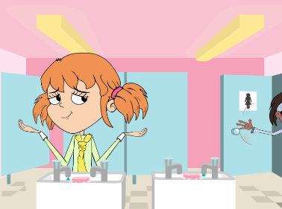
You should always wash your hands after going to the toilet. Many harmful microbes that make you ill are found in toilets. Good personal hygiene is essential to a healthy lifestyle and can greatly reduce the spread of infection. Trials show that proper hand washing reduces absenteeism in schools, not just from tummy bugs but from coughs and colds too.
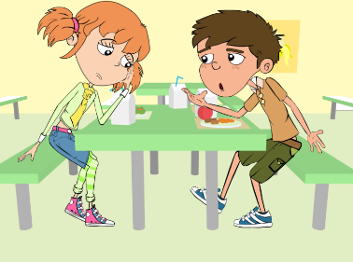
Eva should NOT use her sisters antibiotics. There are many different types of antibiotics which treat different bacterial infections. Doctor’s prescribe specific antibiotics for specific illnesses and at a dose suitable for the patient. Taking someone else’s antibiotics may mean your infection does not get better.
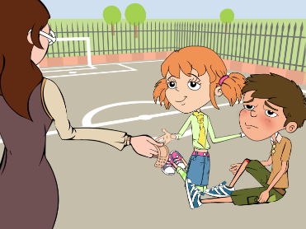
Mrs Brooke should have washed Luca’s cut knee to clean any dirt or microbes which may have been present. Antiseptic cream applied to deeper cuts can also help prevent infection. There is generally no need to cover smaller cuts and grazes with a plaster, fresh air will help the scabbing process.
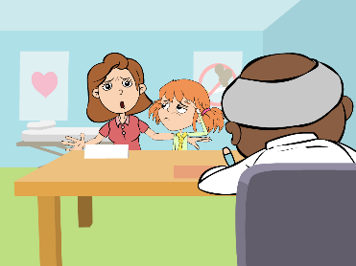#
Dr Cooper is right; antibiotics only work on bacterial infections. Coughs and colds are caused by viruses and in many cases the body’s own natural defences will fight these infections. Other medicines from the chemists help with the symptoms of coughs and colds.
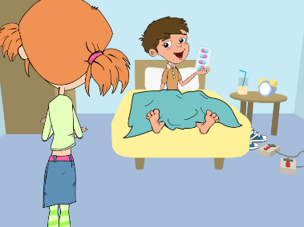
It is important for Luca to finish the course of antibiotics. Not finishing the course could result in the bacteria not being killed properly and becoming resistant to the antibiotic in the future.

SH1 - Antibiotics Comic Strip
Ina went to school not feeling very well. She had a headache and a runny nose. When she arrived in the classroom she took a seat beside Eva. She soon realised that Eva was also not well.
Are you OK Eva?
Not really but my mum said that I have to come to school *cough*
Mine too. But I’m not coughing. You really should cover your mouth you know.
At lunch time, Eva and Ina went to the toilet. Ina was hungry and in a hurry to have her lunch.
Come on Eva, I’m hungry! And don’t forget to wash your hands.
Why do I need to wash my hands?
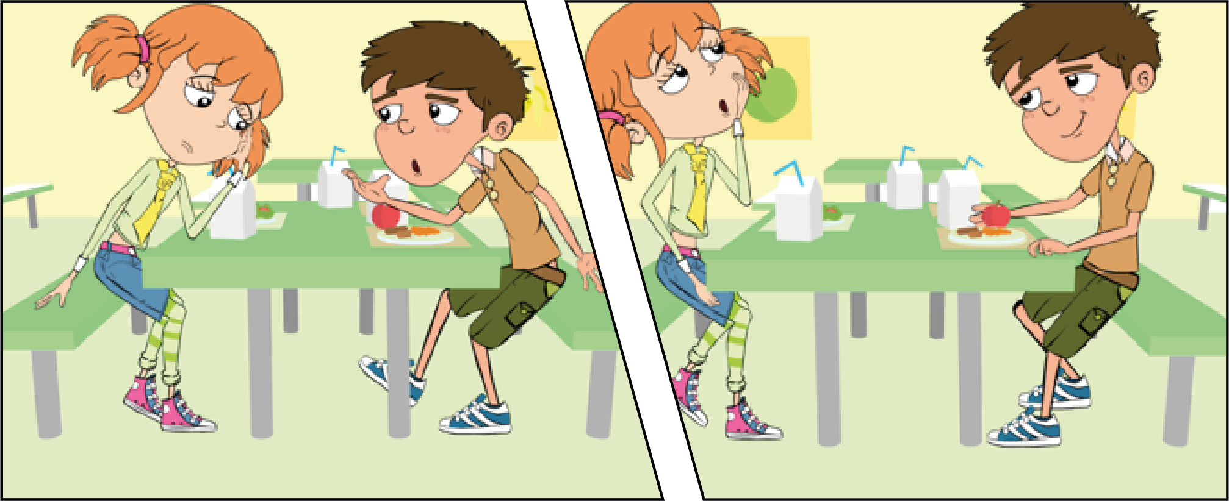
During lunch Eva was talking to her friend Luca about her headache and runny nose.
It really hurts
and I think I’m getting a cold.
Don’t you have any antibiotics at home you can take?
That’s a good idea. We still have some from when my sister had an ear infection. I’ll ask my mum.

SH2 - Antibiotics Comic Strip
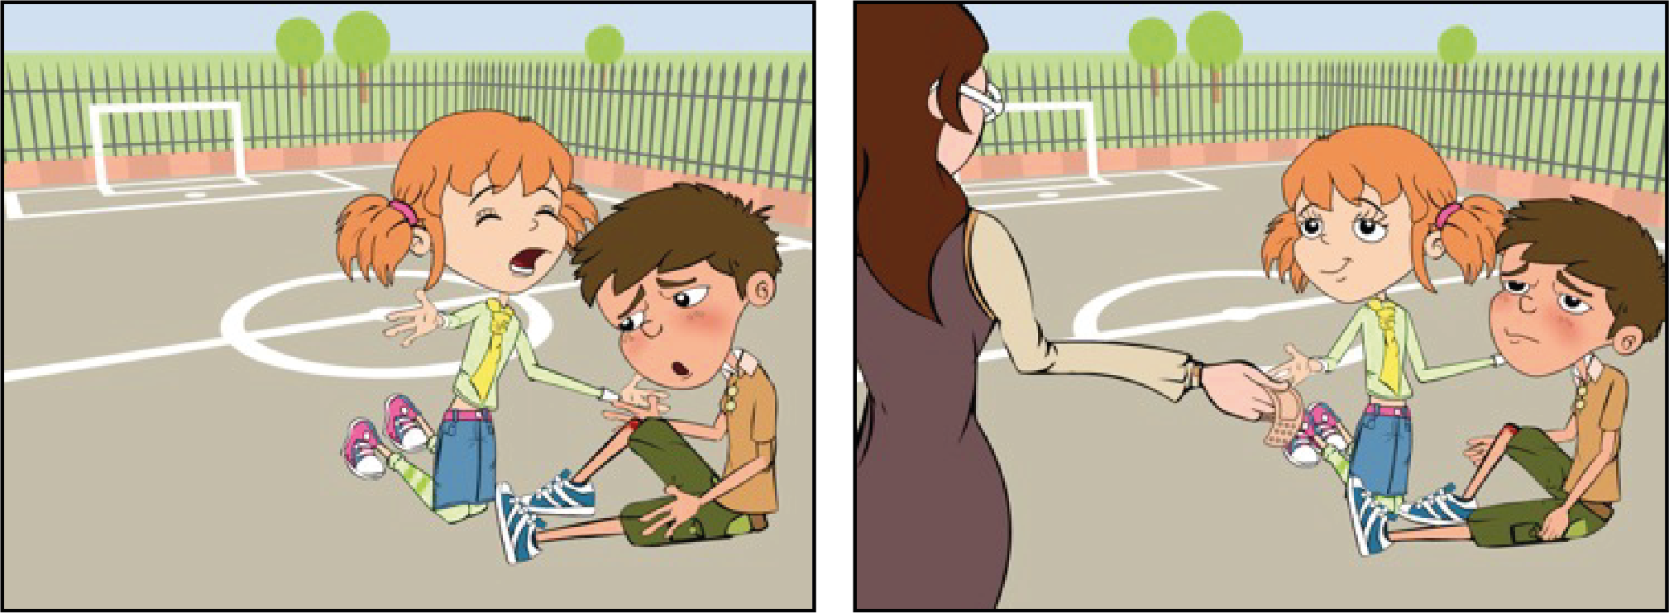
After they had eaten, the children went out to play. Luca fell over and cut his knee very deeply.
Owww my knee is bleeding.
Oh dear. Let me see. It’s not too bad. Let’s just put a plaster on it.
Come on, let’s take you to see Mrs Brooke.
When Eva got home, her mother decided to take her to her doctor. Dr. Cooper said that she had a bad cold.
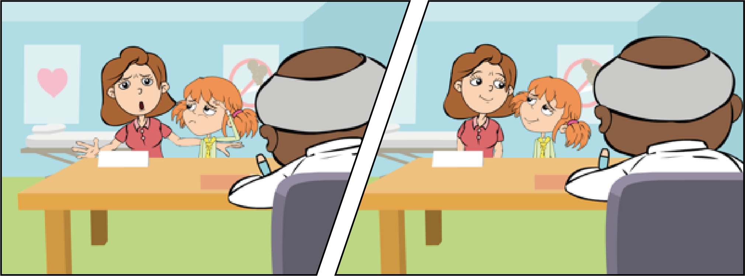
Go home and get some bed rest, take some painkillers for the headache if you need to
But she’s ill, you have to give her some antibiotics.
I’m sorry, but there’s no need.
A few days later, Luca didn’t come to school, so Eva called around to see him on her way from school.
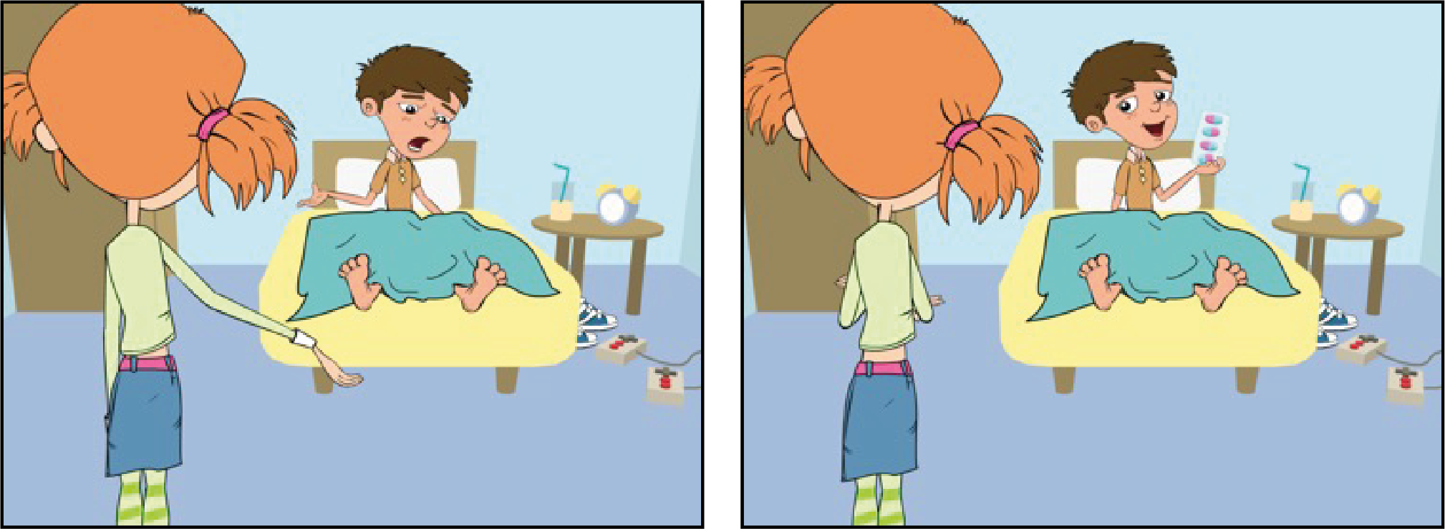
You weren’t in school today, are you OK?
Oh no, did he give you painkillers?
No, my knee Is still really painful, so my dad took me to see Dr Cooper and he said my cut was infected
No, he gave me antibiotics to help
fight the infection and told me to take them until they were all finished.

SH3 - Antibiotics Flashcards

Harmful microbes make us ill
Yes or No
I can treat coughs and colds with Antibiotics
Yes or No
I should always wash my hands after going to the toilet
Yes or No

If my friend is ill I
can give them my old antibiotics
Yes or No
I should always
cover my coughs
and sneezes with
a tissue
Yes or No
Most of the time my
immune system can fight infections like the common cold by itself
Yes or No

If my doctor gives me antibiotics to take for 7 days but I feel better after 3 days I can stop taking them
Yes or No
Antibiotics only
work on bacterial
Infections
Yes or No
I should only take antibiotics prescribed by my doctor
Yes or No

SW1 - Word Mix Up Game Sheet

Word Mix Up
The smallest of the microbes - usually harmful
Antibiotic

A drug used to treat a disease or injury
Bacteria

A sign of illness e.g. headache, diarrhoea and fever
Infection

Special medicine used to treat bacterial infections
Medicine

A disease caused by a microbe
Painkiller

Very small microbe that can be helpful or harmful
Virus

Symptom
A drug used to take
away pain

