

## SH1 - Antibiotics Comic Strip

Ina went to school not feeling very well. She had a headache and a runny nose. When she arrived in the classroom she took a seat beside Eva. She soon realised that Eva was also not well.

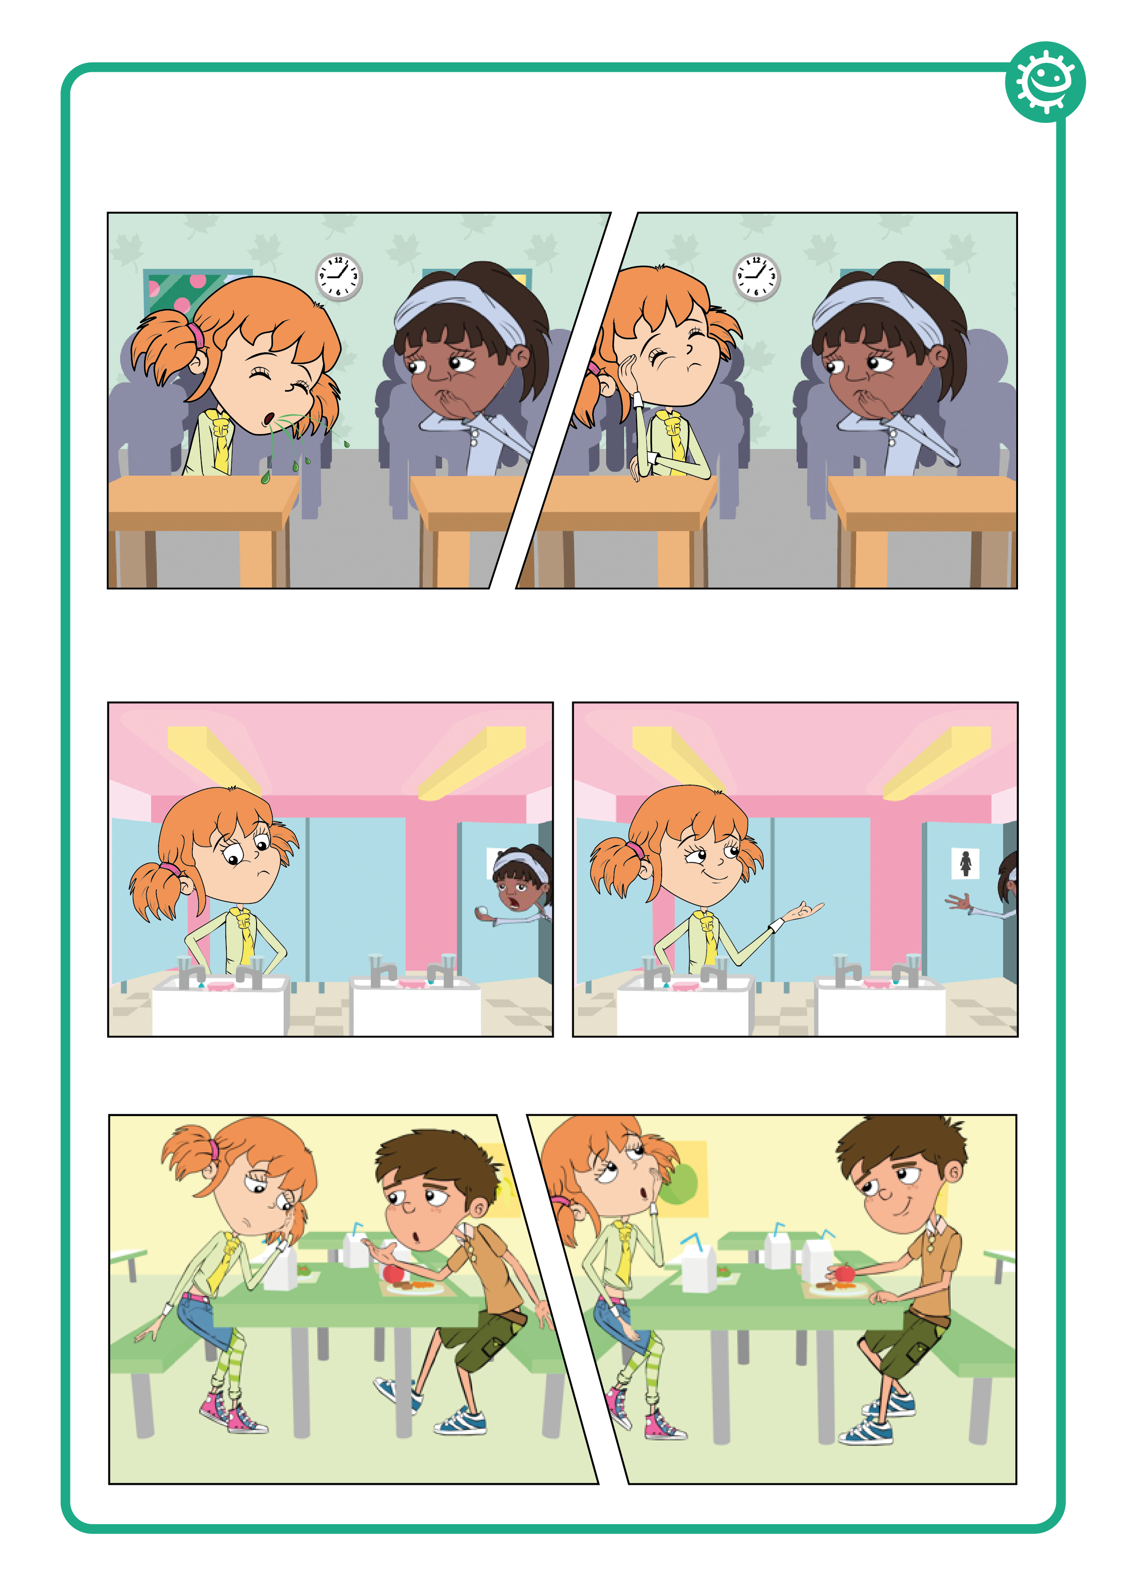

Are you OK Eva?

Not really but my mum said that I have to come to school *cough*

Mine too. But I’m not coughing. You really should cover your mouth you know.

At lunch time, Eva and Ina went to the toilet. Ina was hungry and in a hurry to have her lunch.



Come on Eva, I’m hungry! And don’t forget to wash your hands.

Why do I need to wash my hands?

During lunch Eva was talking to her friend Luca about her headache and runny nose.

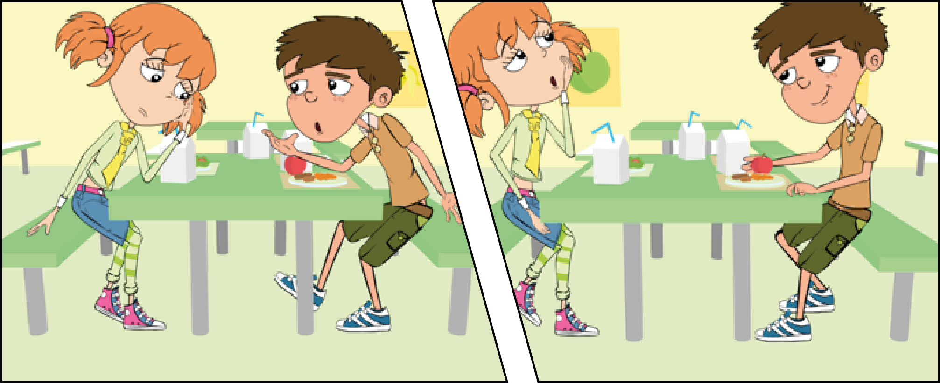

It really hurts

and I think I’m getting a cold.

Don’t you have any antibiotics at home you can take?

That’s a good idea. We still have some from when my sister had an ear infection. I’ll ask my mum.



## SH2 - Antibiotics Comic Strip

After they had eaten, the children went out to play. Luca fell over and cut his knee very deeply.

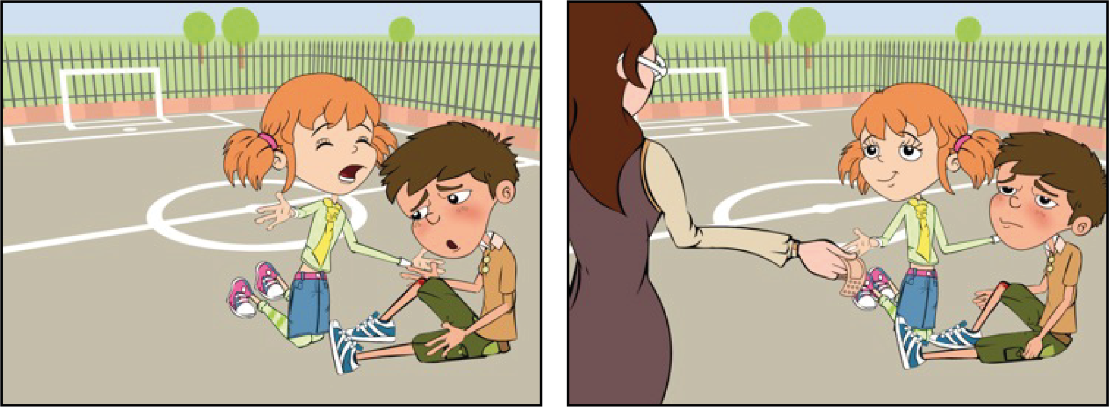

Owww my knee is bleeding.

Oh dear. Let me see. It’s not too bad. Let’s just put a plaster on it.

Come on, let’s take you to see Mrs Brooke.

When Eva got home, her mother decided to take her to her doctor. Dr. Cooper said that she had a bad cold.

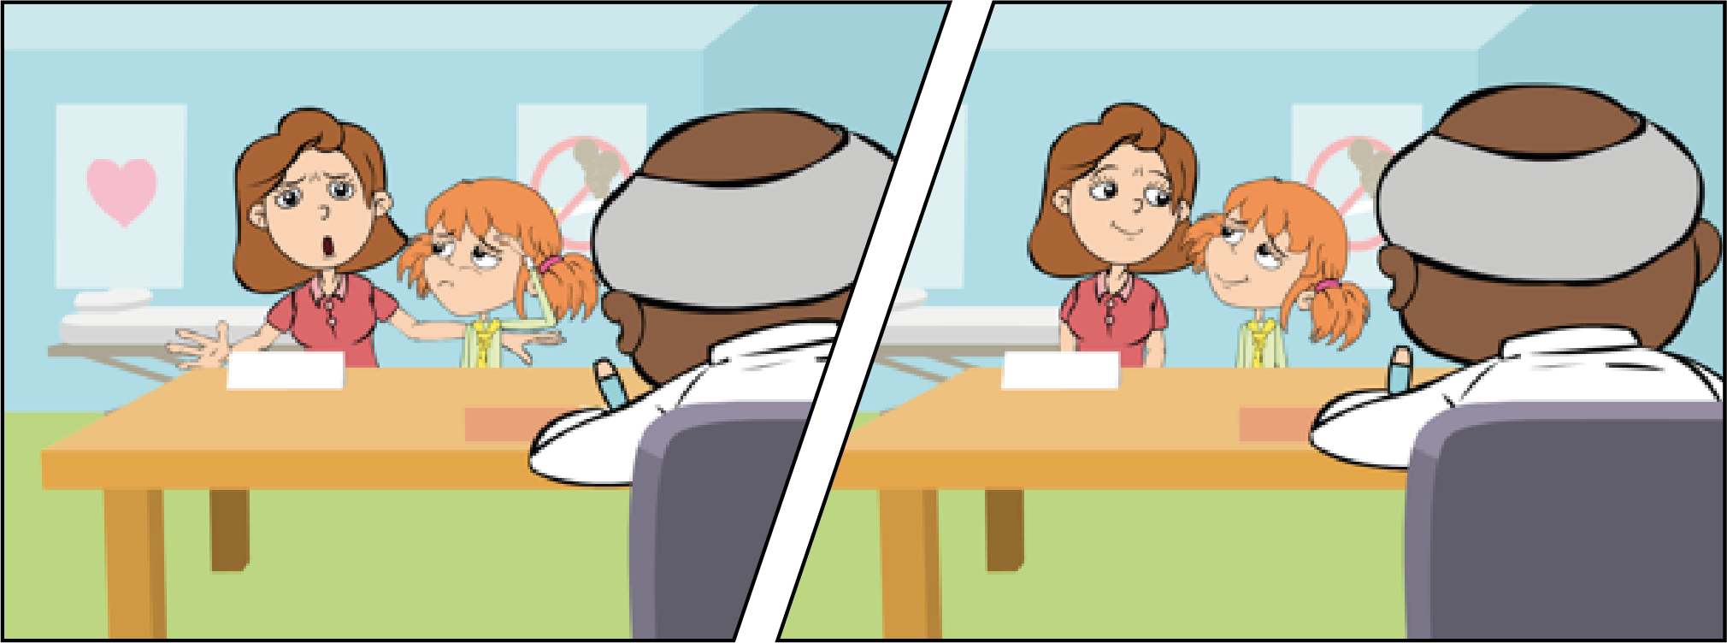

Go home and get some bed rest, take some painkillers for the headache if you need to

But she’s ill, you have to give her some antibiotics.

I’m sorry, but there’s no need.

A few days later, Luca didn’t come to school, so Eva called around to see him on her way from school.

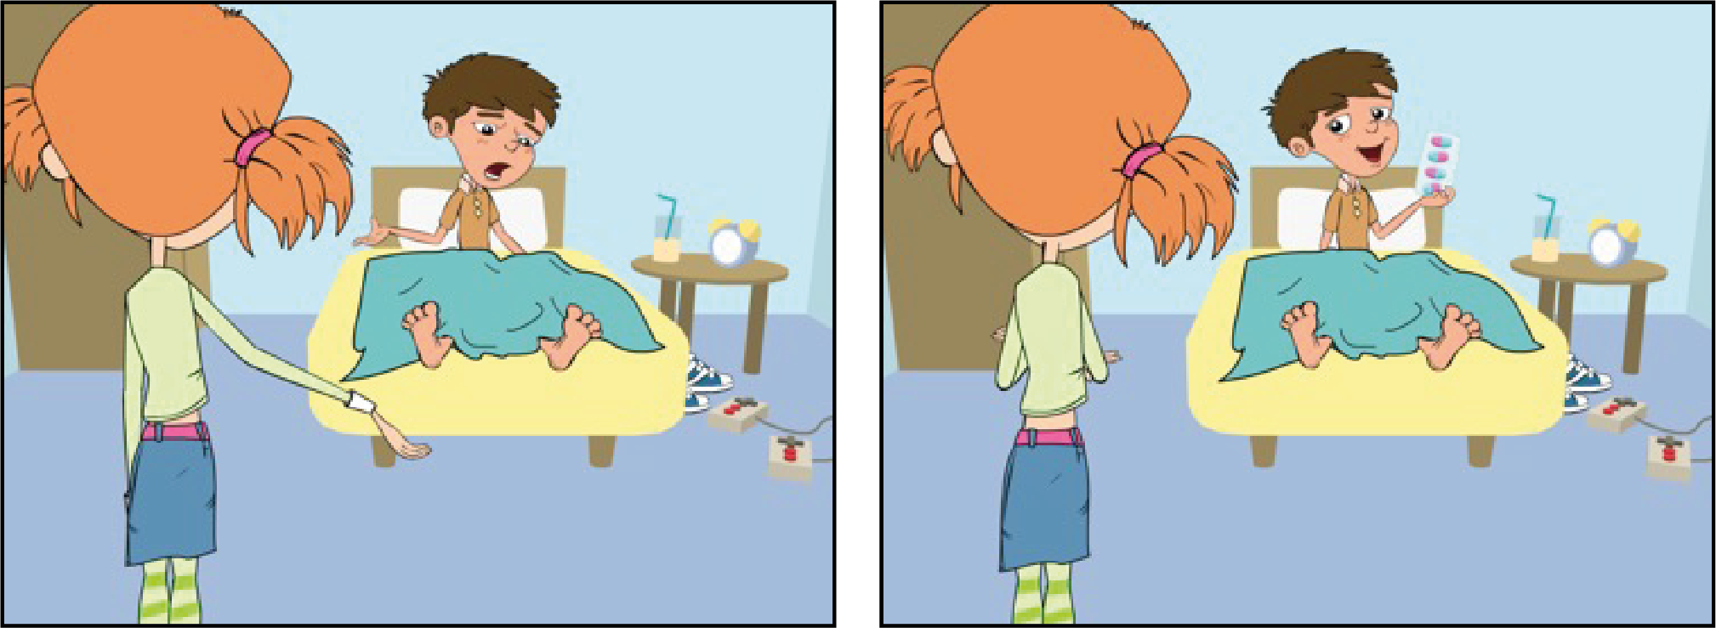

You weren’t in school today, are you OK?

Oh no, did he give you painkillers?

No, my knee Is still really painful, so my dad took me to see Dr Cooper and he said my cut was infected

No, he gave me antibiotics to help

fight the infection and told me to take them until they were all finished.