

## TS1 – Comic Strip Discussion Points

#### Discussion Points

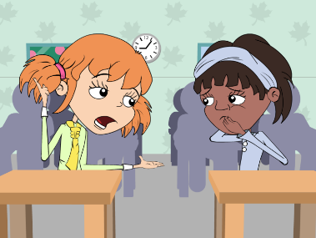

Eva should cover her mouth whist coughing. Infection can easily spread from person to person through coughing and sneezing. A sneeze travels at approximately 100mph and at high force meaning that the microbes carried in a sneeze can travel very far and infect other people.

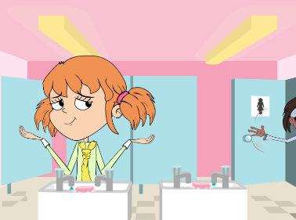

You should always wash your hands after going to the toilet. Many harmful microbes that make you ill are found in toilets. Good personal hygiene is essential to a healthy lifestyle and can greatly reduce the spread of infection. Trials show that proper hand washing reduces absenteeism in schools, not just from tummy bugs but from coughs and colds too.

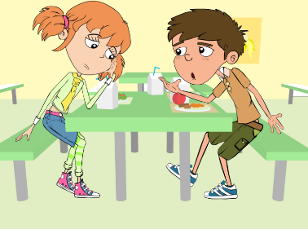

Eva should NOT use her sisters antibiotics. There are many different types of antibiotics which treat different bacterial infections. Doctor’s prescribe specific antibiotics for specific illnesses and at a dose suitable for the patient. Taking someone else’s antibiotics may mean your infection does not get better.

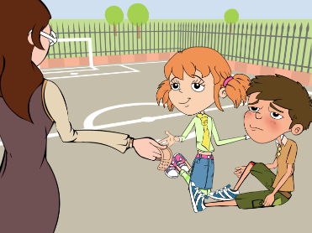

Mrs Brooke should have washed Luca’s cut knee to clean any dirt or microbes which may have been present. Antiseptic cream applied to deeper cuts can also help prevent infection. There is generally no need to cover smaller cuts and grazes with a plaster, fresh air will help the scabbing process.

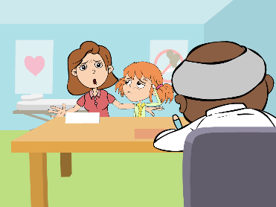#

Dr Cooper is right; antibiotics only work on bacterial infections. Coughs and colds are caused by viruses and in many cases the body’s own natural defences will fight these infections. Other medicines from the chemists help with the symptoms of coughs and colds.

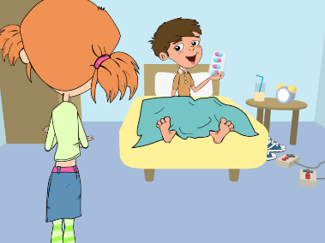

It is important for Luca to finish the course of antibiotics. Not finishing the course could result in the bacteria not being killed properly and becoming resistant to the antibiotic in the future.