Spread of Infection: Food Hygiene
Key Stage 2

Lesson 6: Food Hygiene
Students will go through an interactive quiz which follows the preparation of a meal. Along the way, students will have to make decisions about what to do next and answer questions.

Learning Outcomes

All students will:
- Understand that microbes can be found on our food and can transfer to humans.
- Understand that cooking food properly can kill harmful microbes.
- Understand that bacterium multiply very quickly.

Most students will:
- Understand that refrigeration only stops microbes growing, it doesn’t kill them.
- Understand the difference between “use by” and “best before”.

Curriculum Links

PHSE/RHSE
- Health and prevention

Science
- Working scientifically
- Living things and their habitats
- Animals, including humans

English
- Reading & comprehension
- Spoken language

Design and Technology
- Cooking and nutrition

Lesson 6: Food Hygiene

Resources Required

Starter Activity: Class Discussion

Per class
- Copy of SH1
- Copy of SH2

Main Activity: Kitchen Check

Per class
- Copy of PP1 (available from e-bug.eu website)

Extension Activity 1: Fridge Raiders

Per group
- Copy of SH3
- Copy of SH4
- Copy of TS1

Extension Activity 2: Food Hygiene Quiz

Per student
- Copy of SW1

Extension Activity 3: Spot the Mistake

Per group
- Copy of SW2

Extension Activity 4: Label Sort

Per student
- Copy of SW3

Supporting Materials
- SH1 & SH2 Class Discussion
- SH3 Fridge Raiders
- SH4 Fridge Raiders
- TS1 Fridge Raiders
- SW1 Food Hygiene Quiz
- SW2 Spot the Mistakes
- SW3 Label Sort

Advanced Preparation
For the Extension Activity Fridge Raiders, laminate a copy of SH3 and the images on SH4. Alternatively, MS PowerPoint Slides of the images are available on the e-Bug website e-bug.eu

Lesson 6: Food Hygiene

Key Words
Microbes
Foodborne illness
Bacteria
Use by
Best before
Refrigeration

Health & Safety
For safe microbiological practices in the classroom consult CLEAPPS
www.cleapps.org.uk

Weblinks
e-bug.eu/eng/KS2/lesson/ Food-Hygiene

Introduction
- Explain to the students that some microbes like to grow in nice warm damp places, such as inside our bodies, and when they find somewhere they like, they grow and multiply. But they usually don’t like places that are very warm or cold. Explain to the class that for this lesson they will be learning how harmful microbes can enter our bodies through the food we eat.
- Ask students if they know why we cook food or keep it in a fridge. Explain that putting food in the fridge only slows or stops microbial growth, it doesn’t kill it. The microbes will grow again when they come out of the fridge. The only way to kill microbes is to cook food until it is really hot and cooked all the way through. This is because very warm temperatures kill many harmful microbes.
- Discuss with the class which foods contain the most harmful bacterium. Show the class pictures of various food types (SH1) and ask them which they think could contain the useful/harmless bacteria and which contain the harmful bacterium. Answers for the discussion are provided on SH2.

Activity

Main Activity: Kitchen Check
- Set up the Kitchen Check MS PowerPoint quiz (available on the e-Bug website e-bug.eu) on a computer, tablet or projector.
- Students take part in an interactive quiz which follows the preparation of a meal. Students will be presented with questions to answer and explanations will be displayed.
- At the end of the quiz, students will understand where food hygiene risks lie and will be able to apply them to their own food preparation practices.

Extension Activities

Fridge Raiders
Using the laminated copies of SH3 and SH4, lay out the images of the large fridge and foods kept in the fridge on a table or display the student handouts on a whiteboard. Ask students to place the foods in the fridge on the correct shelf according to best food hygiene practices. Ask the students which foods should also be covered up to prevent cross contamination. Teacher answers can be found in TS1. Students learn how to store food safely, and that refrigeration only slows the growth of microbes, it doesn’t kill them.

Food Hygiene Quiz
Provide SW2 to groups of 2 or 3 and ask students to spot the best practice kitchen mistakes and discuss them with the class. Answers are available on the e-Bug website.

Label Sort
Allocate SW3 to groups of 3 or 4. Ask students to match food labels to their correct definition to help students learn how to consume food safely.

Learning Consolidation
At the end of the lesson, ask the class if they can name ways to reduce the spread of microbes when handling food. For example:
- Wash my hands before and after handling food.
- Clean kitchen surfaces and utensils before and after preparing food.
- Wash fruit and vegetables before eating them.
- Don’t wash raw meat to avoid harmful microbes splashing onto other foods and surfaces.
- Don’t eat food that is past its used by date.

SH1 – Class Discussion

Discuss the types of microbes that are commonly found on or in these foods?
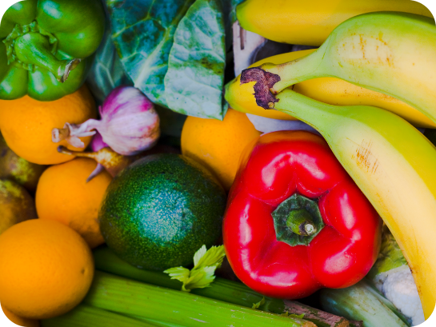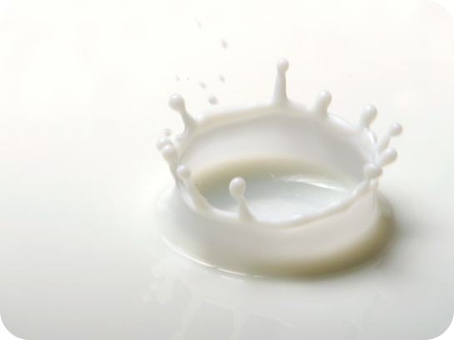
Fruit and Vegetables
Milk

Yoghurt
Bread

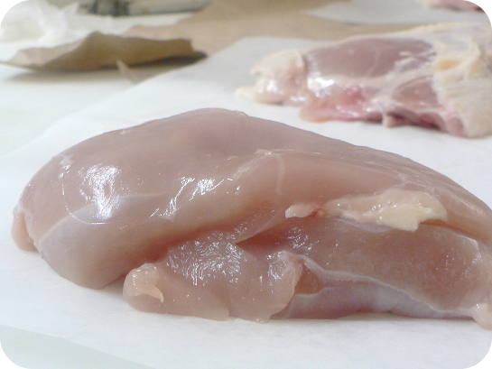
Chicken
Sausages

SH2 - Class Discussion - Answers

Answers
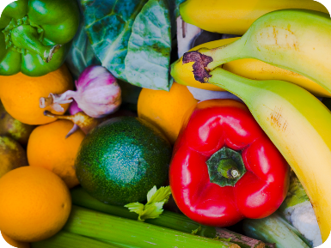
Fruit and Vegetables: Most of the microbes found on fruit and vegetables are harmless, but sometimes harmful microbes can be found in the soil in which they are grown. It is therefore important to wash all fruit and vegetables before cooking and/or eating them.

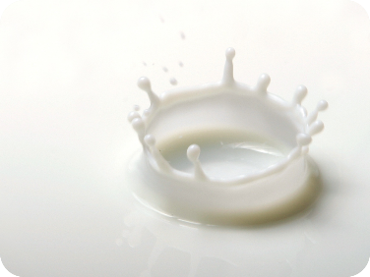
Milk: Fresh milk contains Lactobacillus Bacterium which help us digest food. There can also be harmful microbes that are removed when the milk is heated up (pasteurised) before it is sent to the shops.

Yoghurt: Yoghurt usually contains Lactobacillus
Bacterium which help us digest food.

Bread: The yeast Saccharomyces cerevisiae
helps bread to rise.

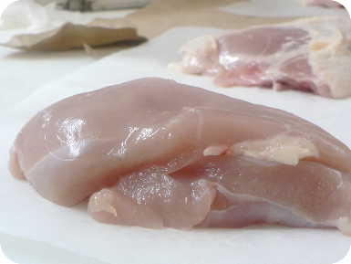
Raw Chicken: Raw chicken may contain
Salmonella, E. coli or Campylobacter Bacterium,
all of which can cause food poisoning in humans.

Raw Sausages: Raw meat may contain
Salmonella, E. coli Bacterium which can cause
food poisoning in humans.

TS1 – Fridge Raiders
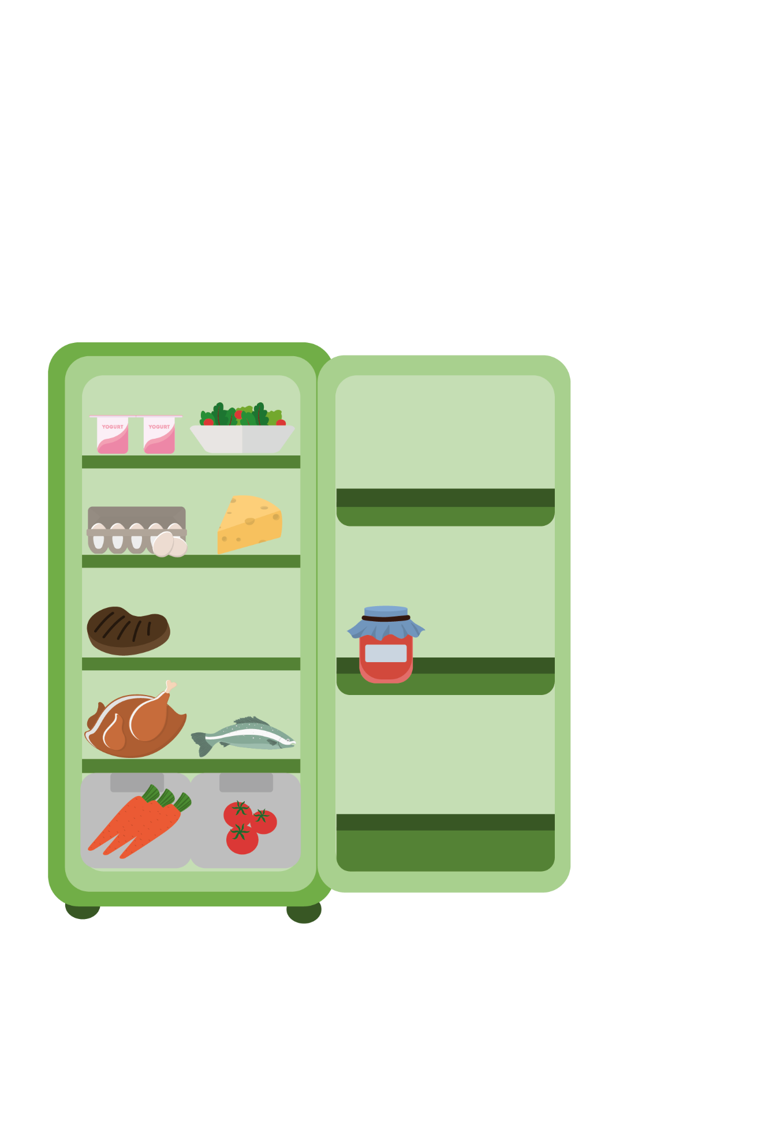

Fridge Raiders – Answer Sheet

Cooked meat should be
covered and stored away
from raw meat
Pre-prepared food, such as
this salad, should be covered
and kept in the fridge until use

Some jars of food,
for example jam,
need to be stored
in the fridge once
opened

Raw meat and fish should be covered and kept on the bottom shelf in the fridge
Store fruit and vegetables and salad in the draw at the bottom of the fridge

SH3 – Fridge Raiders
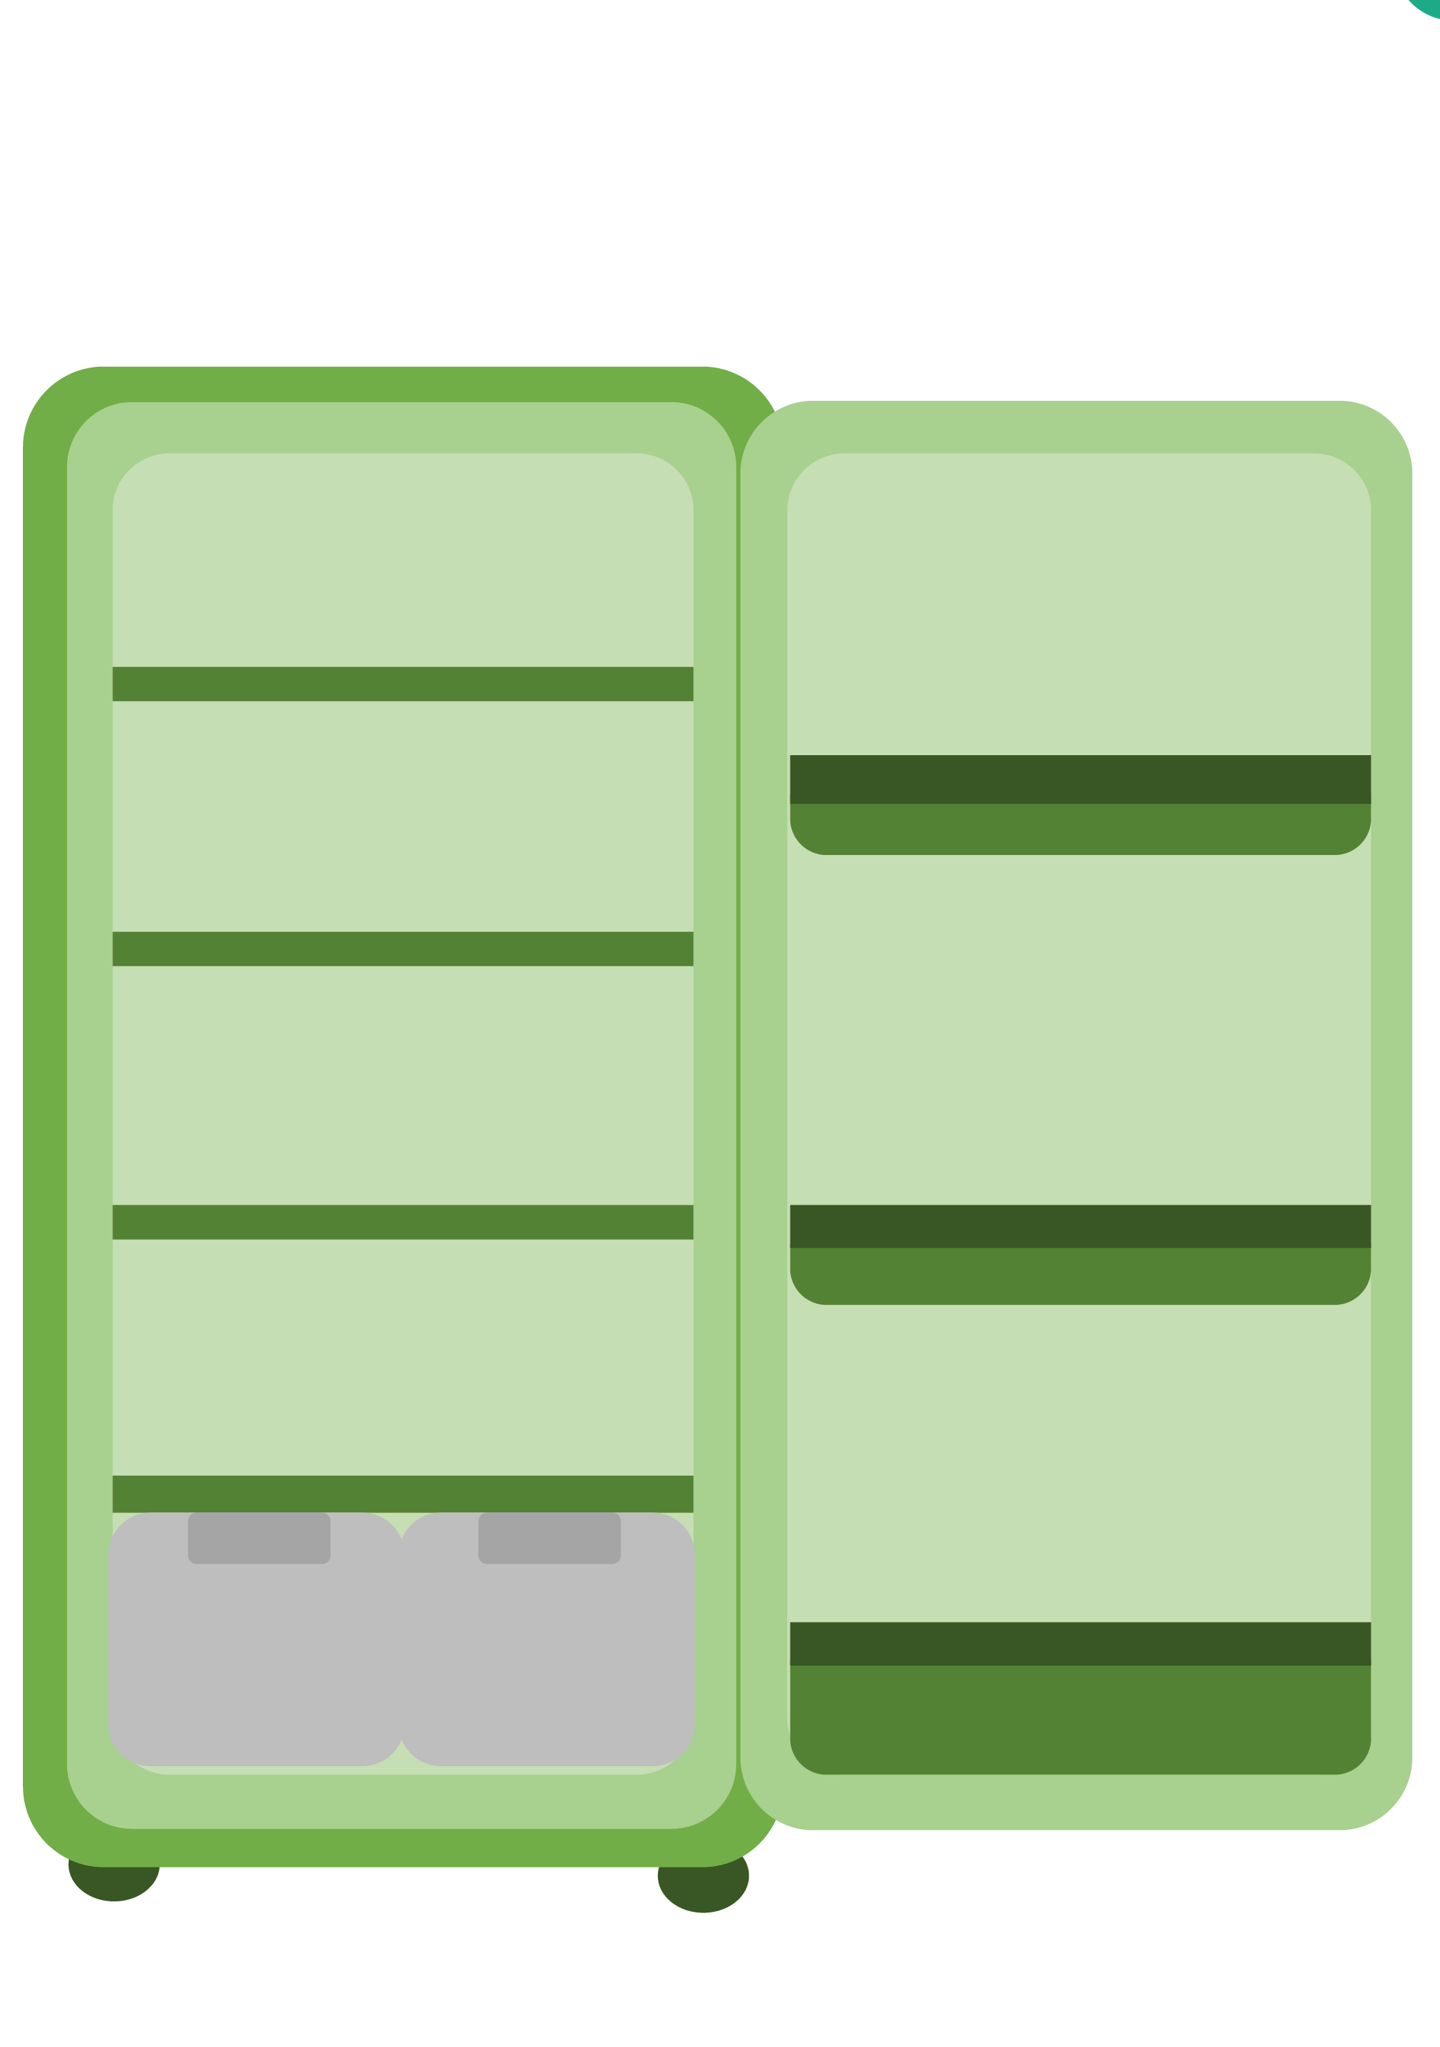

Fridge Raiders

SH4 – Fridge Raiders

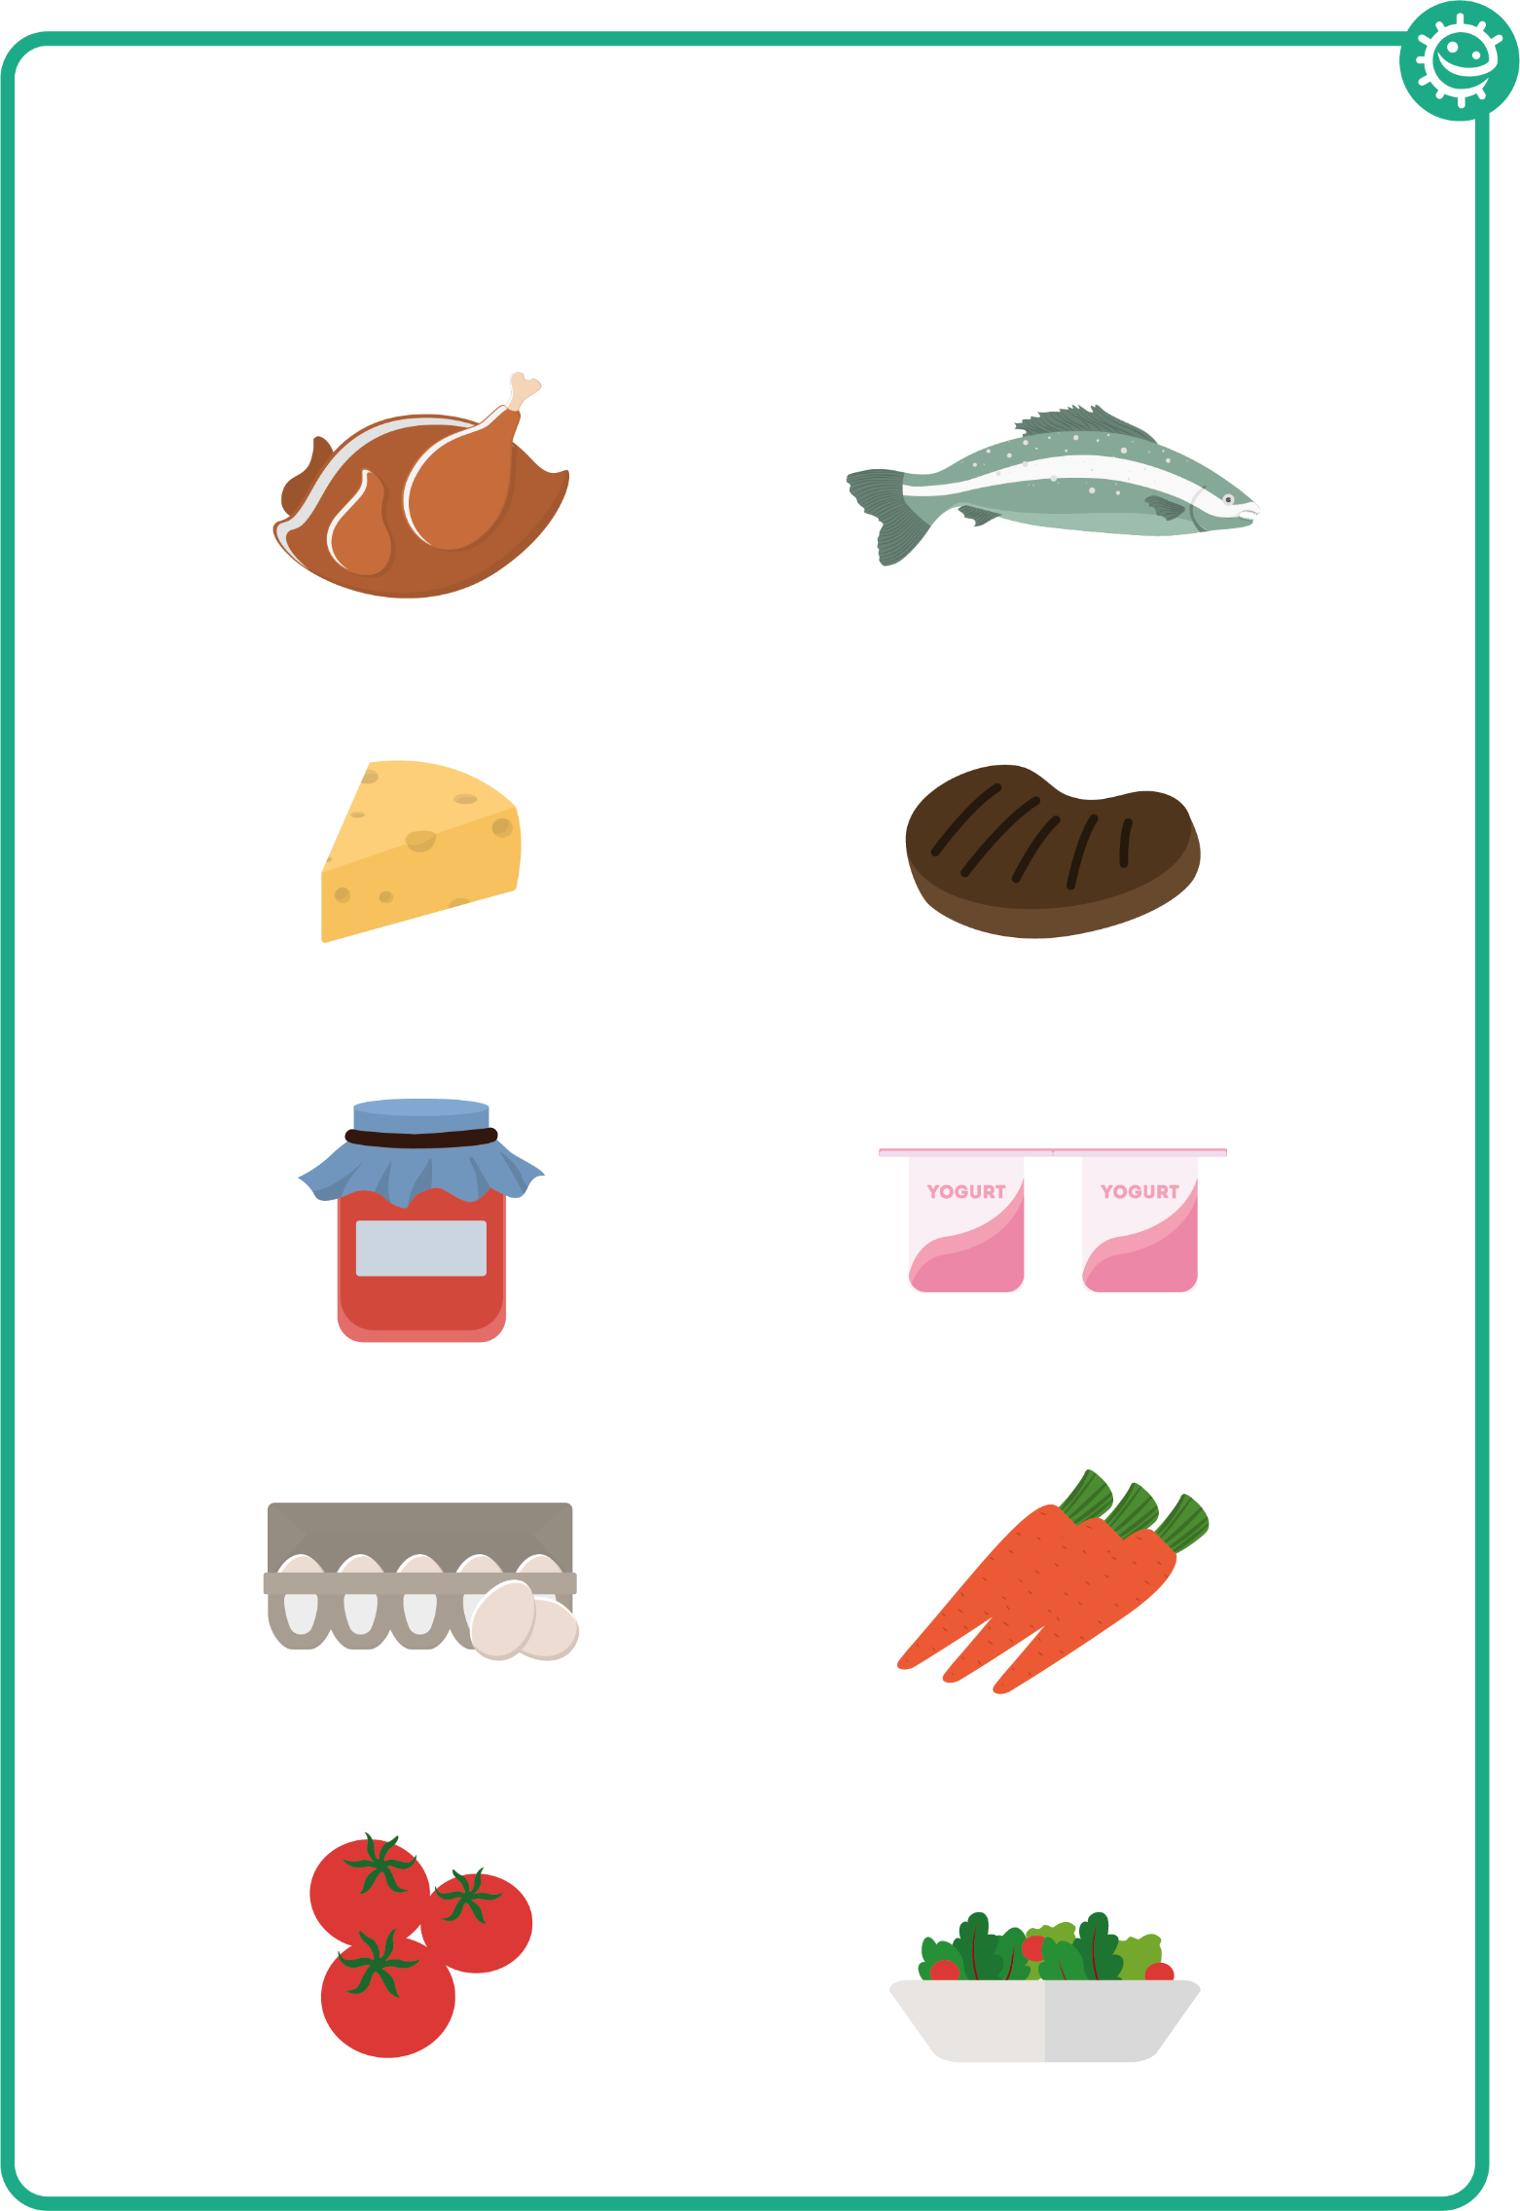

Fridge Raiders

SW1 - Food Hygiene Quiz

Quiz: Food Hygiene
Please tick as many answers as appropriate
Harmful microbes can commonly be found on:
(3 points)
- Raw meat
- Raw fish
- Fruit and vegetables
- Yoghurt
Meat and vegetables should be:
(1 point)
- Sorted on the same shelf in the fridge
- Cut on different chopping boards
- Cut with the same knife
- Stored in a warm cupboard
Which food may contain useful microbes?
(3 points)
- Cheese
- Yoghurt
- Bread
- Raw chicken
The best way to destroy harmful microbes on food is to: (1 point)
- To make sure food is cooked on the outside
- Cook food as quickly as possible
- Cook food thoroughly at high temperatures
- To make sure food is warm before we eat it
Refrigeration:
(2 points)
- Kills all microbes
- Speeds up microbe growth
- Only stops microbes growing, it doesn’t kill them
- Should be set to 4°C or below
How can we prevent food poisoning?
(2 points)
- Store raw meat/chicken in the fridge
- Cook meat/chicken thoroughly before we eat it
- By washing raw chicken
- Eating yoghurt

SW1 - Food Hygiene Quiz

Quiz: Food Hygiene
Continued...
Match the terms with their definitions:
(3 points)

Food spoilage
The deterioration of colour, texture and flavour of food
Use by
The food is safe to eat after this date, but may no longer be at its best quality
Best before
Food is safe to eat up until this date, but should not be eaten after it

Which of the following is not one of the four key ways you can prevent food poisoning?
(1 point)
- Cleaning during food preparation
- Cooking food thoroughly
- Using the same chopping board
- and utensils during food preparation
- Storing food correctly in refrigerators at ≤4°C
What infections can you get from poor hand washing? (1 point)
- Salmonella
- Cold and flu
- Diarrhoea
- All of the above

SW2 - Spot the Mistakes – low ink

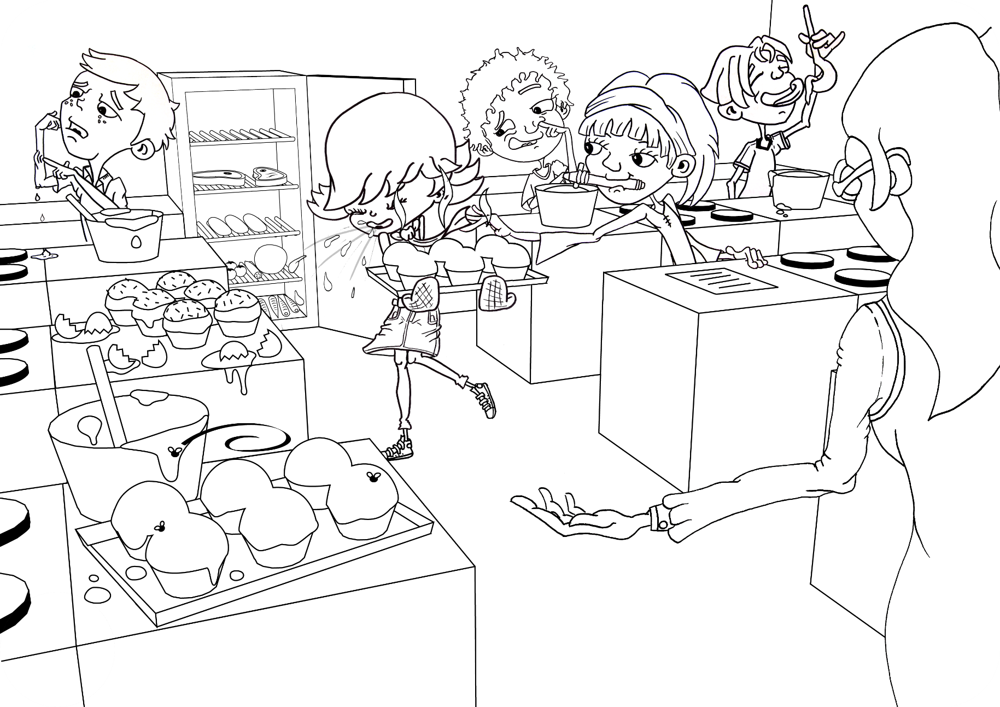
Can you circle 9 things that the students in this cookery class should not be doing and why?

SW2 - Spot the Mistakes – high ink

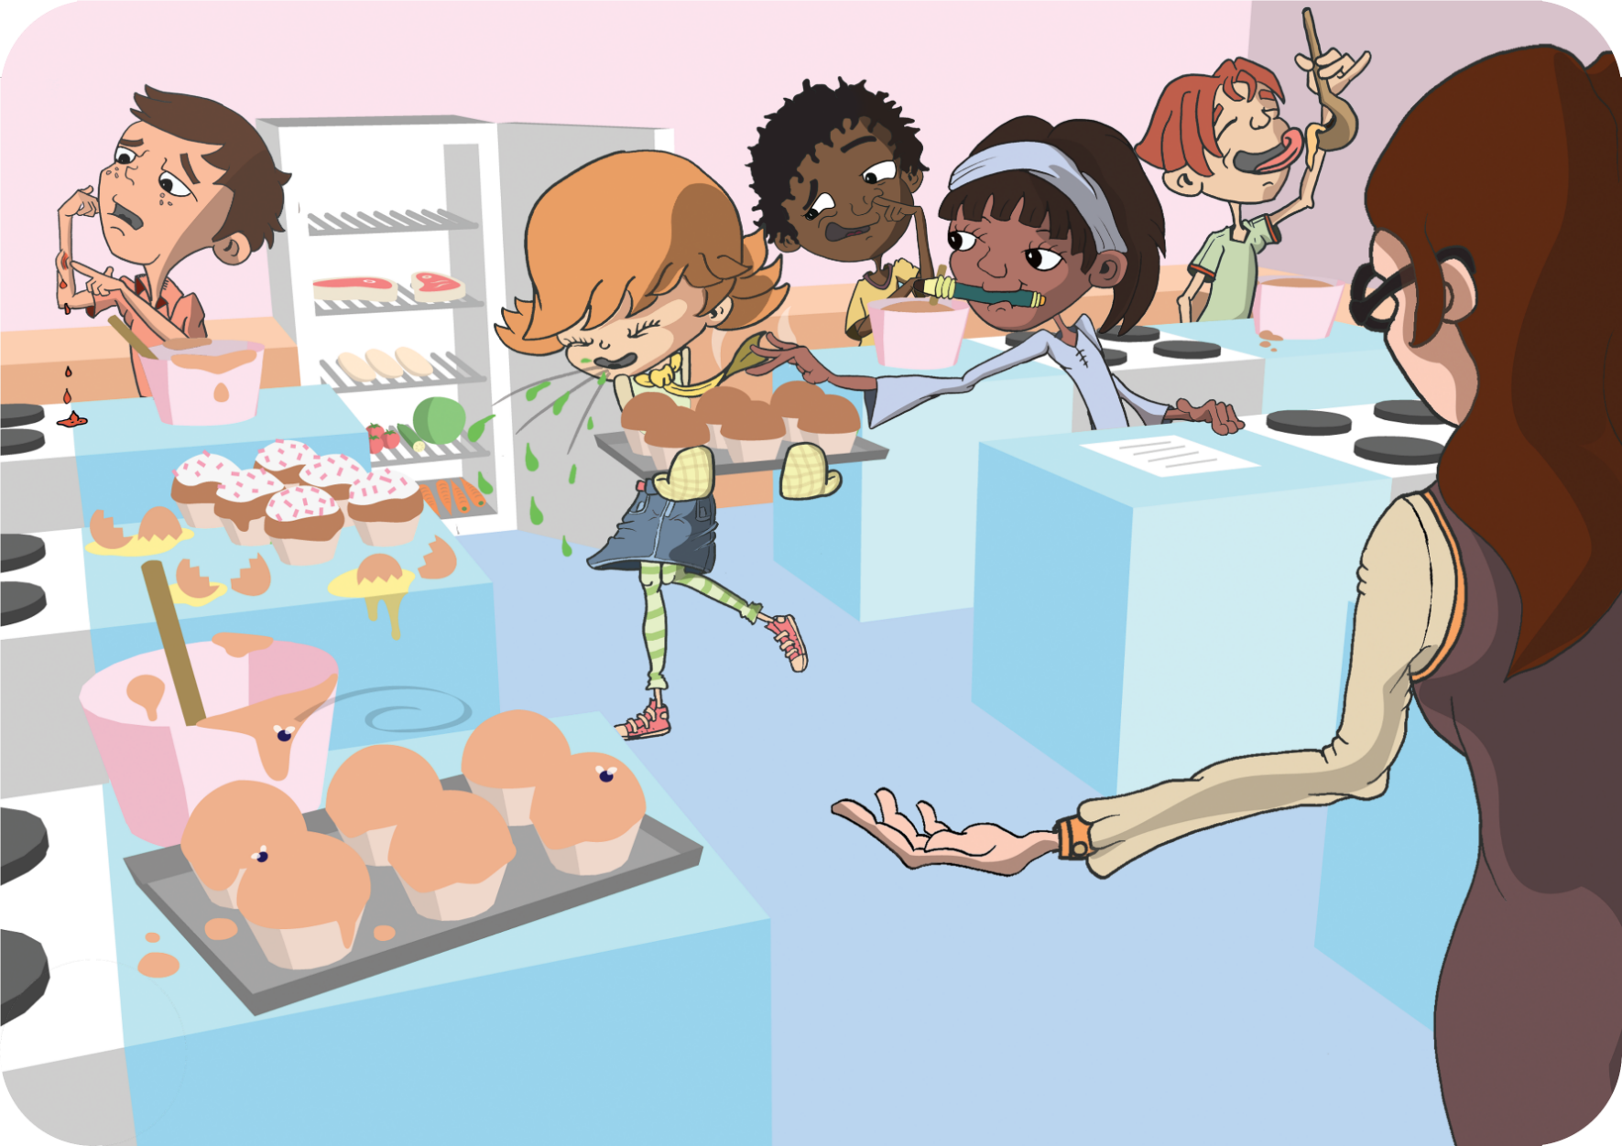
Can you circle 9 things that the students in this cookery class should not be doing and why?

TS2 - Spot the Mistakes – Answers

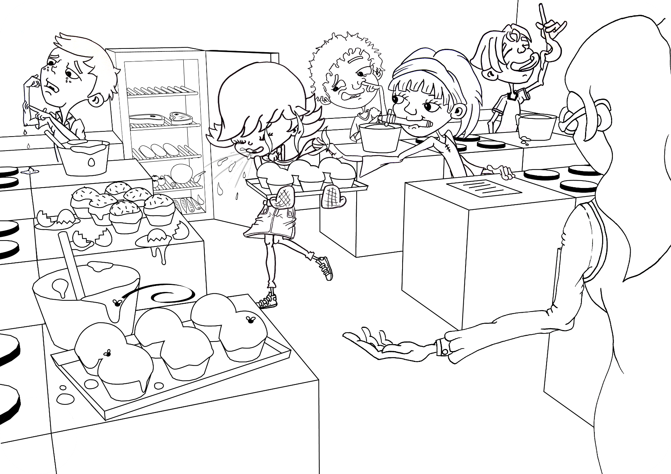

SW3 - Label Sort Worksheet

This label means that food
should be eaten within the
amount of days it says on
the packaging. After this
date the food may not be
safe to eat.

Keep refrigerated once opened

These dates are seen on food that goes off
quickly, such as meat products and ready
prepared salads. Don’t use any food or
drink after the end of the date on the label,
even if it looks and smells fine. Eating food
after this date could put your health at risk.

Consume within 3 days of opening

Shops often use these dates on their shelves, mainly for stock purposes. These are not required by law and are instructions for shop staff, NOT for shoppers.

Display until
Best before
Use by
These dates are about quality not safety.
This food will taste its best before the date
shown. Eating it after this date will not
mean you will get ill but the flavour might
not be as good. These dates appear on a
wide range of frozen, dried, tinned and
other foods.
This label means that once
you have removed the
packaging and exposed
the food to the air it should
be refrigerated so to stop
microbes growing.

Label Sort
Match the food label to the correct definition

