## SH1 – Class Discussion



### Discuss the types of microbes that are commonly found on or in these foods?

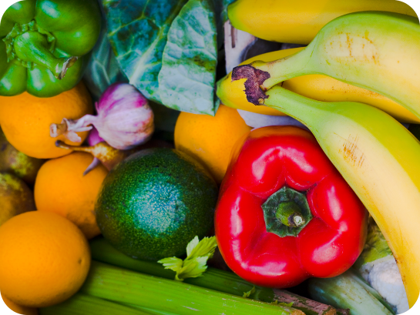 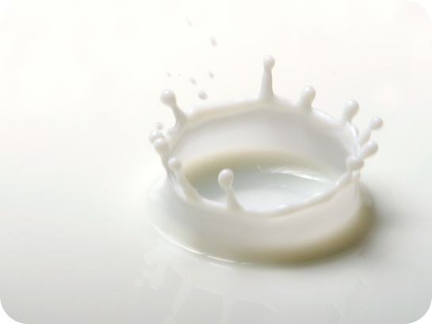

Fruit and Vegetables

Milk

 

Yoghurt

Bread

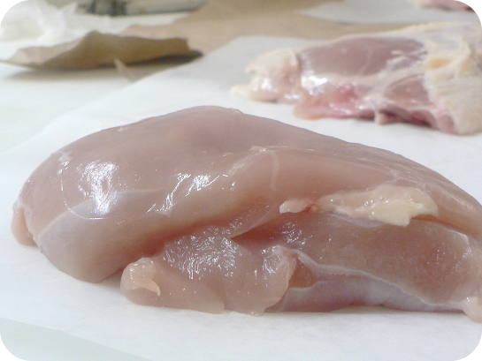 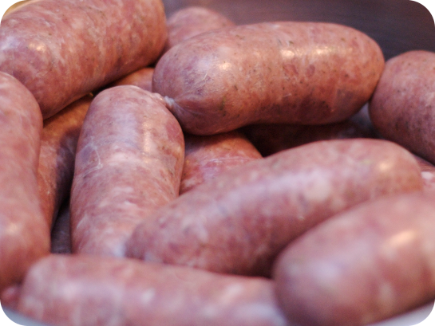

Chicken

Sausages



## SH2 - Class Discussion - Answers

### Answers

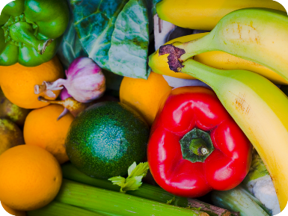

Fruit and Vegetables: Most of the microbes found on fruit and vegetables are harmless, but sometimes harmful microbes can be found in the soil in which they are grown. It is therefore important to wash all fruit and vegetables before cooking and/or eating them.

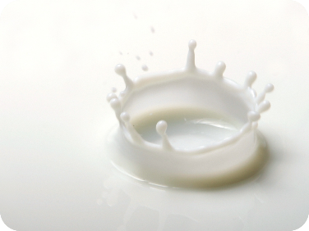

Milk: Fresh milk contains *Lactobacillus* Bacterium which help us digest food. There can also be harmful microbes that are removed when the milk is heated up (pasteurised) before it is sent to the shops.



Yoghurt: Yoghurt usually contains *Lactobacillus*

Bacterium which help us digest food.



Bread: The yeast *Saccharomyces* cerevisiae

helps bread to rise.

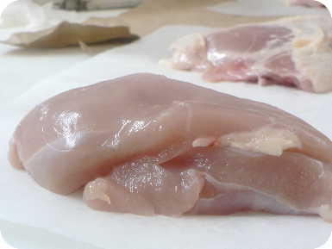

Raw Chicken: Raw chicken may contain

*Salmonella, E. coli* or *Campylobacter* Bacterium,

all of which can cause food poisoning in humans.

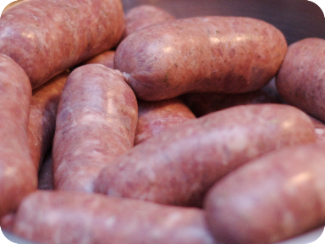

Raw Sausages: Raw meat may contain

*Salmonella, E. coli* Bacterium which can cause

food poisoning in humans.