

## SH3 – Fridge Raiders



### Fridge Raiders



## SH4 – Fridge Raiders

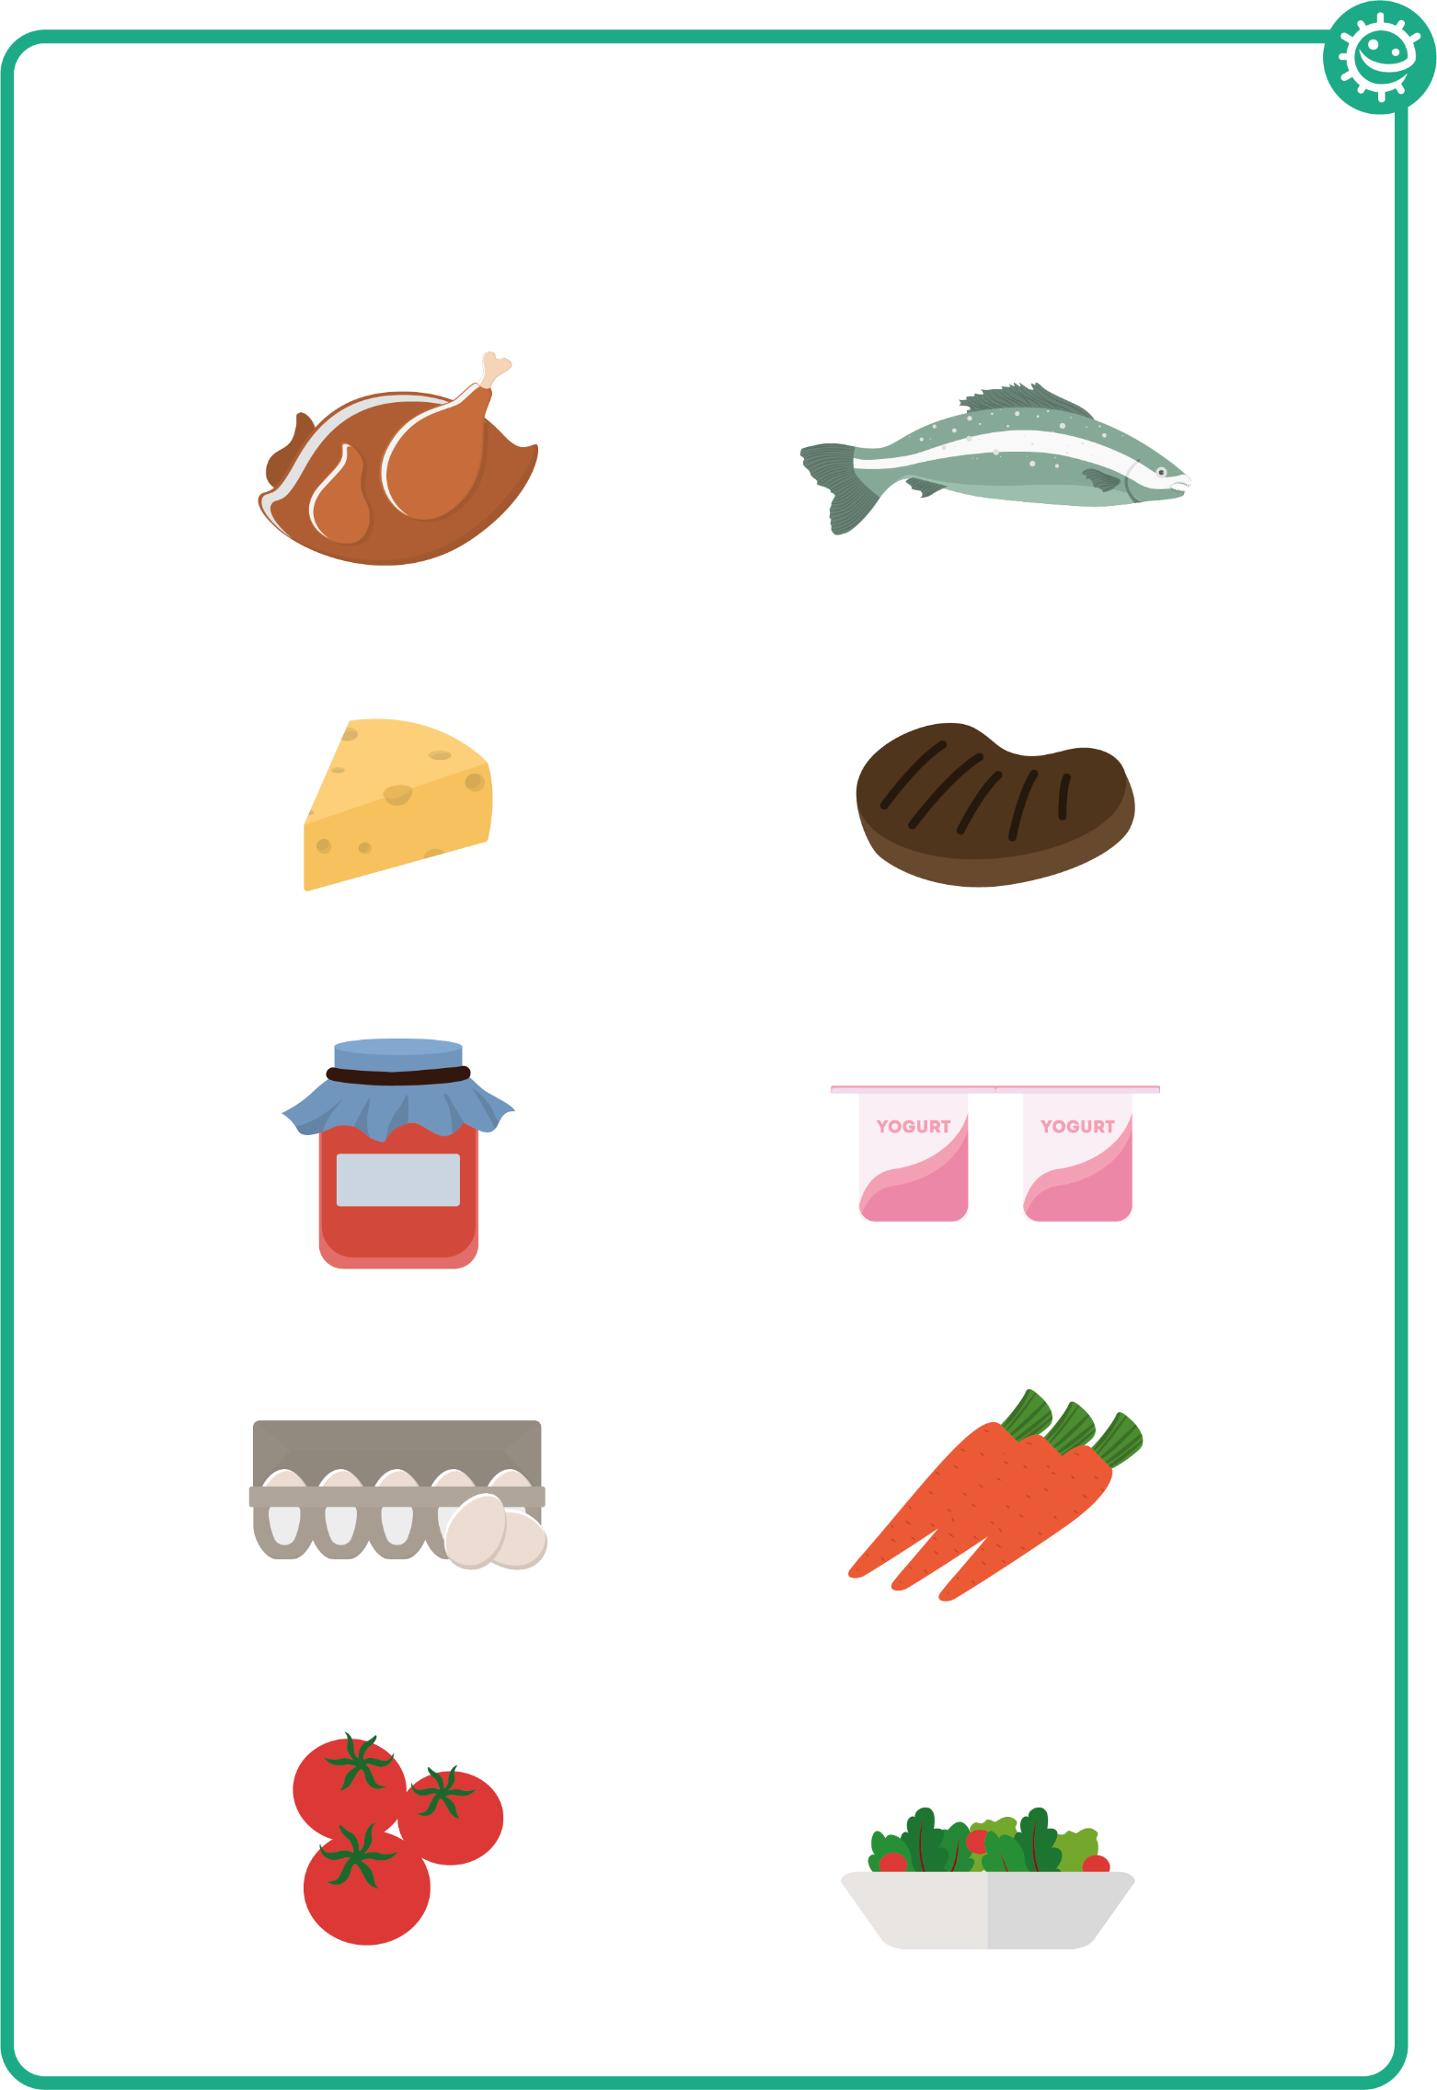

### Fridge Raiders