

## SW2 - Spot the Mistakes – low ink

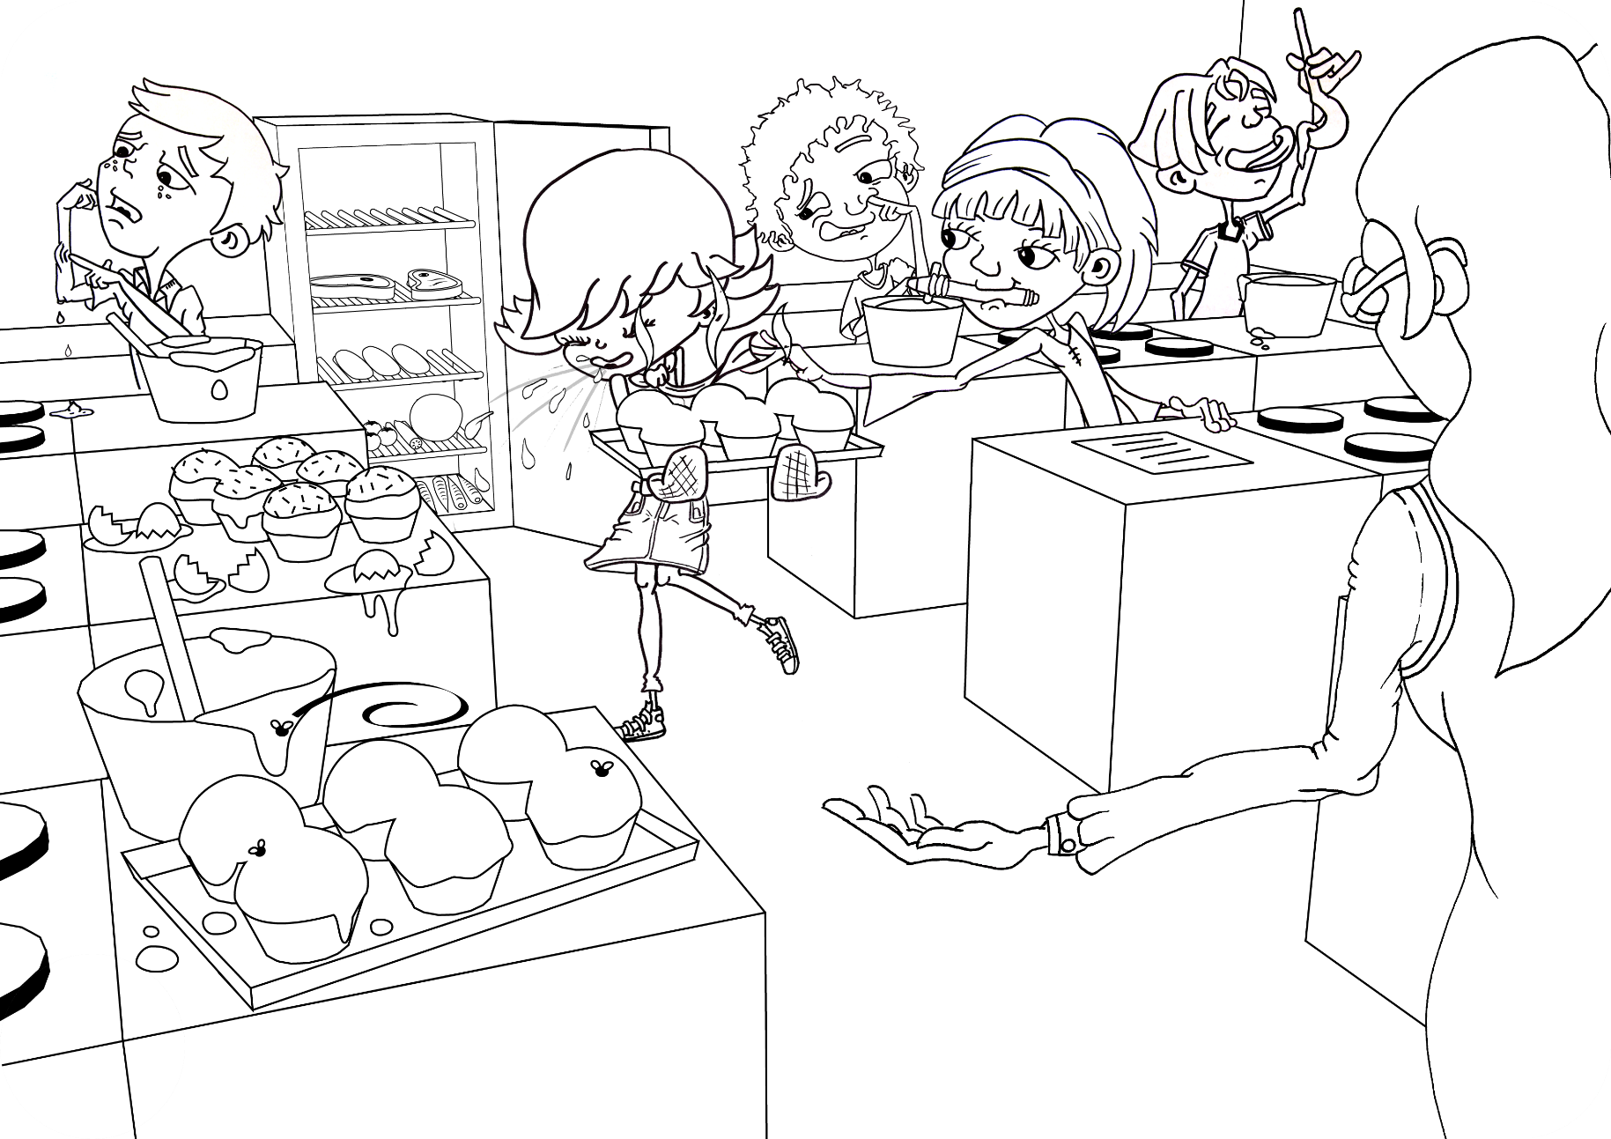

Can you circle 9 things that the students in this cookery class should not be doing and why?



## SW2 - Spot the Mistakes – high ink

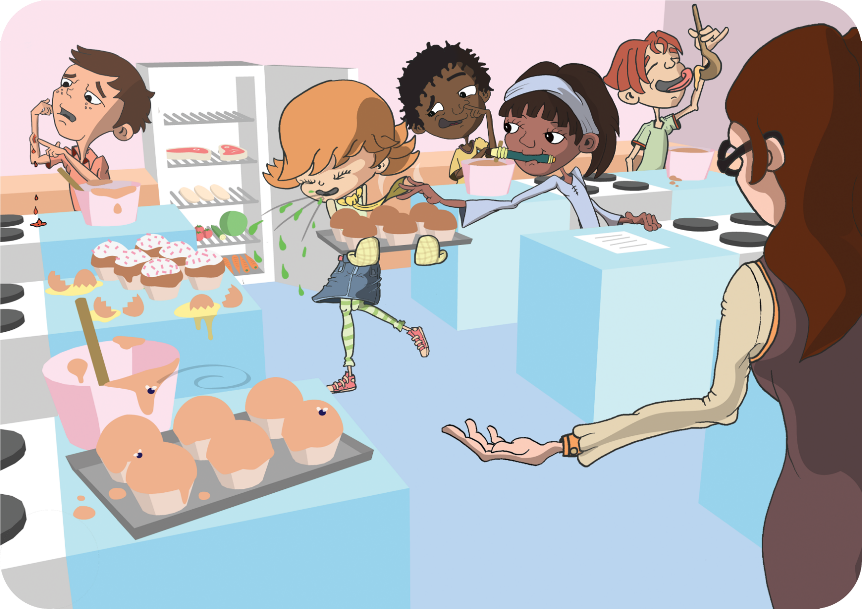

Can you circle 9 things that the students in this cookery class should not be doing and why?