Teacher Refresher – Food Hygiene
Key Stage 2
Harmful microbes found in food can lead to food poisoning e.g. bacterial species such as Salmonella, E. coli and Campylobacter are commonly found on raw meats and can cause diarrhoea and vomiting in humans and sometimes even death – though this is rare. The symptoms of foodborne illness usually start within a few days of eating the food that caused the infection. They are usually better within a week and can include stomach pains, diarrhoea, vomiting, nausea, general fatigue/ache/chills and fever. Not everyone will experience these symptoms, but they can usually be treated at home.
Useful microbes can be used to make food and drink, e.g. the yeast Saccharomyces cerevisae is used to make bread and beer. Lactobacilli bacteria are used in yoghurt and cheese making.
Food spoilage is the deterioration of the colour, texture and flavour of food. It can be caused by many things, including microbes. For example, the fungus Rhizopus stolonifer causes bread mould. Microbes that cause foodborne illness may or may not cause food spoilage.
There are four key ways you can prevent food poisoning and food spoilage:
- Cleaning ‘as you go’ during food preparation to avoid the build-up of mess and prevent bacteria from spreading.
- Cooking food until it has reached 70°C and stayed at that temperature for 2 minutes. General advice is that white meat/mince should be steaming hot and cooked all the way through (juices run clear).
- Chilling, including cooling it down quickly to stop microbes from multiplying and storing food correctly. Refrigerators should be kept ≤4°C.
- Preventing cross-contamination of harmful microbes found on food spreading to other foods (for example via our hands or kitchen utensils), which then cause illness when those foods are eaten.
One of the key moments for hygiene is when handling and preparing raw foods, particularly poultry. Remember that you should not wash raw chicken or other meats before cooking them, as this can splash microbes onto surfaces or other foods and increase the risk of foodborne illness.
Labels placed on foods are used to determine when it is safe to eat the food, or when the quality of the food is at its best. ‘Use by’ refers to when the food is still safe to eat. Food should not be consumed after this date. ‘Best before’ refers to when the food will be at its best quality, but it is worth noting that consumption after this date should still be safe.

SH2 - Class Discussion - Answers

Answers
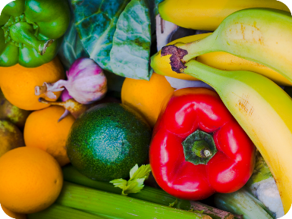
Fruit and Vegetables: Most of the microbes found on fruit and vegetables are harmless, but sometimes harmful microbes can be found in the soil in which they are grown. It is therefore important to wash all fruit and vegetables before cooking and/or eating them.

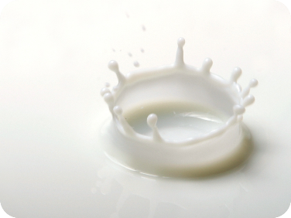
Milk: Fresh milk contains Lactobacillus Bacterium which help us digest food. There can also be harmful microbes that are removed when the milk is heated up (pasteurised) before it is sent to the shops.

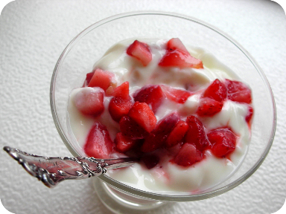
Yoghurt: Yoghurt usually contains Lactobacillus
Bacterium which help us digest food.

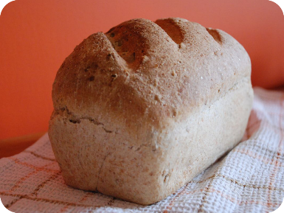
Bread: The yeast Saccharomyces cerevisiae
helps bread to rise.

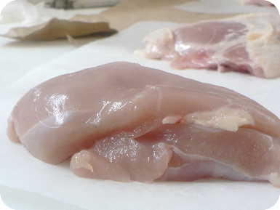
Raw Chicken: Raw chicken may contain
Salmonella, E. coli or Campylobacter Bacterium,
all of which can cause food poisoning in humans.

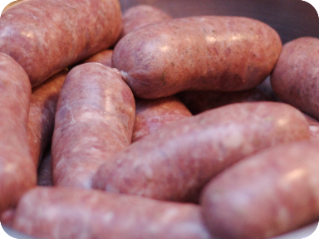
Raw Sausages: Raw meat may contain
Salmonella, E. coli Bacterium which can cause
food poisoning in humans.

TS1 – Fridge Raiders
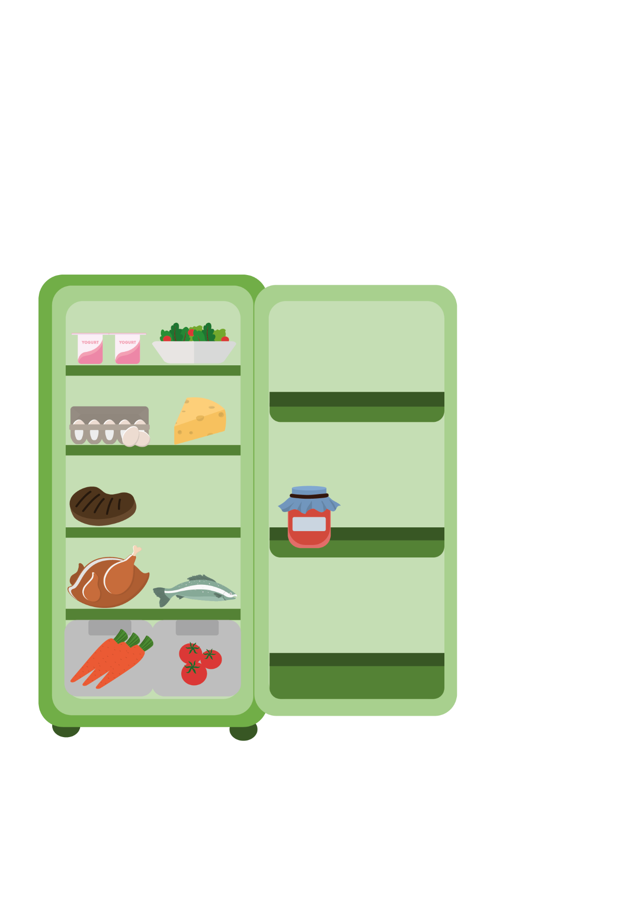

Fridge Raiders – Answer Sheet

Cooked meat should be
covered and stored away
from raw meat
Pre-prepared food, such as
this salad, should be covered
and kept in the fridge until use

Some jars of food,
for example jam,
need to be stored
in the fridge once
opened

Raw meat and fish should be covered and kept on the bottom shelf in the fridge
Store fruit and vegetables and salad in the draw at the bottom of the fridge

TS2 - Spot the Mistakes – Answers

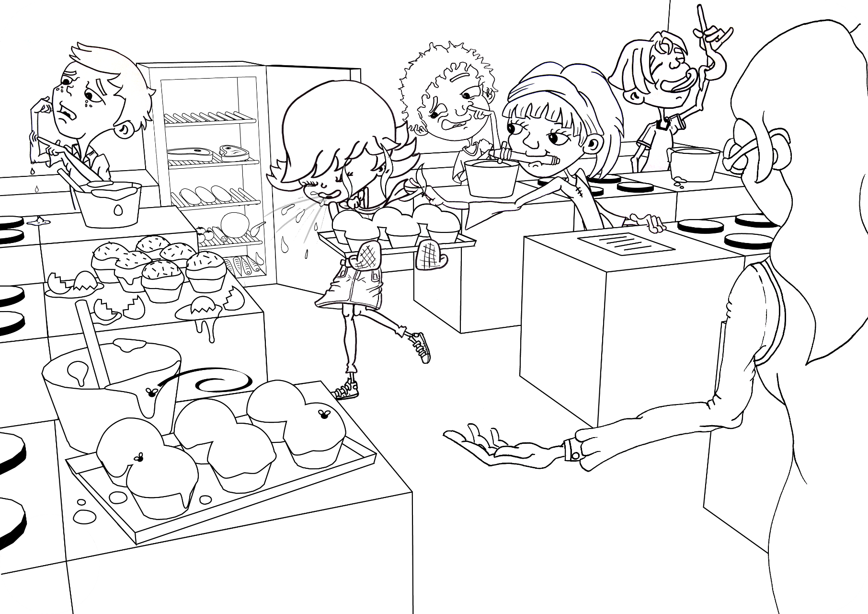

SH4 Fridge Raiders
Also available as TS1
- Cooked meat should be covered and stored away from raw meat
- Pre prepared food, such as salad, should be covered and kept in the fridge until use
- Some jars of food, for example jam, need to be stored in the fridge once opened
- Raw meat and fish should be covered and kept on the bottom shelf in the fridge
- Store fruit and vegetables and salad in the draw at the bottom of the fridge

SW3 Label Sort

Use by
These dates are seen on food that goes off quickly, such as meat products and ready prepared salads. Don’t use any food or drink after the end of the date on the label, even if it looks and smells fine. Eating food after this date could put your health at risk.

Best Before
These dates are about quality not safety. This food will taste its best before the date shown. Eating it after this date will not mean you will get ill but the flavour might not be as good. These dates appear on a wide range of frozen, dried, tinned and other foods.

Display until
Shops often use these dates on their shelves, mainly for stock purposes. These are not required by law and are instructions for shop staff, NOT for shoppers.

Consume within 3 days of opening
This label means that food should be eaten within the amount of days it says on the packaging. After this date the food may not be safe to eat.

Keep refrigerated once opened
This label means that once you have removed the packaging and exposed the food to the air it should be refrigerated so to stop microbes growing.

SW1 Food Hygiene Quiz

Match the definition
Best before:
The food is safe to eat after this date but may no longer be its best quality

Use by:
Food is safe to eat up until this date but should not be eaten after it

Food spoilage:
The deterioration of colour, texture, and flavour of food

Which of the following is not one of the four key ways you can prevent food poisoning?
Using the same chopping board and utensils during food preparation

What infections can you get from poor hand washing? (1 point)
All of the above

