

## TS1 – Fridge Raiders

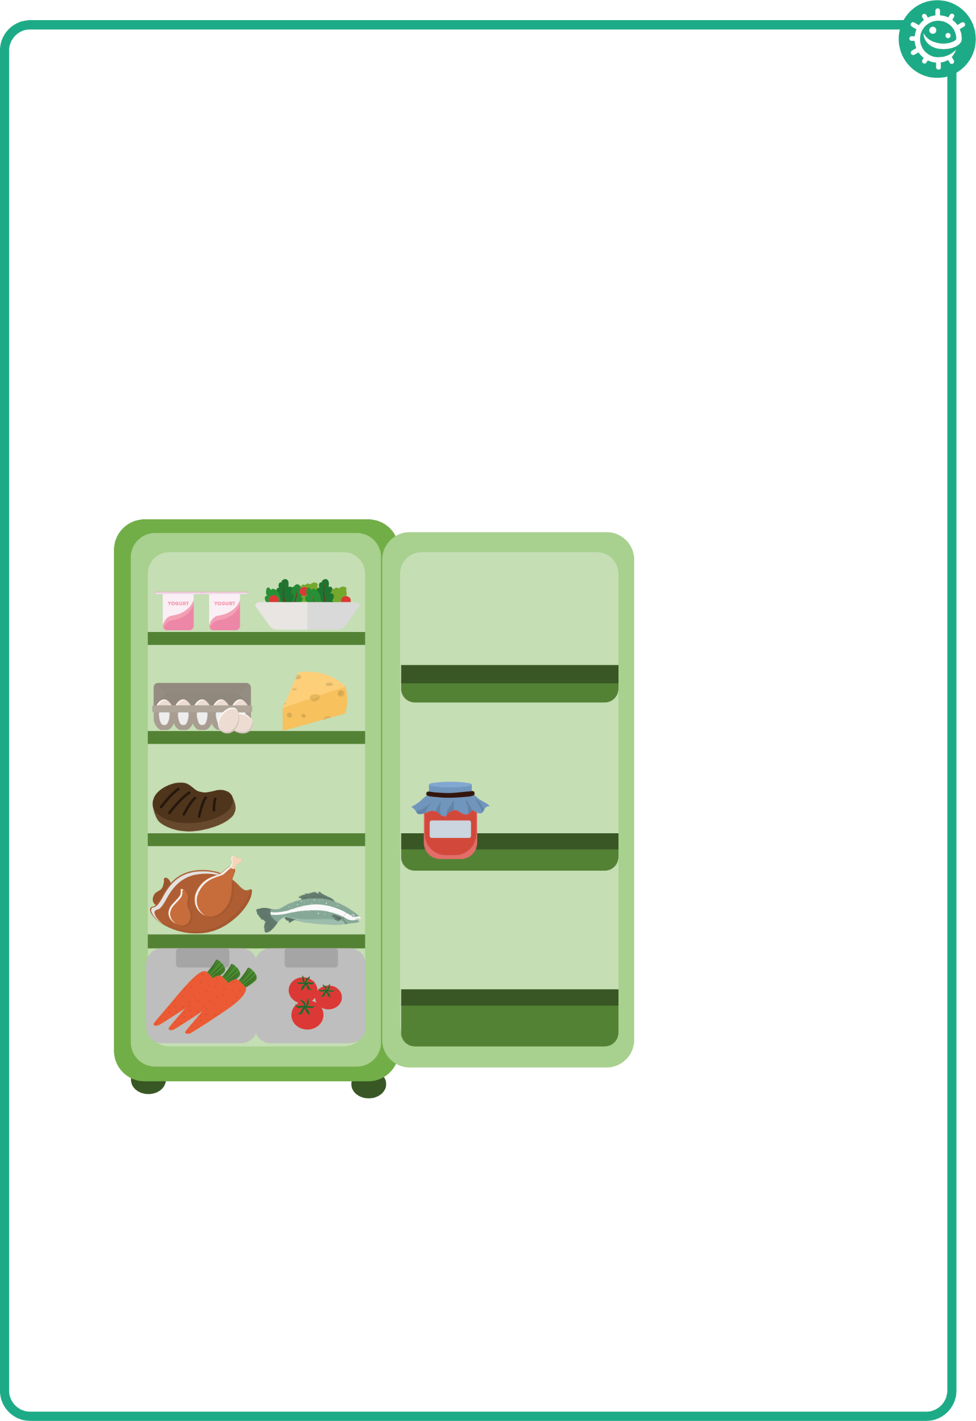

### Fridge Raiders – Answer Sheet

Cooked meat should be

covered and stored away

from raw meat

Pre-prepared food, such as

this salad, should be covered

and kept in the fridge until use

Some jars of food,

for example jam,

need to be stored

in the fridge once

opened

Raw meat and fish should be covered and kept on the bottom shelf in the fridge

Store fruit and vegetables and salad in the draw at the bottom of the fridge