# Spread of Infection: Hand Hygiene



**Key Stage 2**

# Lesson 4: Hand Hygiene

By taking part in a classroom experiment, students learn how microbes can spread from one person to another through touch and why it is important to wash hands properly.

## Learning Outcomes

### All students will:

* Understand that infection can be spread through unclean hands.
* Understand that hand washing can prevent the spread of infection.
* Understand when and how to wash hands.

### Most students will:

* Understand why we should use soap to wash our hands.
* Understand that washing hands is one of the best ways to prevent the spread of microbes

## **Curriculum Links**

### PHSE/RHSE

* Health and prevention

### Science

* Working scientifically
* Living things and their habitats
* Animals, including humans

### English

* Reading & comprehension

### Design and Technology

* Cooking and nutrition

### Art and Design

* Painting
* Recording observations

** Lesson 4: Hand Hygiene**

## **Resources Required**

### Main Activity: Healthy hands

#### Per group

* Copy of SH1
* Copy of SH2
* Basin (or sink)
* Hand soap
* Paper towels
* Pens
* Water
* Oil based UV gel or powder and UV lamp or cooking oil and cinnamon/eco-friendly glitter

#### Per student

* Copy of SW1
* Copy of SW2

### Activity 2: What have we missed

#### Per group

* Copy of SH2
* Blank paper
* Finger or body paints (non-toxic and washable)
* Smocks/aprons to cover clothing for younger groups
* Hand washing facilities or basin with soap and water
* Paper towel for drying hands

### Extension Activity 1: Fill in the Blanks

#### Per student

* Copy of SW3

### Extension Activity 2: Hand Hygiene Quiz

#### Per group

* Copy of SW4

### Extension Activity 3: Sequencing Activity

#### Per student

* Copy of SH3

## Supporting Materials

* SH1 How Clean are Your Hands
* SH2 Hand Washing Poster
* SH3 Washing Your Hands Sequencing Activity
* SW1 Student Recording Sheet
* SW2 Hand Print Student Worksheet
* SW3 Hand Hygiene Fill in the Blank Worksheet
* SW4 Hand Hygiene Quiz

## Advanced Preparation

### Main Activity: Healthy Hands

1. Arrange four desks side by side for the 4 stations. Each desk should contain one of the following:
   1. A sign reading ‘No hand washing’
   2. A basin of water, paper towels and a sign reading ‘Wash for 3 seconds’
   3. A basin of water, paper towels and a sign reading ‘Wash for 20 seconds’
   4. A basin of water, hand soap, paper towels and a sign reading ‘Wash in Water and Hand Soap for 20 seconds’

### Activity 2: What Have We Missed?

For each student prepare:

1. Smock or shirt to cover clothing
2. A small dollop of finger paint
3. Basin with water and soap if hand washing facilities not available (could be used for group of 2-3).

****. **Lesson 4: Hand Hygiene**

## Key Words

Bacteria

Hygiene

Infection

Microbe

Soap

Transfer

## Modifications

1. If UV gel or powder and a UV lamp are unavailable, ask the students at the front to cover their hands in cooking oil or an equivalent non-harmful oil and sprinkle well or cover with cinnamon or eco-friendly glitter.
2. Students with additional needs: The use of eco-friendly glitter allows the students to feel the 'microbes' on their skin. It might help students if you demonstrate what will happen in this activity.

## Weblinks

## e-bug.eu/eng/KS2/lesson/ Hand-HygieneHealth & Safety

If social distancing does not allow students to shake hands, gel could be transferred by having students touch objects and see how the gel transfers from hands to surfaces (or vice versa), with the hand washing and cleaning of objects to follow. If appropriate, this can be combined with a PE game where you cover a ball/baton with gel, play a game and then show the students how the gel from the object has spread around by the room by touch. 2. It is essential to ensure that use of the lamp is supervised and that pupils place their hands under the UV radiation for as short a time as possible. It is also vital that pupils do not stare directly at the UV lamp; the eyes are most at risk from extended viewing of UV radiation. Depending on the design of the UV lamp that is available, it should be held firmly, for example with retort stands and clamps, so that the radiation shines downwards onto the bench and that the lamp cannot be moved and shone into pupils’ faces.

For safe microbiological practices in the classroom consult CLEAPPS

[www.cleapps.org.uk](http://www.cleapps.org.uk)

## Introduction

## Begin the lesson by asking how many students have washed their hands today. Ask them why they washed their hands (to wash away any dirt or microbes that might be on their hands) and what would happen if they didn’t wash away the microbes (they might get ill if any harmful microbes from their dirty hands gets in their mouth or an open cut, or they could pass them on to someone else).

## Tell the students that we use our hands all the time, they are naturally covered with microbes that live in our bodies and pick up millions of microbes from the environment every day. Although many of these microbes are harmless, some could be harmful. Explain to the students that we spread microbes to our friends and others through touch, and this is why we wash our hands. One study found that people touch their face 23 times per hour, about 280 times a day. Explain that touch is an important sense to give information to our brain, but we should be aware of how easy it is to spread microbes when our hands are dirty.

## Explain to students that they are going to carry out an activity to show how best to wash their hands with soap and water and remove any of the harmful microbes which may be on their hands.

## Activity

### Main Activity: Healthy Hands

1. Divide the class into four equal groups.
2. Ask each student to stand in a row one behind the other and assign groups as follows:
   1. No hand washing
   2. Wash hands in water for 3 seconds
   3. Wash hands in water for 20 seconds
   4. Wash hands in water with soap for 20 seconds
3. Ask the first person in each group to close their eyes and cover their hands in UV gel or powder. This is to avoid students washing their hands more thoroughly than they usually would. Ask the lead person to wash their hands according to the group they are in.
4. Once completed, they should open their eyes, turn around and shake hands with the person behind them. It is important that they shake hands firmly and well. The second person should then shake hands with the third person and so on until everyone in the group has shaken hands with the person in front of them.
5. When the task is complete, turn down the lights and shine the UV lamp over everyone’s hands, starting with group A. Students should notice the difference in the number of microbes on the hands of students in different groups.
6. Ask students to complete SW1 to record the results of the experiment. Provide students with SW2 and ask them to colour the hands to replicate the results of the experiment. SH1 can be used as a guide.
7. Ask students to follow a teacher demonstration of the six-step hand washing technique using SH2 six steps poster. Ensure that students thoroughly wash their hands with soap and water.
8. Explain that hand sanitiser can be applied using the same steps but then needs to be allowed to dry and is not washed off like soap. Remember to shake the UV gel or powder before starting and to change the water if it starts to get murky.

### Activity 2: What have we missed?

1. Ask students to wear the protective clothing and sit down.
2. Explain students will learn the best way to wash their hands to remove germs by pretending that paint is soap.
3. Put a small squirt of paint in each of the student’s hands. Ask the groups to close their eyes and pretend they are washing their hands. Only give them about 5 seconds to do this and explain that this is to see what happens if we wash our hands for too short a duration.
4. Ask students to open their eyes and hold up their hands.
5. Discuss what part of their hands is missing the soap. Ask them how they think they could make sure that all their hands are covered with soap, so the germs can be washed away/killed.
6. Use the six steps of hand washing poster (SH2) to explain how to wash hands and for how long. Hand sanitiser can be applied using the same steps but then needs to be allowed to dry.
7. At this point students may want to make handprints on a blank piece of paper.
8. Have the students 'wash' with the paint on their hands again (may need to provide additional paint) and see if they cover more of their hands with the soap when they follow the six steps. They can make additional handprints if desired.
9. Repeat the six-step hand washing technique.

## Discussion

Lead the discussion to reflect on the learning objectives:

1. Microbes spread very easily from you to other people.
2. The best way to stop harmful microbes spreading to others is by washing our hands.
3. Use soap when washing hands, and wash all parts of our hands, including thumbs. Remember not to splash and dash! Use a song of your choice to time your hand washing.
4. If soap and water isn’t available, hand sanitiser is also effective. You should apply following the six steps and allow to air dry.

Ask the following questions to discuss what the group has learnt:

1. What have you learnt today?
2. How has the activity changed the way you wash your hands?
3. When is it important to wash your hands?

## Extension Activities

### Fill in the Blanks

Provide students with SW3 and ask them to fill in the blanks using the correct words provided. Students can complete this activity individually in the classroom or as homework. Answers are available on the e-Bug website.

### Hand Hygiene Quiz

SW4 is a fun consolidation quiz. Allocate students to groups of 3 or 4 and provide one quiz sheet per team. The team with the most points wins. Answers are available on the e-Bug website.

### Sequencing Activity

Students can use SH2 as a guide to order the cards in SH3. Ask students to place the cards in the correct hand washing order as a useful way to support learning

## Learning Consolidation

At the end of the lesson, ask the class to answer the following questions.

1. What song will you choose to use when washing your hands? How many steps are there to wash every part of your hands?

Answer: Six steps

1. What are the key moments in the day that you must wash your hands?

Answer: Before eating, after using the toilet, after touching animals, after coughing, sneezing or blowing your nose, if you are ill or have been around ill people, when you get home or go into another place like school

1. What can you use if you are not able to wash your hands with soap and water?

Answer: Hand sanitiser



## SH1 – How Clean are Your Hands Handout

### How Clean are Your Hands?

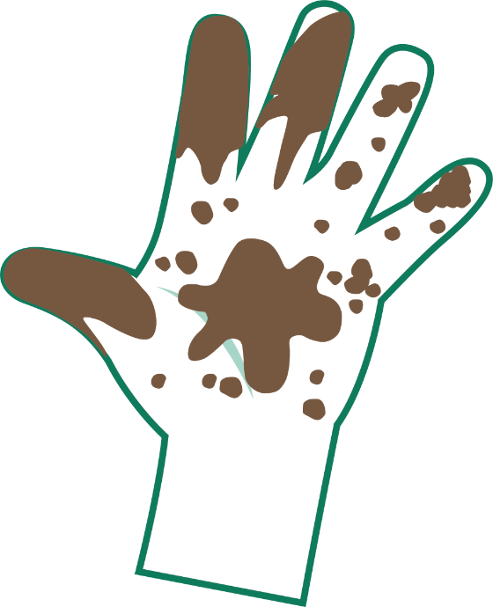 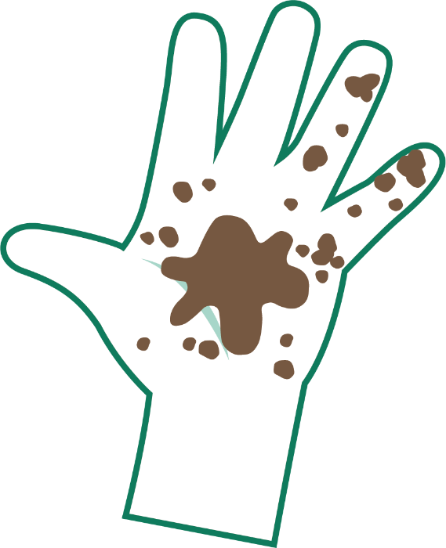

Very Dirty

Dirty

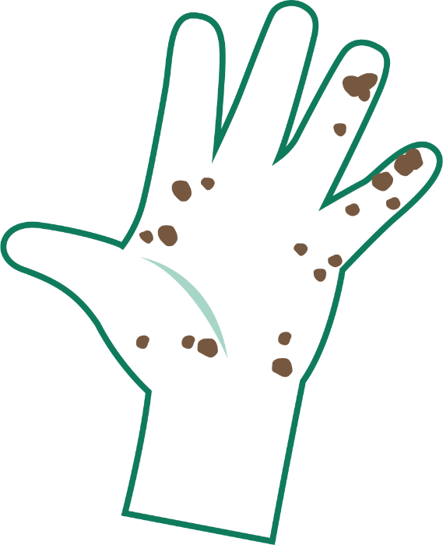 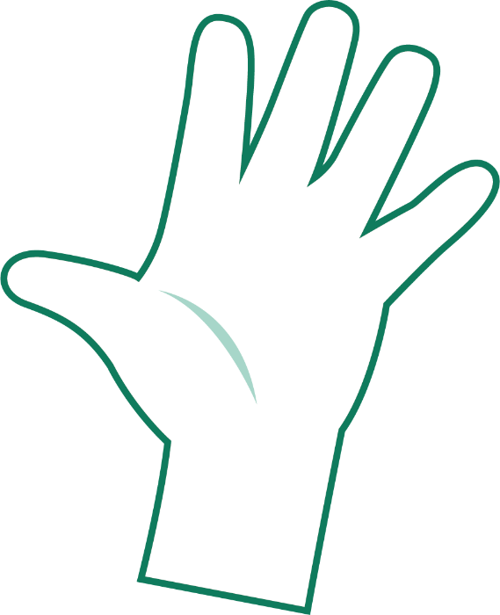

A Bit Dirty

Clean



## SH2 – Hand Washing Poster

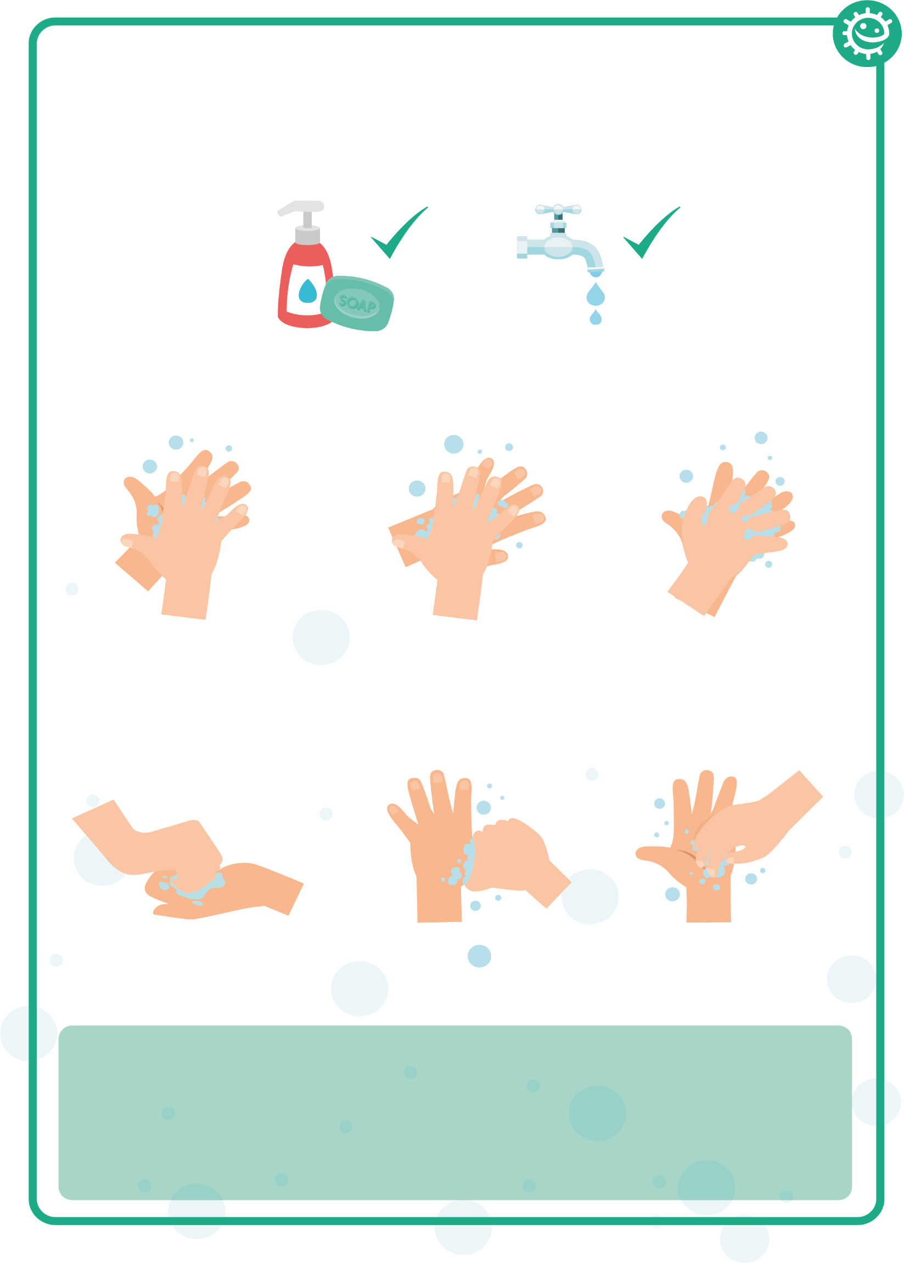

1

2

3

4

5

6

Palm to palm

Back of hands

Between fingers

Back of fingers

Thumbs

Tip of fingers

### Wash your hands with soap and water for 20 seconds

To help keep time, sing ‘Happy Birthday’ twice

## SH3 - Washing Your Hands Sequencing Activity

**Back**

**of fingers**

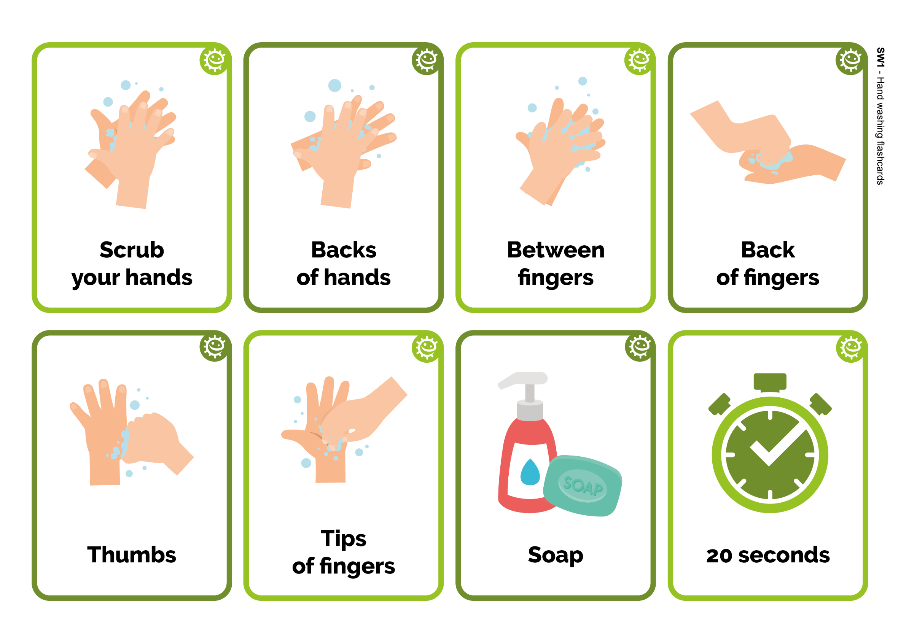

Back

of fingers



20 seconds



Between fingers



Soap

**Backs**

**of hands**



Backs

of hands



Tips of fingers

Scrub

your hands

Scrub

your hands



Thumbs





## SW1 - Student Recording Sheet 1/2

### Healthy Hands Procedure

|  |  |  |  |  |  |
| --- | --- | --- | --- | --- | --- |
|  | Student 1 | Student 2 | Student 3 | Student 4 | Student 5 |
| No wash (control) |  |  |  |  |  |
| Wash for 3 secs |  |  |  |  |  |
| Wash for 20 secs |  |  |  |  |  |
| Wash with soap and water for 20 secs |  |  |  |  |  |

After the activity, use the ‘How Clean are Your Hands?’ guide to write your results in the box provided and see how far the microbes have spread

**After washing (or not) and shaking hands**

On the next page draw where you saw microbes after hand washing and shaking, for your group only.

The method of hand washing that removed most microbes from the lead person was:

* Wash for 3 seconds
* Wash for 20 seconds
* Wash for 20 seconds with soap & water

The method of hand washing that removed fewest microbes from the lead person was:

* Wash for 3 secs
* Wash for 20 secs
* Wash for 20 secs with soap & water

The method of hand washing which spread the most microbes along the line was:

* Wash for 3 secs
* Wash for 20 secs
* Wash for 20 secs with soap & water

The method of hand washing which removed the fewest microbes along the line was?

Draw a graph of how far the microbes spread for all four groups (including control).



## SW1 - Student Recording Sheet 2/2



Fascinating Fact

90% of germs on the hand are found under the nails!

My conclusions:

1. What is the best way of getting rid of microbes from our hands?

_________________________________________

1. What difference does using soap make?

_________________________________________

1. When should we wash our hands?  
   _________________________________________



## SW2 - Handprint Student Worksheet

Student 3

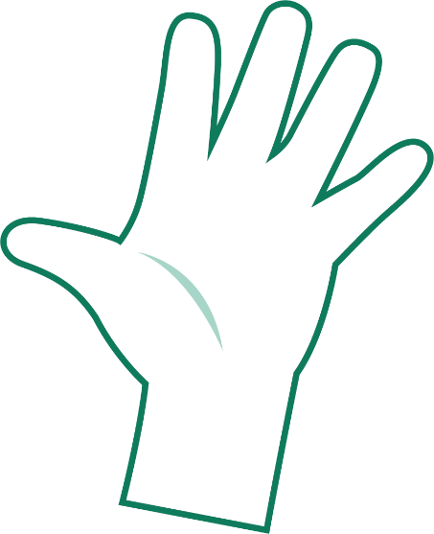

Student 5



Student 2



Student 4



Student 1



## SW3 - Hand Hygiene Fill in the Blanks Worksheet

### Complete the sentences below using the key words

Our hands are naturally covered with _ _ _ _ _ _ _ _ that live on our

bodies and pick up millions more from our environment everyday.

Microbes can _ _ _ _ _ _ easily from child to child when we touch each other.

Although some microbes can be useful, others can be harmful and cause _ _ _ _ _ _ _ _ _.

_ _ _ _ _ _ _ _ _ _ _ is the most effective way of reducing and preventing the spread of infection.

Washing our hands with _ _ _ _ and water at key moments removes any harmful microbes we pick up on our hands from our surroundings.

We should wash our hands for _ _ _ _ _ _ _ _ _ , which is the length of the happy birthday song twice.

Washing hands in water alone will only remove _ _ _ _ and

grime.

If soap is unavailable, we should use _ _ _ _ _ _ _ _ _ _ _ _ _ as long as there is no visible dirt/other substance on hands.

Key words:

Hand sanitiser, Microbes, Dirt, Infection, Soap, Hand washing,

Spread, 20 seconds



## SW4 - Hand Hygiene Quiz

### Quiz: Hand Hygiene

Please tick as many answers as appropriate

Name_______________________

How can you spread microbes to others? (2 points)

* By touching them
* By looking at them
* By speaking to them on the phone
* By sneezing

Why should we use soap to wash our hands? (2 points)

* It helps remove invisible microbes too small to be seen by our eyes
* It breaks up the oil on our hands which trap microbes
* It keeps our hands moist
* It doesn’t matter if we use soap or not

Which is NOT one of the 6 steps of hand washing?

(1 point)

* Palm to palm
* The thumbs
* Arms
* In between fingers

Who might be at risk as a result of you not washing your hands properly? (1 point)

* You
* Your family
* Your friends
* All of the above

When should we wash our hands? (3 points)

* After stroking a pet
* After sneezing or coughing
* After watching TV
* After using the bathroom or changing a soiled nappy

How can you stop harmful microbes from spreading?

(2 points)

* Do nothing
* Wash hands in water
* Use hand sanitiser if soap and water are not available
* Wash your hands with running water and soap

After we sneeze into our tissue, we should: (2 points)

* Wash our hands immediately
* Dry our hands on our clothes
* Take antibiotics
* Put the tissue straight into the bin

How long should we wash our hands for? (1 point)

* 10 seconds
* 20 seconds (length of Happy birthday song twice)
* 1 minute
* 5 minutes