

## SH2 – Hand Washing Poster

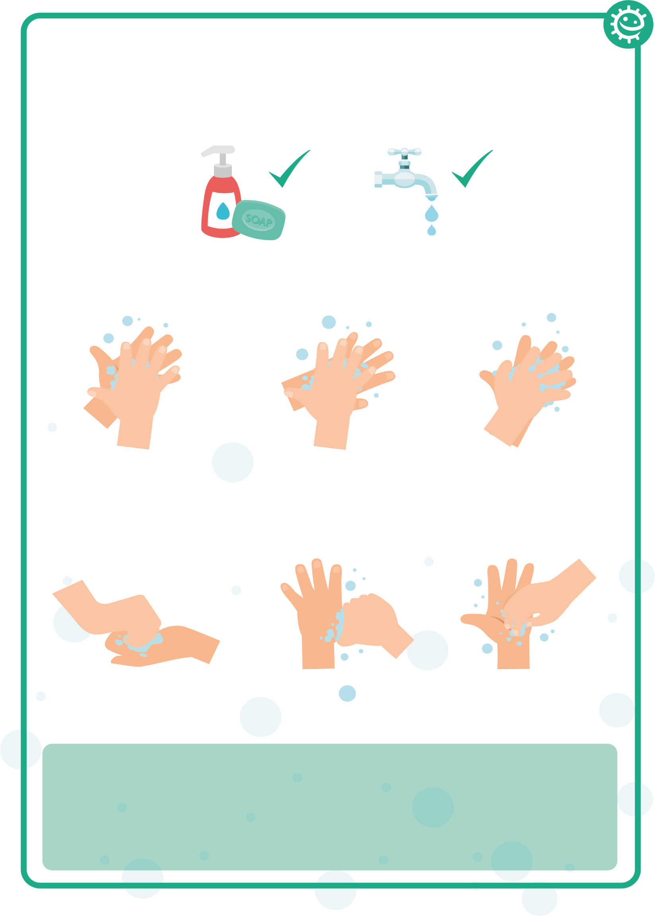

1

2

3

4

5

6

Palm to palm

Back of hands

Between fingers

Back of fingers

Thumbs

Tip of fingers

### Wash your hands with soap and water for 20 seconds

To help keep time, sing ‘Happy Birthday’ twice