Teacher Refresher – Harmful Microbes
Key Stage 2
Micro-organisms, more commonly known as ‘germs’, ‘bugs’ or ‘microbes’, are tiny living things too small to be seen with the naked eye. They are found almost everywhere on Earth. It is important to clarify that microbes are not innately ‘useful’ or ‘harmful’. Rather that some microbes can be useful to humans whilst others can be harmful depending on the situation. For example, the mould Aspergillus is used to help make chocolate, however can cause harm to humans if inhaled into the lungs. Although extremely small, microbes come in many different shapes and sizes. The three groups of microbes covered in this resource are viruses, bacteria and fungi.
Viruses are the smallest of the three and often cause illnesses like coughs and colds. They need a ‘host’ cell in order to survive and reproduce. Once inside the host cell, they rapidly multiply and destroy the cell in the process. One type of virus is Rhinovirus, also known as the common cold virus. There are over 25 different species that can cause the common cold.
Bacteria are single-celled organisms that are smaller than fungi but larger than viruses. They can be divided into three main groups by their shapes – cocci (balls), bacilli (rods) and spirals. Cocci can also be broken down into three shapes - clusters, chains or groups of two. These shapes can be used to help identify the type of infection a patient has. If a single bacterial cell was scaled up 5,000 times it would be the size of a garden pea.
Fungi are the largest of the three microbes and are multi-cellular organisms (made up of more than one cell). Some fungi are useful, and some can be harmful to humans. For example, Saccharomyces is a yeast that is used to help bread rise. Fungi obtain their food by either decomposing dead organic matter or by living as parasites on a host. Fungi secrete secondary products while feeding that cause swelling and itching, such as athlete’s foot.
Most microbes are not harmful, and it is important to remind students of this. Some microbes are only harmful to humans when taken out of their normal environment. Escherichia coli (E. coli) is commonly found in our gut and is harmless, but if it is transmitted to the urinary tract it can cause bladder and kidney infections.

Useful microbes
One of the main ways in which microbes are beneficial is in the food industry. Cheese, bread, yoghurt, chocolate, vinegar and alcohol are all produced through the growth of microbes. The microbes used to make these products cause a chemical change known as fermentation – a process by which the microbes break down the complex sugars into simple compounds like carbon dioxide and alcohol. Fermentation changes the product from one food to another.
When the bacteria Streptococcus thermophilous or Lactobacillus bulgaricus are added to milk they consume the sugars during growth, turning the milk into yoghurt. So much acid is produced in fermented milk products that few potentially harmful microbes can survive there.
Lactobacillus are generally referred to as a good or ‘friendly’ bacteria. The friendly bacteria that help us digest food have been termed probiotic bacteria, literally meaning ‘for life’. It is these bacteria that we find in yoghurts and probiotic drinks.
Yeast, Saccharomyces cerevisiae, is used to make bread and dough products through fermentation. In order to multiply and grow, yeast needs the right environment, which includes moisture, food (in the form of sugar or starch) and a warm temperature (20° to 30°C is best). As the yeast ferments it gives off gasses which get trapped in the dough and the lump of dough expands.

Harmful Microbes
Some microbes can be harmful to humans and can cause disease: the Influenza virus causes the flu (short for Influenza – other respiratory tract infections are common cold or influenza-like illness), Campylobacter bacteria can cause food poisoning and the dermatophyte fungi, such as Trichophyton, can cause diseases such as athlete’s foot and ringworm. Microbes like these are known as pathogens. Each microbe can make us ill in different ways.
When harmful bacteria reproduce in our bodies, they can produce harmful substances called toxins which can make us very unwell, fortunately this is rare. Once inside a cell, they multiply until fully grown and leave the host cell. Dermatophytes generally prefer to grow or colonise under the skin and the products they produce while feeding cause swelling and itching. Someone who is ill because of a harmful disease-causing microbe is said to be infected.
Many harmful microbes can pass from one person to another by a number of different routes – air, touch, water, food, aerosols (such as sneezes and water vapour), animals, etc. Diseases caused by such microbes are said to be infectious diseases. In many instances, our normal body flora (microbes) also help prevent harmful microbes growing by either colonising the area so that there is no room for the harmful microbes to grow or by altering the environment. For example, the normal flora in our gut keeps us healthy by preventing harmful bacteria like Clostridiodies difficile from multiplying. When our normal body flora is compromised, Clostridiodies difficile can multiply and cause diarrhoea and other problems in the gut.

TS1 – Class Discussion Teaching Points

Micro-organisms: Harmful Microbes
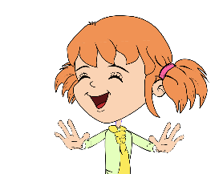
Teaching Points
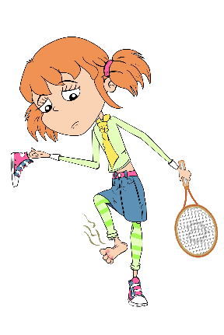
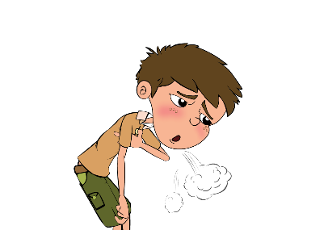
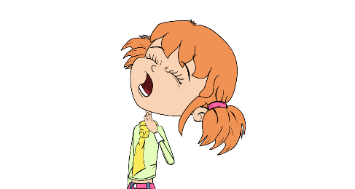
- Eva likes to keep her hands and nails clean. If we look closely at Eva’s hands we can see that they are covered in lots of tiny microbes. These microbes are useful microbes that live on our skin and help keep us healthy.
- Luca is always out playing football and having fun with his friends, however, he doesn’t worry about washing his hands very often. If we look closely at Luca’s hands we can see that they too are covered with lots of tiny microbes although some of these are harmful and could make him very ill if they got inside his body.
- Eva isn’t very well, she has a really sore throat. Sometimes sore throats are caused by coughing and a runny nose, which can make the throat swell up and become quite painful. If this happens then Eva should drink lots of fluids and take painkillers. Sometimes, however, bacteria (e.g. Streptococcus) and viruses can also cause us to have a sore throat.
- In this picture, do you think that Luca is ill because of microbes? The answer is no, Luca has a condition known as asthma which causes him to get out of breath very easily. Asthma is a disease of the lungs and airways but is not caused by microbes. It is important to remember that not all illnesses are caused by microbes.
- What do you think is wrong with Luca in this picture? Poor Luca has eaten undercooked chicken at a BBQ and has now got food poisoning caused by Campylobacter. There are lots of microbes on meat, which although they don’t harm the animal can make us very ill. It is important to cook food properly to kill any harmful microbes which may be present.
- Eva plays tennis and she has sweaty, smelly feet. She is always in a hurry so she doesn’t wash or dry her feet properly. Her feet smell and are also very itchy and swollen in between her toes. This is because fungi known as dermatophytes like to live between the toes, especially if they are damp. They cause a disease known as athlete’s foot which causes your toes to swell up, the skin between them to crack and become VERY itchy and sometimes smelly.

 | ₁C | O | U | G | ₂H
 |  |  |  |  | A
 | ₃S |  |  |  | Y
 | L |  |  |  | F
₄M | E | A | S | L | E | S
 | E |  |  |  | V |  |  | ₅A
 | P |  |  |  | E |  |  | T
 | Y |  | ₆D | I | R | T | Y | H | A | N | D | S
 |  |  |  |  |  |  |  | L
 |  |  | ₇I | N | F | L | U | E | N | Z | A
 |  | ₈S |  |  |  |  |  | T
 |  | P |  |  |  |  |  | E
 | ₉F | O | O | ₁₀D | P | O | I | S | O | N | I | N | G
 |  | T |  | I |  |  |  | F
 |  |  |  | A |  |  |  | O |  | ₁₁V
 |  |  |  | R |  |  |  | O |  | O
 |  |  |  | R |  | ₁₂A | S | T | H | M | A
 |  |  |  | H |  |  |  |  |  | I
 |  |  |  | O |  |  |  |  |  | T
 |  |  |  | E
 |  | ₁₃H | E | A | D | A | C | H | E
SW1 - Harmful Microbes Cross and Wordsearch Worksheet

Bad Bug Challenge
Across:
1. I make you do this when you have a cold to spread microbes
by causing a tickle in your throat
4. I am a viral disease that can give you swollen itchy red spots all over your body.
6. If they are not clean what part of your body can spread microbes from person to person. Washing me gets rid of bad
microbes (2 words)
7. I am a viral disease that will give you headaches, a runny nose and make you hot and sweaty.
9. You will get me if you don’t cook your meat properly or wash your hands after handling raw meat (2 words).
12. I am a disease of the lungs, not caused by microbes. I make you so short of breath that you need to use an inhaler.
13. I am another word for pain in your head

Down:
2. I make your eyes swollen and itchy. I am not caused by a microbe. I am caused by an allergy to pollen.
3. How you feel when your body is fighting infection.
5. I am a fungal infection of your feet. I make your toes itchy. I
spread if you don’t wash and dry your feet well. (2 words).
8. I am often seen on teenager’s faces. I am sometimes caused by microbes on the skin.
10. Bad microbes in your tummy can sometimes cause this. If you don’t wash your hands after going to the toilet it can spread around your school.
11. Watch out. Bad tummy microbes can sometimes take you by Surprise and make you do this.

SW2 - Harmful Microbes Wordsearch Worksheet

Bad Bug Challenge
Can you find all the words associated with Bad Bugs in the word search below? Remember that the words can be horizontal (across), vertical (down) or diagonal (top left to bottom right).
F | C | E | A | R | T | M | Y | Y | U | A | N | S | D | F
F | O | M | G | B | F | L | U | M | B | H | N | H | J | K
Z | L | O | N | Z | R | W | K | A | Y | E | A | E | A | L
F | D | S | D | H | G | D | A | S | T | H | M | A | T | A
V | B | H | N | P | H | N | J | O | H | D | D | D | G | T
V | V | V | A | C | O | U | G | H | N | C | I | A | B | H
M | O | E | S | X | J | I | D | F | B | G | R | C | G | L
E | T | M | M | Z | U | N | S | A | M | A | T | H | A | E
A | N | D | I | A | R | R | H | O | E | A | Y | E | J | T
S | Z | X | C | T | V | B | G | T | N | D | H | J | H | E
L | R | T | A | Y | U | N | I | A | O | I | A | F | G | S
E | Q | W | E | R | I | N | F | L | U | E | N | Z | A | F
S | P | O | T | I | O | P | L | B | K | J | D | G | G | O
A | S | D | M | S | L | E | E | P | Y | E | S | S | F | O
H | A | Y | F | E | V | E | R | N | F | G | N | H | K | T
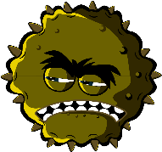
Cough, Cold, Food Poisoning, Dirty Hands, Headache, Hayfever, Asthma, Spot, Flu, Influenza, Athletes Foot, Sleepy, Measles, Vomit

SH3 True/ False Flashcards Answers
Sore throats are always caused by harmful microbes?
False

All Illnesses are caused by microbes?
False

Fungi do not generally kill their hosts
True

Athlete’s foot is caused by fungi?
True

Another name for a harmful microbe is a pathogen?
True

Influenza virus cause the common flu?
True

SW3 Microbes Quiz Answers
Which of these are microbes?
- Bacteria
- Virus
- Fungi
Microbes are found:
- Everywhere
Which foods or drinks are produced through the growth of microbes?
- Cheese
- Bread
- Yoghurt
- Fizzy drinks
What is another word for a harmful microbes?
- Pathogen
Which is the smallest?
- Virus
Microbes:
- Can be harmful or useful
Which of these microbes causes the common cold?
- Virus
Which of these are shapes of microbes?
- All of the above

