

## TS1 – Class Discussion Teaching Points

### Micro-organisms: Harmful Microbes

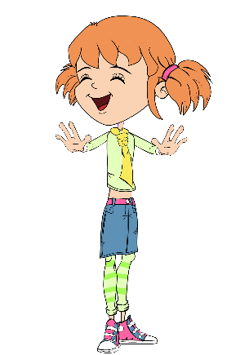

Teaching Points

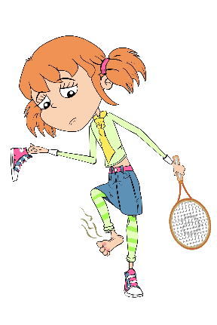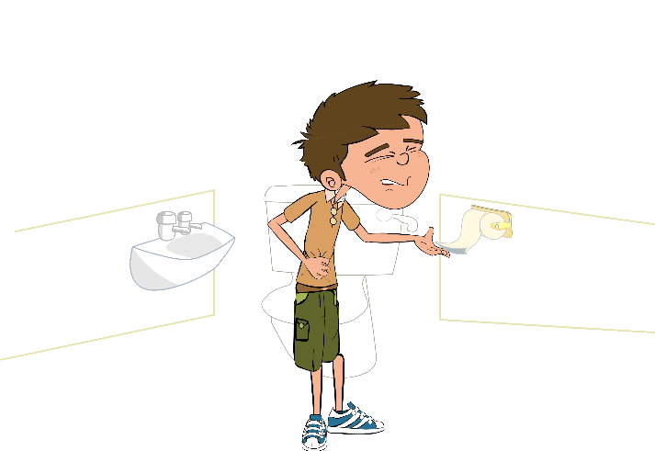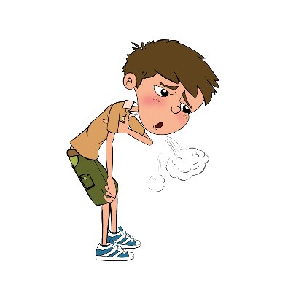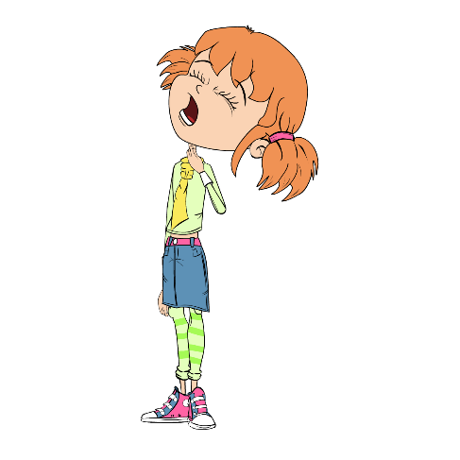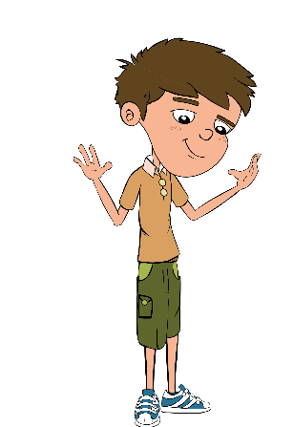

1. Eva likes to keep her hands and nails clean. If we look closely at Eva’s hands we can see that they are covered in lots of tiny microbes. These microbes are useful microbes that live on our skin and help keep us healthy.
2. Luca is always out playing football and having fun with his friends, however, he doesn’t worry about washing his hands very often. If we look closely at Luca’s hands we can see that they too are covered with lots of tiny microbes although some of these are harmful and could make him very ill if they got inside his body.
3. Eva isn’t very well, she has a really sore throat. Sometimes sore throats are caused by coughing and a runny nose, which can make the throat swell up and become quite painful. If this happens then Eva should drink lots of fluids and take painkillers. Sometimes, however, bacteria (e.g. *Streptococcus*) and viruses can also cause us to have a sore throat.
4. In this picture, do you think that Luca is ill because of microbes? The answer is no, Luca has a condition known as asthma which causes him to get out of breath very easily. Asthma is a disease of the lungs and airways but is not caused by microbes. It is important to remember that not all illnesses are caused by microbes.
5. What do you think is wrong with Luca in this picture? Poor Luca has eaten undercooked chicken at a BBQ and has now got food poisoning caused by *Campylobacter*. There are lots of microbes on meat, which although they don’t harm the animal can make us very ill. It is important to cook food properly to kill any harmful microbes which may be present.
6. Eva plays tennis and she has sweaty, smelly feet. She is always in a hurry so she doesn’t wash or dry her feet properly. Her feet smell and are also very itchy and swollen in between her toes. This is because fungi known as dermatophytes like to live between the toes, especially if they are damp. They cause a disease known as athlete’s foot which causes your toes to swell up, the skin between them to crack and become VERY itchy and sometimes smelly.