



## SH2 – Designabug Example

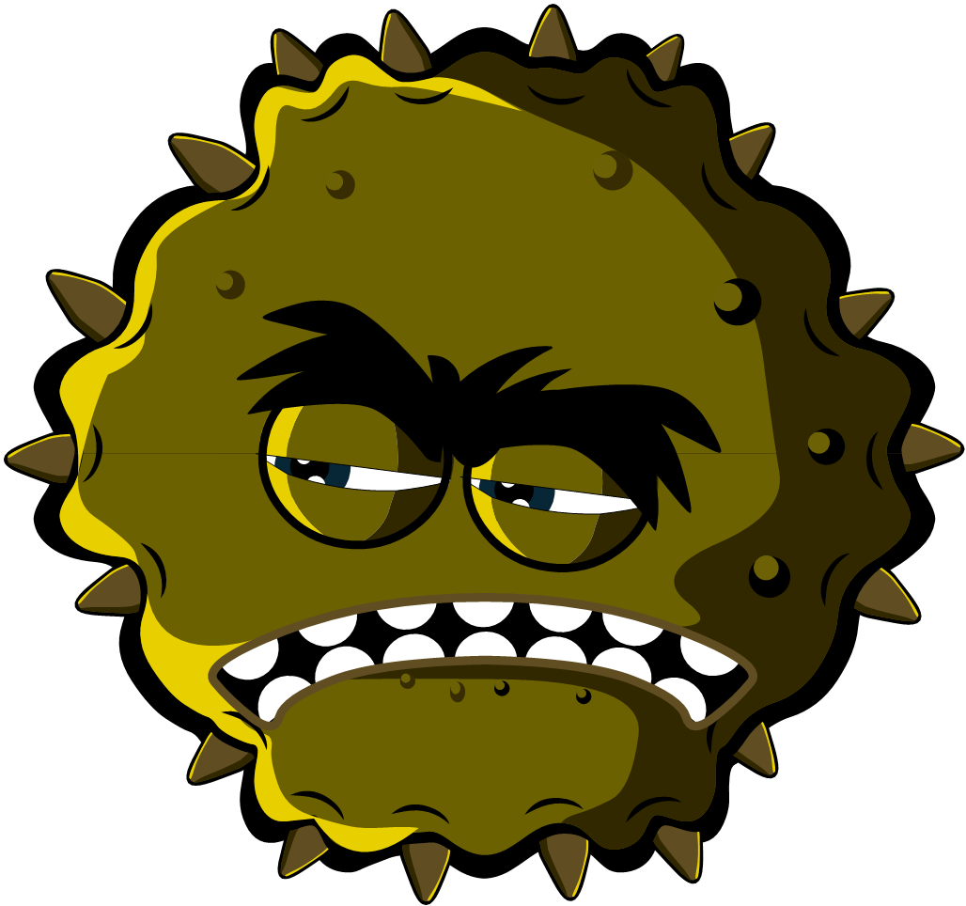

Microbe name

Charlotte Sneezysnot

### Designabug

Virus

Microbe type

Useful of Harmful

Harmful

I am a harmful virus and I like to live in your nose. My super sticky grippers help me stick to your nose cells. You don’t want me there because I make you sneeze and cough.

Microbe Story

Special Features

Lots of sticky grippers all around my body and I’m very small

Strength/Weakness

I need to live in your cells do don’t sneeze in a tissue and throw me in the bin – I’ll die