



## SH3 – What are Microbes?

Fungi are the largest of all microbes.

Fungi can be found in the air, on plants and in water.

Mould, which grows on bread, is a type of fungus.

Some antibiotics are made by fungi.

Dermatophyte

Penicillium

Fungi

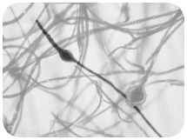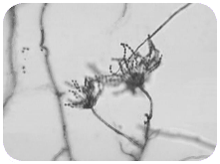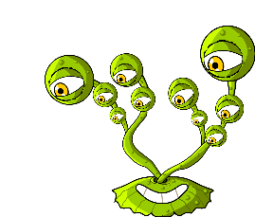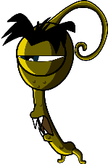

Bacteria are so small that 1000s could fit on the full stop at the end of this sentence.

Some bacteria are helpful in cooking, for example, making yoghurt and cheese.

Some bacteria are harmful and cause infection.

Bacteria multiply very fast..

Balls

(Staphylococcus)

Rods

(Lactobacillus)

There are three different types of bacteria.

They look like:

Bacteria

Spirals

(Campylobacter)

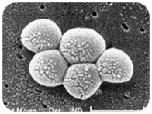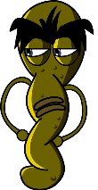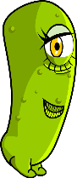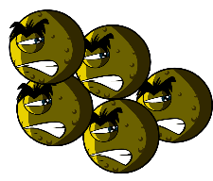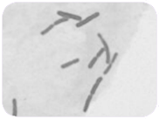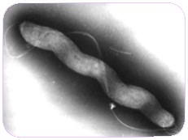

Viruses

Influenza

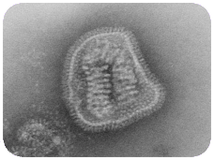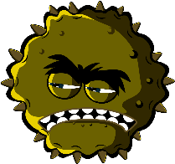

Viruses are even smaller than bacteria and can sometimes live INSIDE bacteria.

Some viruses make us sick.

Diseases like CHICKENPOX and the FLU are caused by viruses.

Viruses can spread from one person to another but it depends on the type of virus.

### What are Microbes?

* They are found EVERYWHERE!
* Some microbes are useful or even good for us
* Some microbes can make us ill
* Microbes are living organisms
* They are so small we need a microscope to see them
* They come in different shapes and sizes

There are 3 different types of microbes: