

## SH4 – How Big is a Microbe

### How Big is a Microbe?

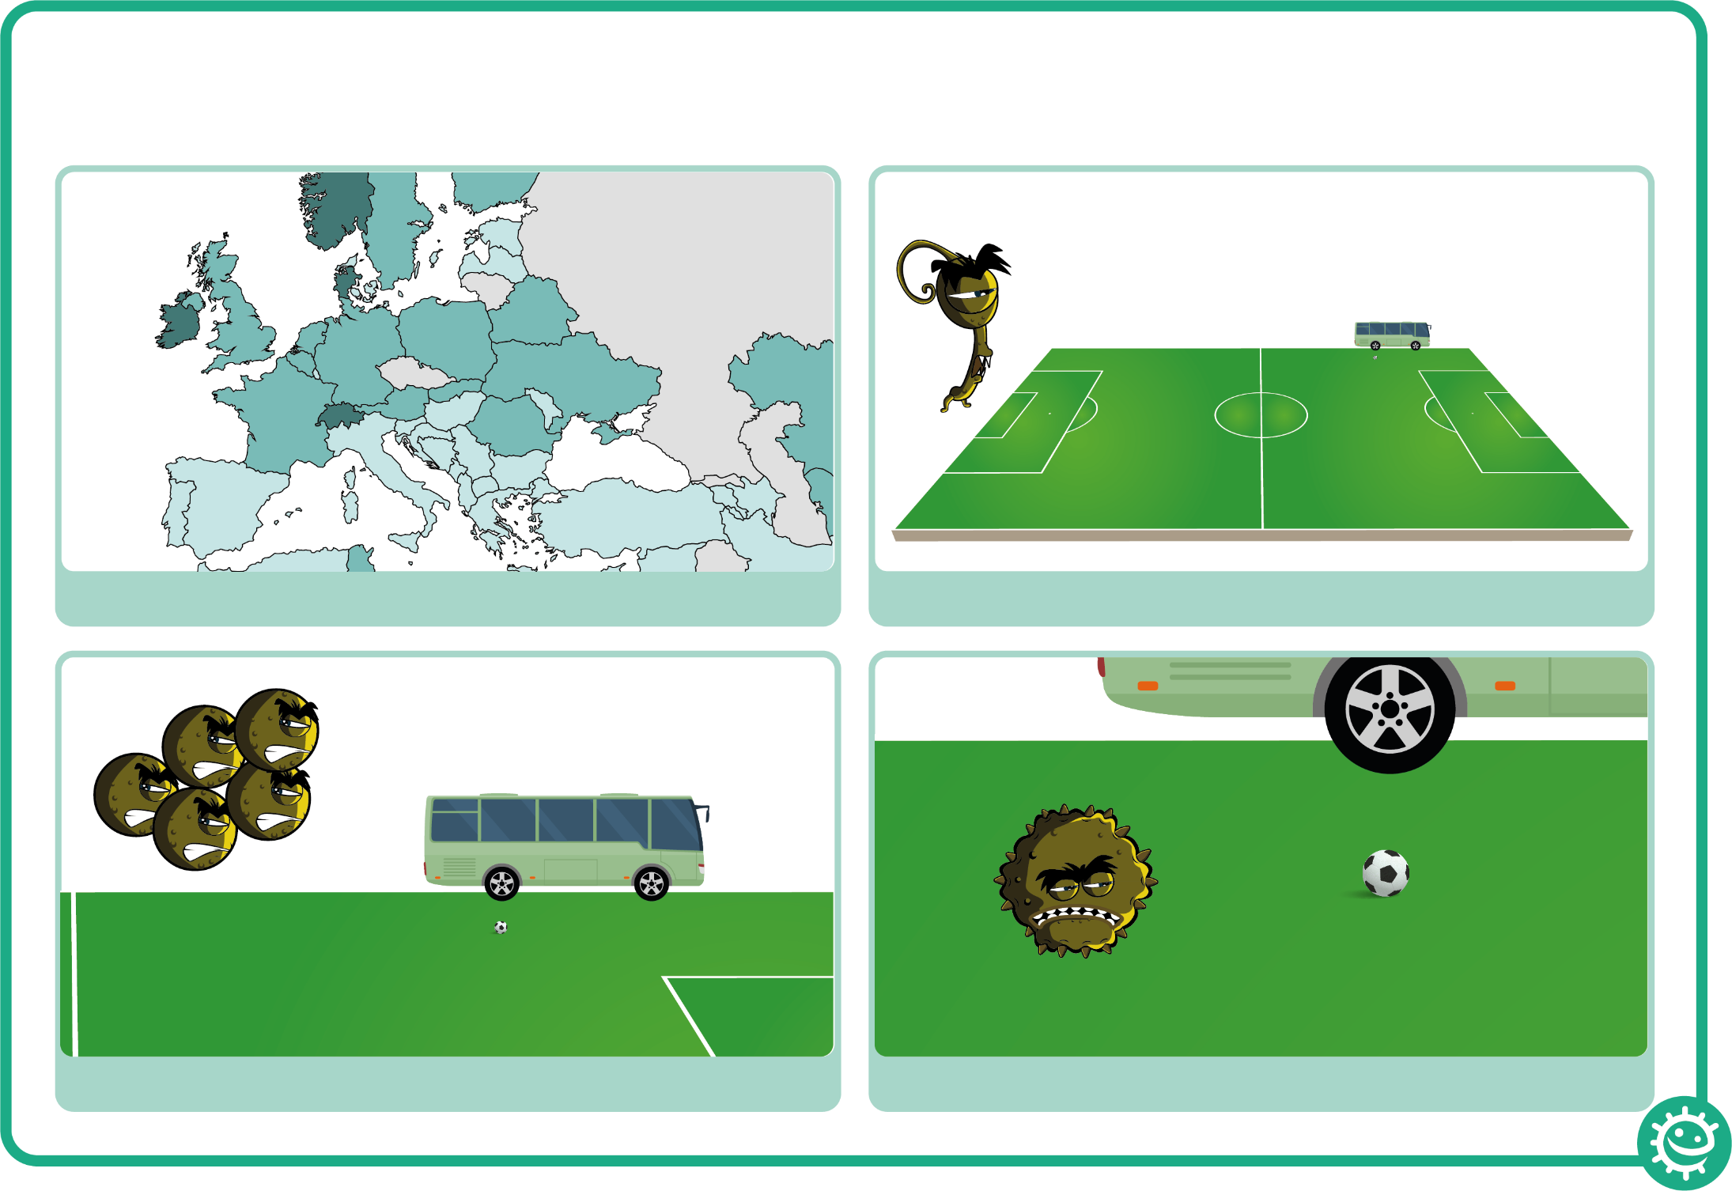

2. A fungus would be the size of a football pitch

4. A virus would be the size of a football

3. A bacterium would be the size of a bus

1. If you were as big as Europe..