

## SW2 – What Microbe am I?

My name is *Campylobacter*. I have a pretty spiral shape and I like to live in chickens but if I get into your tummy I make you very ill – I can give you diarrhoea. What am I? *Campylobacter* is a ______________________

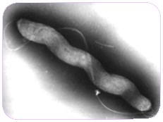

I’m called a *Dermatophyte* and I like to live on your skin. I especially like living in damp places like between the toes on sweaty feet. When I live there I give people athlete’s foot. What am I? *Dermatophytes* are:

______________________

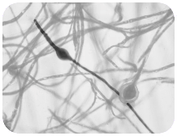

My name is *Penicillium* and you’ll find me growing on old oranges or stale bread making them look mouldy. Humans use me to make

an antibiotic known as Penicillin which can make them better, but only from bacterial infections. What am I? *Penicillium* is a:

______________________

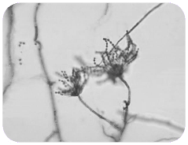

My name is *Lactobacillus*. People call me ‘friendly’ because I change milk into yoghurt. When you eat me in yoghurt I live in your

guts and help you digest other food. What am I?

*Lactobacillus* is a:

______________________

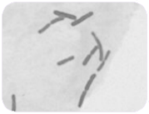

My name is SARS-CoV-2

although some people call me Covid-19. People don’t really like me because I can make them really ill. I easily spread from person to person through coughing and sneezing. What type of microbe am I? SARS-CoV-2 (COVID-19) is:

______________________

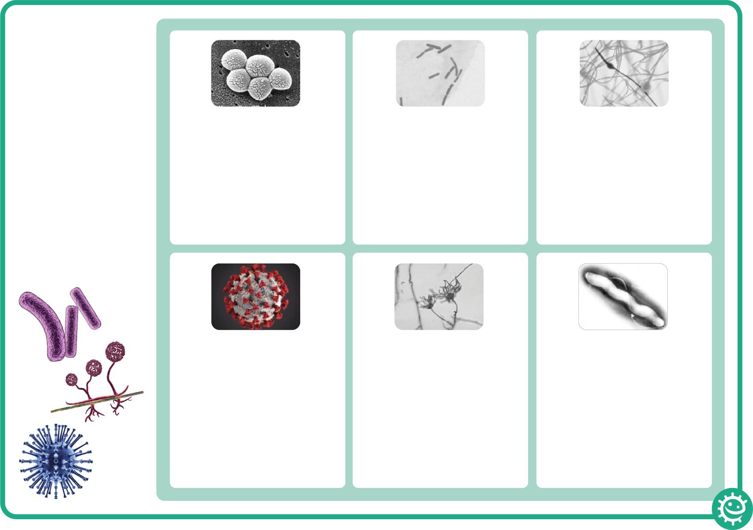

My name is *Staphylococcus*. I am round in shape and I like to live in your nose or armpit. If I live on your skin I can give you spots. If I get into your bloodstream I can

make you ill. What am I?

*Staphylococcus* is a:

______________________

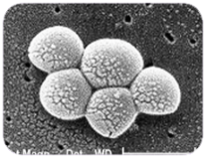

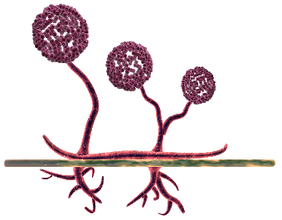

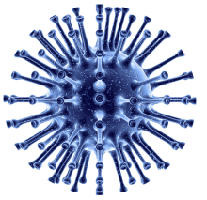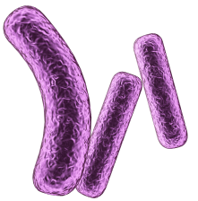

### What Microbe am I?

There are 3 different

types of microbe –

bacteria, viruses

and fungi.

From the pictures and

descriptions, can you

work out which

microbe is which?