

## SW3 – What are Microbes Worksheet

### What are Microbes?

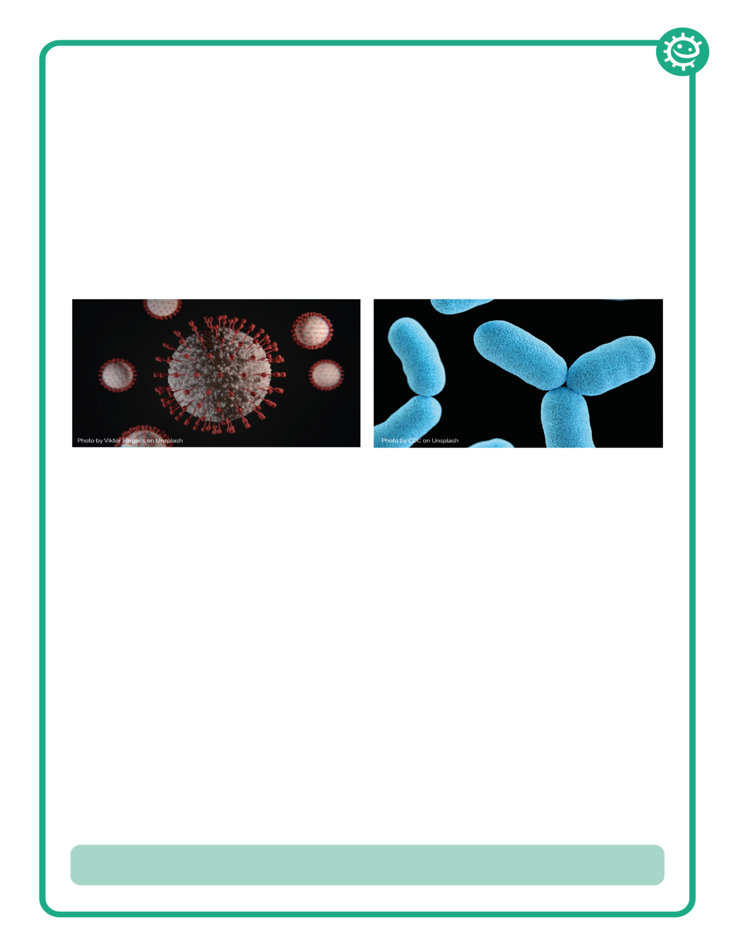

______________, more commonly known as germs, bugs or microbes, are

tiny living things too small to be seen with the naked eye. They are found

almost everywhere on earth.

Some microbes are useful, and others can be harmful to humans. There

are ______ main groups of microbes:

__________ are the smallest of the three microbes described and can be

harmful to humans. Viruses cannot survive by themselves. They need a

‘host’ cell to survive. Once inside the host cell, they rapidly multiply and

destroy the cell in the process. One type of virus is SARS-CoV-2.

Fungi are the largest of the three microbes described and are multicellular

organisms (made up of more than one cell). Some fungi are useful,

and some can be harmful to humans. For example, Saccharomyces is a

_________ that is used to help bread rise.

Bacteria are ____________________organisms that are smaller than fungi

but larger than viruses. They can be divided into three main groups by their

shapes – cocci (balls), bacilli (rods) and spirals. Cocci can also be broken

down into three groups by how the cocci are arranged: staphylococci

(clusters), streptococci (chains) and diplococci (pairs). These shapes can be

used to identify the type of infection a patient has. If a single bacterial cell

was scaled up 5,000 times it would be the size of a garden ______.

Words to use: Viruses, pea, micro-organisms, single-celled, three, yeast