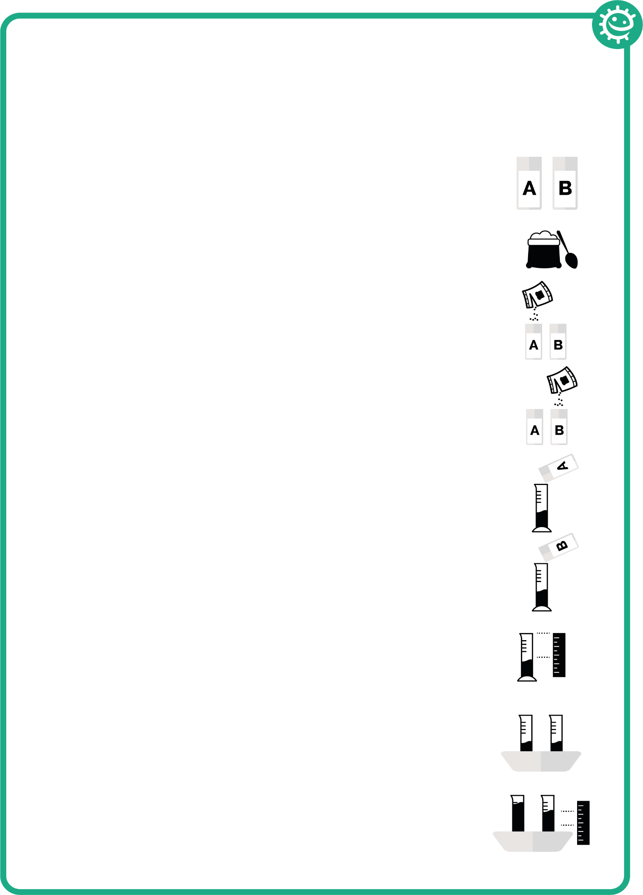

## SH1 – Yeast Races Experiment Handout

### Yeast Races

Experiment

1. Label one of the plastic cups A and one B
2. Add four teaspoons of flour to each cup
3. Add enough yeast solution to cup A and stir thoroughly until it looks like thick milkshake
4. Add enough yeast solution and sugar to plastic cup B and stir thoroughly until it looks like thick milkshake
5. Pour the contents of cup A into graduated cylinder A until it reaches about 30ml
6. Pour the contents of cup B into graduated cylinder B until it reaches about 30ml
7. Record the exact height of the dough in each cylinder
8. Place both measuring cylinder into a basin of hot water
9. Measure the height of the dough every 5 minutes for 30 minutes