  
  
  
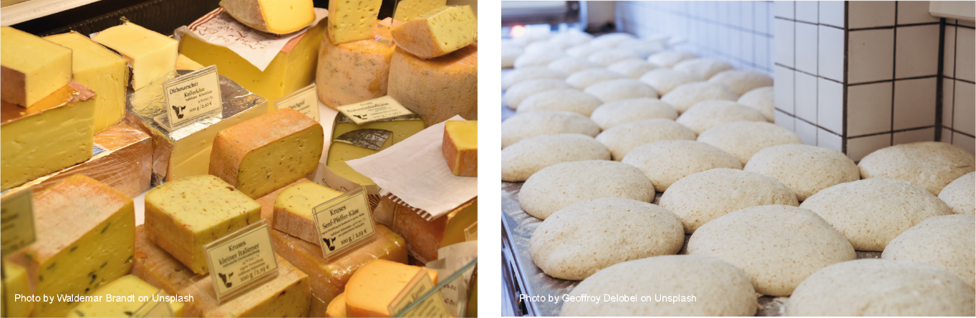

## SW2 – Useful Microbes Fill in the Blanks Worksheet

### Microbes and Food

Microbes are single-celled organisms, most of which are useful, although some of them cause illness and disease. One of the main ways in which microbes are useful is in the food industry. Cheese, bread, yoghurt, chocolate, vinegar and alcohol are all produced through the growth of microbes. The microbes used to make these products cause a chemical change known as _ _ _ _ _ _ _ _ _ _ _ _ a process by which the microbes break down the complex sugars into simple compounds like carbon dioxide and alcohol. Fermentation changes the product from one food to another.

When the bacteria *Streptococcus thermophilous* or _ _ _ _ _ _ _ _ _ _ _ _ _ _ _ _ _ _ _ _ _ _ _ are added to milk they consume the sugars during growth, turning the milk into yoghurt. So much acid is produced in fermented milk products that few potentially harmful microbes can survive there. *Lactobacillus* is generally referred to as a good or ‘friendly’ bacterium. The friendly bacteria that help us digest food have been termed probiotic bacteria, literally meaning ‘for life’. It is these bacteria that we find in _ _ _ _ _ _ _ _ and probiotic drinks.

Yeast, *Saccharomyces cerevisiae*, is used to make _ _ _ _ _ and _ _ _ _ _ _ products through fermentation. In order to multiply and grow, yeast needs the right environment, which includes moisture, food (in the form of sugar or starch) and a warm temperature (20° to 30°C is best). As the yeast ferments it gives off _ _ _ _ _ _ _ _ which get trapped in the dough and the lump of dough expands.

Words to use: *Lactobacillus bulgaricus*, bread, air (CO2), fermentation, yoghurt, cheese