Key Stage 2
Prevention of Infection: Vaccinations

Lesson 9: Vaccinations
Students use their reading comprehension and creative skills to answer questions on, and act out, the discovery of vaccinations by Edward Jenner.

Learning Outcomes

All students will:
- Understand that vaccines help prevent a range of infections, including the flu.

Most students will:
- Understand that there are not vaccines for all infections.

Curriculum Links

PHSE/RHSE
- Health and prevention

Science
- Working scientifically
- Living things and their habitats

English
- Reading & comprehension
- Spoken language
- Writing

Lesson 9: Vaccinations

Resources Required

Main Activity: Historic Heroes

Per student
- Copy of SH1
- Copy of SW1

Extension Activity: Role Play

Per group
- Copy of SH2

Extension Activity: Vaccinations Quiz

Per student
- Copy of SW2

Additional Resources

Per student
- Copy of SH3 (available from the e-bug.eu website)
- Copy of PP1 (available from the e-bug.eu website)

Supporting Materials
- SH1 Historic Heroes Student Handout
- SH2 The Discovery of Vaccinations Script
- SH3 Vaccines Factsheet
- SW1 Historic Heroes Gap Fill Activity
- SW2 Vaccinations Quiz

Lesson 9: Vaccinations

Key Words
Antibody
Antigen
Bacteria
Disease
Immune system
Immunise
Vaccines
Virus
White blood cell (WBC)

Health & Safety
For safe microbiological practices in the classroom consult CLEAPPS
www.cleapps.org.uk

Weblinks
e-bug.eu/eng/KS2/lesson/ Vaccinations

Introduction
- Begin the lesson by explaining that although there are many harmful microbes that can make us ill, in some cases, there are things we can do to prevent this happening.
- Explain that vaccinations are a harmless small amount of the microbe (e.g. disease markings or outer coat) that teaches our body how to fight the harmful microbe when or if we get attacked by the disease. Discuss class experiences of vaccinations, which vaccinations they remember getting and when they got them. For example, ask students to raise their hands if they have received the flu vaccination at school.
- Show the class images in PP1 of the disease and bacteria/viruses which they are likely to have been immunised against. Emphasise that in the 1700s these diseases were extremely common.
- Highlight that without their vaccinations, many of the students in the class would not have survived past 5 years of age. Explain that diseases like whooping cough, polio and TB are now extremely rare due to vaccinations.
- Remind students that some microbes change their outer coats like we change our clothes. Some microbes change their markings/coats so quickly that scientists cannot create vaccines for many infections (e.g. common cold/sore throat) or they have to make a new vaccine every year, like the flu vaccine.

Activity

Main Activity: Historic Heroes
- Provide each student with a copy of SW1.
- Read the story of Edward Jenner (SH1) to the class, either show the story to the class on the whiteboard or provide each student with a copy of SH1. The class can then read along with the story.
- After reading the story, ask the class to fill in the spaces on their worksheet (SW1).
- Students should also answer the questions at the bottom of the worksheet. Students will learn what vaccinations are, how they work, and why they are important.

Discussion
Check for understanding by asking students the following questions.
What are vaccines? Answer: Vaccines protect a person against a particular disease. They are dead or severely weakened versions of the microbe.
Who discovered vaccines? Answer: Edward Jenner discovered vaccines in 1796.
When should vaccines be used? Answer: Vaccines should be administered before an illness occurs; vaccines are a preventative measure.
When should vaccines be used? Answer: Vaccines should be administered before an illness occurs; vaccines are a preventative measure.

Extension Activities

Discovery of vaccinations role play activity
Provide groups of 3 or 4 students with a copy of SH2. Students can bring the story of Edward Jenner to life by recreating his story into a play to present to the class.
To expand on this activity, ask students to pretend they are Edward Jenner and write a diary entry for the day he made his discovery.

Vaccinations Quiz
Provide groups of 2 or 3 students with SW2 and the team with the most points wins. Answers are available on the e-bug website.

Common Vaccination Questions Q&A discussion
The following Question and Answer discussion will support student understanding of vaccinations.
- Question: What is a vaccination?
Answer: Vaccinations are another means of helping our immune system protect us against harmful diseases. They use your body’s natural defences to build resistance to specific infections and help make our immune system stronger.
- Question: Why is vaccination important?
Answer: Vaccines are a safe and effective way to prevent us from getting ill. Today there are vaccines to protect us from at least 20 diseases including tetanus, influenza, measles, mumps, polio and meningitis. When we get vaccinated, we aren’t just protecting ourselves but also the people around us. Vaccines help prevent the spread of infection.
- Question: How does a vaccine work?
Answer: When the vaccine is injected into the body the immune system attacks it as if harmful microbes were attacking the body. White blood cells, a part of our immune system, create lots of antibodies to attach to specific markers on the surface, called antigens, of the vaccine organisms. Because the vaccine is an extremely weakened version of the microbes, our immune system can kill all cells from the vaccine and it will not make you ill. By successfully eliminating all the vaccine, the immune system remembers how to combat those microbes. The next time microbes carrying the same markers/antigen enter the body, the immune system is ready to fight it before it has a chance to make you ill. This means you develop immunity against diseases.
- Question: Why should I get vaccinated?
Answer: Vaccines have saved millions of lives. Without vaccines, we are at serious risk of illness and disability from diseases like polio and meningitis. Vaccinations protect ourselves from illness and others from getting ill too. Not everyone can be vaccinated, sometimes very young babies, very old people and people with serious illness e.g. certain allergies – these people depend on others getting vaccinated to prevent the spread of infection and protect them.

Modern Vaccine Scientists
As a class discussion or homework activity ask students to consider the following scientists that are making significant discoveries in global vaccine development:
- Dame Sarah Gilbert Co-Creator of the Oxford/AstraZeneca COVID-19 vaccine.
- Kathrin Jansen Vaccine lead at Pfizer, co-developer of the COVID-19 Pfizer-BioNTech vaccine
- Hanneke Schuitemaker Vaccine lead at Johnson & Johnson’s Janssen Vaccines & Prevention.
- Gagandeep Kang Microbiologist and virologist researching viral infections in children (in particular rotaviral vaccines – rotaviruses are a common cause of severe diarrhoea among young children).
Or ask students to find their own examples.

Learning Consolidation
At the end of the lesson, ask the class the questions below.
- What bodily system fights any harmful microbes that may enter our bodies?
Answer: Our immune system
- Vaccines help prevent a range of infections, for example...?
Answer: i.e. influenza, COVID-19, measles, mumps, rubella, polio, meningitis, whooping cough, TB Or any other example you may have provided
- True or False: There are vaccines for all infections?
Answer: False

SH1 – Historic Heroes Student Handout

Historic Heroes
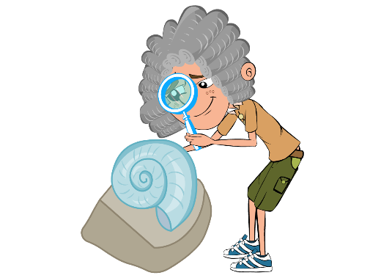
Edward Jenner was born in 1749. As a young boy, Edward
enjoyed science and nature, and spent hours on the banks
of the River Severn looking for fossils. In 1770, at the age of
twenty-one, he began training as a doctor in London. Two
years later Edward began to practise as a doctor in his
hometown of Berkeley, Gloucestershire.

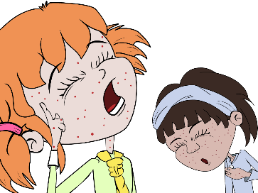
During this time, people were terrified of a horrible disease
called smallpox. People who got this disease got severe
scarring from lesions and sometimes even died. As a
doctor, Edward Jenner listened to what the country people
said about smallpox. They believed that someone who
caught a different mild infection called cowpox from their
cows would not catch the much more serious smallpox.

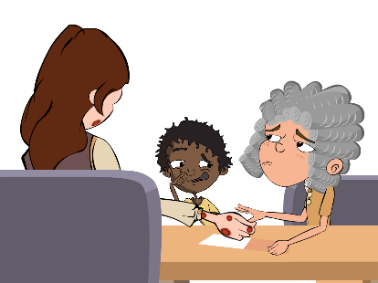
Jenner carried out an experiment to see if the people were
right. In 1796 a milk maid called Sarah Nelmes came to
Jenner complaining of a cowpox rash on her hand that she
caught from Blossom the cow. Jenner took some of the pus
from the cowpox rash on Sarah’s hand. He scratched some
of the pus into the hand of an 8-year-old boy called James
Phipps, the son of his gardener. James fell ill with cowpox
but soon recovered.
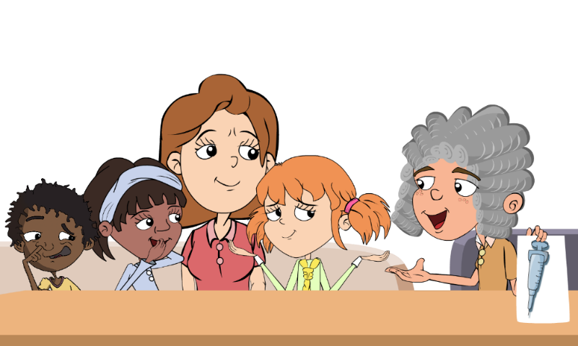
Jenner then took some pus from someone with the dangerous disease, smallpox, and scratched this into James’ arm. James developed a scab but did not develop smallpox, Jenner’s theory was right. Jenner's discovery came to be known as vaccination from the Latin word for a cow: vacca. Jenner went on to vaccinate all the local children with the cowpox to stop them from getting the more dangerous smallpox disease.

SH2 - The Discovery of Vaccinations Script

The Discovery of Vaccinations Script
Scene 1 - by a river
- Narrator - Edward Jenner was born in 1749. As a young boy Edward enjoyed science and nature, spending hours on the banks of the river Severn looking for fossils.
- Jenner - What a lovely day to go looking for fossils on the bank of the river Severn. What could be more perfect?
- Narrator - In 1770, at the age of 21, he began training as a doctor in London. Two years later Edward began to practice as a doctor in his home town of Berkeley, Gloucestershire. At this time smallpox and cowpox were a problem.

Scene 2 - Dr Jenner's office
- Jenner - Oh come in come in, what seems to be the problem Mr and Mrs Smith?
- Mrs Smith - Well Dr Jenner, my husband has got himself a cowpox rash. What can be done for him?
- Mrs Smith - Also doctor, a friend of mine died last year from smallpox. But he never had cowpox.
- Jenner - Yes, do go on Mr Smith.
- Mrs Smith - Well, I know lots of other people who have had cowpox but then never got smallpox. Do you think this means I won’t get it doctor?
- Jenner - You know Mr Smith, you are not the first patient to say that to me. I have my suspicions that you are correct. I will investigate the matter
- Narrator - And the good doctor did just that. When milk maid Sarah Nelmes came to Dr Jenner with a cowpox rash he took the opportunity to experiment with the help of an 8 year old boy, James Phipps.

Scene 3 - Dr Jenner's office
- Sarah - Doctor, I’ve got a cowpox rash on my hand.
- Jenner - OK Miss Nelmes, let me take a look at that. Right young James, come here please and hold out your hand.
- Sarah – What are you doing doctor?
- Jenner - An experiment Miss Nelmes. I shall take some of the pus from your rash and scratch it into James’ hand.
- Narrator - James fell ill with cowpox but soon recovered. Dr Jenner was ready for part 2 of his experiment. It was now that the doctor scratched some pus from someone with smallpox into James’ arm.
- Jenner - James my boy, if all goes to plan your name will go down in medical history.
- James - But what if it doesn’t go to plan Dr Jenner?
- Jenner - I won’t lie to you James, you might well die.
- James - (Gulps) Oh!
- Narrator - But James didn’t die. Jenner’s theory was right and in time his discovery came to be known as vaccination. He then went on to vaccinate all the local children with cowpox to stop them from getting smallpox. Even today his work is still recognized and Gloucestershire Royal Hospital has a unit named after him.

SW1 - Historic Heroes Gap Fill Activity

The Story of Edward Jenner
Reading Comprehension
Can you fill in the blanks in the story from the words in the box below?
Edward Jenner was born in ___________________, England. As a young boy Jenner’s favourite subject was ___________ and when he grew up he became a ___________. At the time the people of England were terrified of a deadly disease called ___________. Symptoms included severe _____________ and many people died. Jenner noticed that milkmaids who caught the harmless infection ____________, from their milking cows did not die from smallpox. Jenner took pus from the hand of a ___________ who had cow pox and infected a boy called __________. The boy got infected with cowpox but soon recovered. Jenner then __________ James with smallpox. A ______ developed but the boy did not develop smallpox. Jenner was delighted that his idea was correct, he went on to __________ all the children in his town with cowpox to stop them getting smallpox.
Cowpox, James Phipps, Smallpox, Gloucestershire, Doctor, Milk-maid, Science, Scarring, Infected, Scab, Vaccinate

A Historic Hero
Dr Edward Jenner is one of the most important people in scientific history.
Without his discovery of vaccinations more than half your class would not be here today.
Did you know?
By the age of 9 each child may have had at least 12 injections to prevent 13 different dangerous infections.
Fascinating Fact
Vaccination comes from the Latin word for a cow – vacca
Understanding
Answer the following questions:
- What was the name of the doctor who discovered vaccinations?
_________________________________________
- What was the name of the deadly disease at the time?
_________________________________________
- What was Jenner’s idea to stop the deadly disease?
_________________________________________
- What happened to James after he was infected with the cowpox?
_________________________________________
- What happened to James after he was infected with the smallpox?
_________________________________________
- Why was it important for Jenner to test his idea on James before treating lots of children?
_________________________________________

SW2 - Respiratory Hygiene Quiz

Quiz: Vaccines
Please tick as many answers as appropriate
Vaccines are used to:
(1 point)
- Prevent infections
- Treat infections
- Postpone infections
By getting vaccinated you can:
(2 points)
- Protect yourself
- Protect people around you
- Protect your useful microbes
How do vaccines work?
(1 point)
- They block the entry of microbes in the body
- They kill microbes in your body
- The immune system attacks the
vaccine and remembers for next time
Which diseases cannot be prevented by vaccination?
(2 points)
- Common cold
- Measles
- Sore throat
- Polio
Vaccines can be effective against:
(1 point)
- Bacterial infections
- Viral infections
- Both bacterial and viral infections
- Neither bacterial or viral infections
Vaccines are made up of:
(1 points)
- Antibodies
- White blood cells
- Weak or inactive versions of the microbe that makes us ill
- Strong microbes that make us ill
Herd immunity is:
(1 point)
- When animals such as cattle have been vaccinated
- A type of immunity naturally present in the body
- When enough of the population is vaccinated to prevent the spread of
- None of the above
Which diseases are eradicated or rare thanks to vaccinations? (3 points)
- Smallpox
- Cough
- Polio
- Tetanus

