

## SH1 – Historic Heroes Student Handout

### Historic Heroes

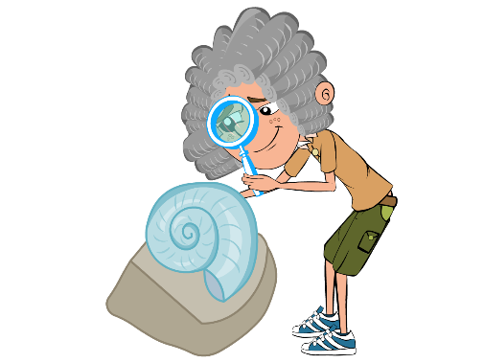

Edward Jenner was born in 1749. As a young boy, Edward

enjoyed science and nature, and spent hours on the banks

of the River Severn looking for fossils. In 1770, at the age of

twenty-one, he began training as a doctor in London. Two

years later Edward began to practise as a doctor in his

hometown of Berkeley, Gloucestershire.

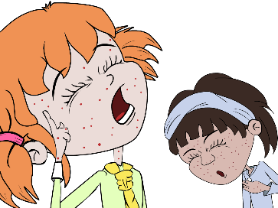

During this time, people were terrified of a horrible disease

called smallpox. People who got this disease got severe

scarring from lesions and sometimes even died. As a

doctor, Edward Jenner listened to what the country people

said about smallpox. They believed that someone who

caught a different mild infection called cowpox from their

cows would not catch the much more serious smallpox.

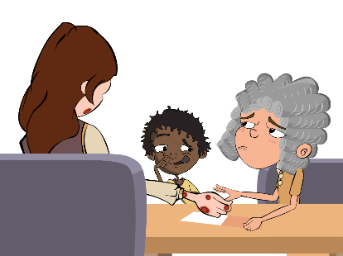

Jenner carried out an experiment to see if the people were

right. In 1796 a milk maid called Sarah Nelmes came to

Jenner complaining of a cowpox rash on her hand that she

caught from Blossom the cow. Jenner took some of the pus

from the cowpox rash on Sarah’s hand. He scratched some

of the pus into the hand of an 8-year-old boy called James

Phipps, the son of his gardener. James fell ill with cowpox

but soon recovered.

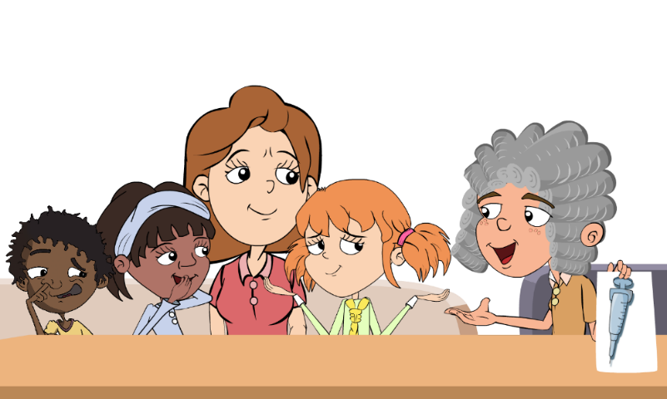

Jenner then took some pus from someone with the dangerous disease, smallpox, and scratched this into James’ arm. James developed a scab but did not develop smallpox, Jenner’s theory was right. Jenner's discovery came to be known as vaccination from the Latin word for a cow: vacca. Jenner went on to vaccinate all the local children with the cowpox to stop them from getting the more dangerous smallpox disease.