Infection Prevention and Control (IPC): Hand Hygiene
Key Stage 3

Lesson 4: Hand Hygiene
Through a classroom experiment, students learn how microbes can spread from one person to another by touch and why it is important to wash hands properly.

Learning Outcomes

All students will:
- Understand that infection can be spread through unclean hands.
- Understand that sometimes microbes can make us ill.
- Understand how, when, and why to wash their hands.
- Understand that hand washing can prevent the spread of infection.

Most students will:
- Understand why we should use soap to wash our hands.
- Understand that prevention of infection, where possible, is better than cure

Curriculum Links

PHSE/RHSE
- Health and prevention

Science
- Working scientifically
- Scientific attitudes
- Experimental skills and investigations

English
- Reading
- Writing

Lesson 4: Hand Hygiene

Resources Required

Main Activity: Hand shaking experiment

Per student
- Copy of SW1
- Copy of SW2
- Petri dishes of nutrient agar (or bread and food storage bags)

Per group
- Copy of SH1
- Copy of SH2
- Copy of SH3
- Basin (or sink)
- Hand dryer/paper towels
- Permanent marker pen
- Soap
- Water

Extension activity: Stomach Bug Chain of Infection

Per group
- Copy of SH1
- Copy of SH2
- Copy of PP1 (available from e-bug.eu)

Extension activity: Hand Hygiene Quiz

Per group
- Copy of SW3

Supporting Materials
- TS1 Answer sheets
- SH1 The Chain of Infection Poster
- SH2 Breaking the Chain of Infection Poster
- SH3 Hand washing Poster
- SW1 Hand Shaking Experiment – Section A
- SW2 Hand Shaking Experiment – Section B
- SW3 Hand Hygiene Quiz

Advanced Preparation
Section A
- Copy SW1, SW2, SH1 and SH2 for each student, or group.
- Copy of TS1 teacher answer sheet.
- Have hand washing facilities available, (soap, warm water, a means to dry hands).
- Prepare 2/3 Petri dishes of nutrient agar (or slice of bread and storage bag) per student.
Section B
- Copy of SW1 and 2 for each student and SH1 for each group
- Arrange four desks side by side for the 4 stations. Each desk should contain one of the following:
  - A sign reading ‘No hand washing’
  - A basin of water, paper towels and a sign reading ‘Wash for 3 seconds’
  - A basin of water, paper towels and a sign reading ‘Wash for 20 seconds’ d
  - A basin of water, hand soap, paper towels and a sign reading ‘Wash in Water and Hand Soap for 20 seconds’ Copy of TS1 teacher answer sheet.
. Lesson 4: Hand Hygiene

Key Words
Hygiene
Infection
Soap
Transfer

Weblinks
e-bug.eu/eng/KS3/lesson/ Hand-Hygiene

Health & Safety
If social distancing does not allow students to shake hands, you can find alternative experiments in Key Stages 2 and 4.
Ensure that the students do not have soap allergies or sensitive skin conditions.
Take care when using sanitiser, risks include splashes.
Ensure to wash hands thoroughly.
Petri dishes - lids must be secured with two small strips of clear tape. Plates must be inverted before incubation. When plates are examined 2 days later, students must not open the plates. Plates must be autoclaved before disposal.

For safe microbiological practices in the classroom consult CLEAPPS
www.cleapps.org.uk

NB: If slices of bread are used instead of nutrient agar plates, bags must not be opened to provide a closer look at the surface of the bread; this could release fungal spores which could be inhaled and cause respiratory distress. The three bags should be placed, unopened, in the normal waste or in a food waste-recycling collection.

Introduction
- Begin the lesson by asking the class ‘if there are millions of disease causing microbes in the world that live everywhere, why aren’t we ill all the time?’. Provide students with SH1 The chain of Infection and SH2 Breaking the Chain of Infection (also available in PP1) to help explain this.
- Highlight that there are different ways in which microbes can be transmitted to people. Ask students if they can think of any. Examples could include through the food we eat, the water we drink and bathe in, the things we touch and from sneezing.
- Ask students: How many of you have washed your hands today? Ask why they washed their hands (to wash away any microbes that might be on their hands), and what would happen if they didn’t wash away the microbes (they might get ill).
- Tell the students that we use our hands all the time, and that they pick up millions of microbes every day. Although many of these are harmless some could be harmful.
- Explain that we spread our microbes to our friends and others through touch, and therefore we need to wash our hands regularly.
- Explain to students that they are going to carry out an activity to help understand the best to wash their hands to remove any of the harmful microbes.

Activity

Main Activity: Hand shaking experiment
NOTE 1: Slices of white bread can be used as alternatives to Petri dishes of nutrient agar if necessary. Students should put a fingerprint on the bread and place inside a food storage bag with a few drops of water. Store the bags upright in a dark place in a similar fashion to the Petri dishes. This method is not as accurate as using the Petri dish method and fungal colonies will grow as opposed to bacterial colonies. Student worksheets may need to be modified.
NOTE 2: If students are using Petri dishes, they should label the base of the dish.
NOTE 3: Care must be taken not to mix up the dirty and clean side of the plate as this will lead to confusing results. Using two plates, one for clean hands and one for dirty hands, may help prevent this problem.
NOTE 4: If time does not permit to carry out the full activity, results can be viewed on the website, www.e-bug.eu. Both section A and B can be carried out in the same lesson, with results reviewed 48 hours later

Section A
- Provide each student in the class with a copy of SW 1 and a Petri dish of nutrient agar. Ask each student to divide the dish in half by drawing a line on the base of the Petri dish. Label one side clean and the other side dirty.
- Each student should put a fingerprint on the side labelled ‘dirty’. Students should then wash their hands thoroughly and place a fingerprint on the side labelled ‘clean’.
- Place the Petri dish in a warm dark place for 48 hours and examine the plates during the next lesson. Students should record their results on SW1.
On the dirty side of the plate students should observe a range of different bacterial and fungal colonies; each different colony type represents a different bacterial or fungal strain – some natural body flora and some contamination from areas they have touched. Students should examine these carefully and describe their morphology and how many of each type of organism they see. On the clean side of the plate students should observe a distinct decrease in the number of different types of colonies observed. This is because hand washing has removed many of the organisms the students have ‘picked up’ through touch. The organisms left growing on the plate are the body’s natural flora. The quantity of these colonies may be higher than on the dirty side of the plate. This is because washing can bring the harmless microbes out of the hair follicles, but these are usually one type of microbe.

Section B
- Divide the class into 4 even groups of students.
- Ask each group to choose a lead person who is NOT going to wash their hands. The other students in the group are going to:
  - quickly wash their hands
  - thoroughly wash their hands without soap
  - thoroughly wash their hands with soap
Students should dry their hands with either an air hand dryer or a clean section of tissue. The student NOT washing his/ her hands should touch as many items in the classroom as possible to pick up lots of microbes including door handles, sink taps, shoes, etc.
- Ask students in each group to stand one behind the other as follows:
- Student 1: No hand washing Control group
- Student(s) 2: Quick wash Hands in water and rub quickly
- Student(s) 3: Thorough wash without soap
- Student(s) 4: Thorough wash with soap
- Provide each student in the class with 2 new nutrient agar plates and a copy of SW2.
- Each student should put a fingerprint on one of their agar plates and label appropriately.
- The lead student (student 1) should then wash their hands. Student 1 should then turn around and shake hands with student(s) 2, making sure to have as much hand contact with the person as possible Student(s) 2 in turn should shake hands with student(s) 3 and so on until they reach the end of the row.
- Each student should now make a fingerprint in their second nutrient agar plate and label appropriately.
- Place the nutrient agar plates in a warm dry place for 48 hours. Ask students to view and record their results on SW2.
- Optional: If time permits, add the following extra row to compare the effectiveness of hand sanitiser with soap:
Wash hands with hand sanitiser (cover completely and allow to dry)

Discussion
Discuss the results with the students. What results did they find the most surprising?
Discuss where the microbes on their hands may have come from. Emphasise to students that not all the microbes on their hands are harmful; there may also be normal body microbes which is why useful microbes may increase following hand washing.
Explain that microbes can stick to the natural oil found on our skin. Washing with water alone flows over this oil and does not wash it away. Soap breaks up this oil so that the water can wash away the microbes.
Explain that hand sanitiser kills microbes when it dries on our hands. It is important that we cover our hands completely with it and allow it to dry when we use it and use soap and water when hands are visibly soiled.
Discuss the pros and cons of using hand sanitiser when soap is not available. a Pros: Hand sanitiser, when used correctly can kill some dangerous microbes without the need for hand washing. It is readily available and easy to use. b Cons: Hand sanitiser does not destroy all microbes that can cause illness and does not remove other substances like dirt or chemicals from our hands. Important to note there are situations where only soap/water can be used such as after using the toilet or when visibly contaminated.

Extension Activities

Stomach Bug Chain of Infection
- This activity can be carried out in groups of 2 – 4 students or as a classroom discussion.
- Ask students if they have ever had a ‘stomach bug’. With the help of SH1 and SH2, ask students to imagine the spread of gastroenteritis (a stomach bug) in their school from a single infected student.
- Ask the class to take into account the situations of everyday life within school (going to the toilet without washing hands or washing them without soap, going to eat at the school canteen, borrowing pens or other things from friends, shaking hands, using a computer…).
- Ask the groups/class to report on the way the infection could spread, and how quickly it could spread in their class or in the school.
- Ask students to think about and discuss the difficulties they may have with hand hygiene in school and how they could improve their use of existing hygiene facilities.

Hand Hygiene Quiz
Provide SW3 to groups of 3 or 4 students. The group with the most points wins. Alternatively, the quiz can be completed at the beginning of the lesson and end to measure understanding.

Hand washing Poster
SH3 Hand washing poster can be used throughout the lesson, displayed in the classroom, or given to students to take home.

TS1 - Hand Shaking Experiment Teacher Answer Sheet – Section A

Hand Shaking Experiment:

Section A Results Answer Sheet
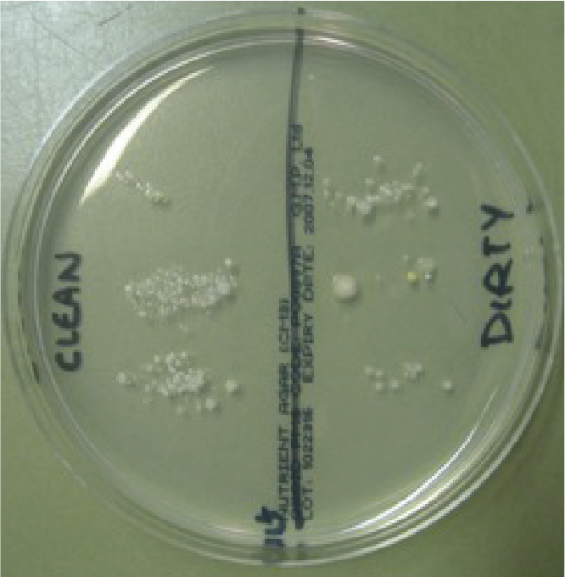
Dirty section
Colony 1 large round cream colonies with a white centre
Colony 2 small yellow colonies
Colony 3 very small cream colonies with irregular shape
Colony 4 small cream round oval colonies
Colony 5 small round white colonies

Clean section
Colony 1 small round white colonies
Colony 2 small cream round oval colonies
Observations
- Which side of the Petri dish contained the highest number of
microbes?
Clean
- Which side of the Petri dish contained more different colonies of microbes?
Dirty
- How many different colony types were there on the:
Clean - 2 Dirty - 5
Conclusions
- Some people may see more microbes on the clean side of the Petri dish than the dirty side. Why?
There may be more microbes on the clean side than the dirty side but if students have washed their hands correctly there should be a lower number of different types of microbes. The increase in the number of microbes is probably due to microbes from the water or the paper towel used to dry their hands.
- Which colonies would you consider the friendly microbes and why?
The microbes on the clean side as they are probably the natural microbes found on our hands.

TS1 - Hand Shaking Experiment Teacher Answer Sheet - Section B

Hand Shaking Experiment:

Section B Conclusions Answer Sheet
- Which method of hand hygiene eliminated the most microbes?
Hand washing with soap and warm water.
- Why would soap help eliminate more microbes than washing with water alone?
Soap helps to break up the natural oil on your skin to which microbes can stick.
- What are the advantages and disadvantages to using antibacterial soap when washing your hands?
Advantages: kill any unwanted microbes Disadvantages: also kill natural skin microbes (note: general (non-antibacterial) soap will remove harmful microbes from the hands)
- What evidence do you have that microbes can be transmitted by hands?
The types of microbes on the first plate are spread along to the other plates and the numbers are gradually decreasing.
- Which areas of the hand do you think would contain the most microbes and why?
Under the fingernails, on the thumbs and between the fingers as these are places that people either forget to wash or don’t wash very well.
- List 5 times when it is important to wash your hands
a. Before cooking
b. After touching pets
c. After using the toilet
d. Before eating
e. After sneezing into them

SH1 - The Chain of Infection Poster
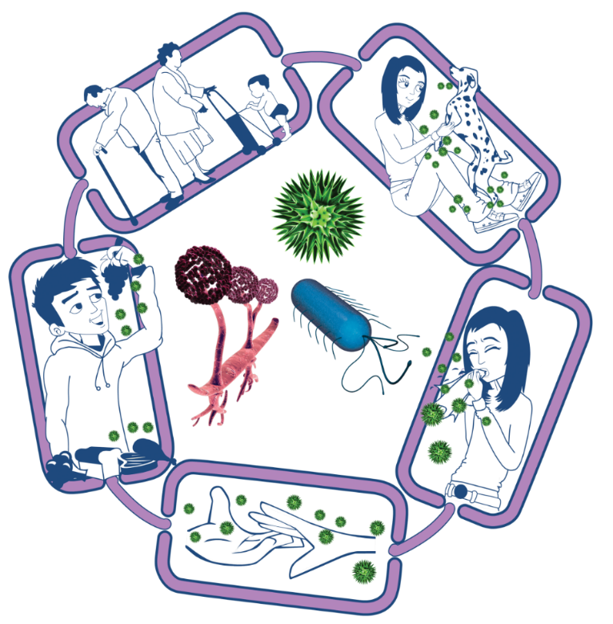
Source of infection
Someone or something carrying the harmful microbes that causes the infection. There are many different sources of infection, these can include:
• People already infected
• Pets or animals
• Contaminated food
Spread of infection
Harmful microbes need a way to be passed from a source to a person. This can be through:
• Direct touch/contact
• Sexual transmission
Harmful microbes are also spread via:
• Hands, hand contact surfaces (e.g. door handles, keyboards, toilets)
• Food contact surfaces
• Air
Way out for microbes
Harmful microbes need a way to get out of an infected person or source before they can spread to someone else. Routes include:
• Sneezing, coughing, saliva
• Bodily fluid
• Juices from raw meat and poultry

The Chain of Infection
Way in for microbes
Harmful microbes need a
way to enter the body before they can cause an infection. This can be
through:
• The food we eat
• Inhalation of aerosols or droplets
• Open cuts or sores
• Things we put in our
mouths
People at risk from
infection
We are all at risk from
infection, but some are at greater risk:
• People on medication
e.g chemotherapy
• The very young/elderly
• People with underlying diseases e.g HIV/AIDS, diabetes

SH2 - Breaking the Chain of Infection Poster

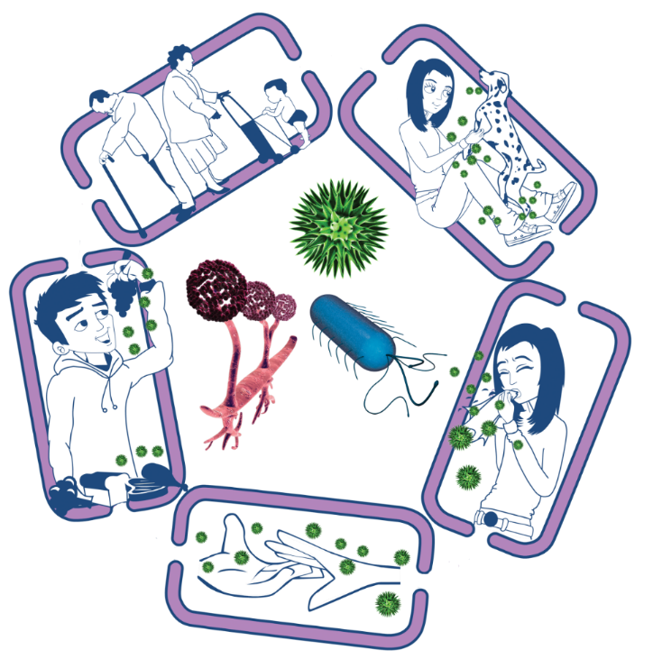
Source of infection
• Isolate infected people
• Take care with raw food
• Wash pets regularly
• Treat pets for pathogens when needed
• Dispose of nappies and soiled clothing appropriately
Way out for microbes
Prevent any:
• Coughs and sneezes
• Faeces
• Vomit
• Bodily fluid
Getting onto surfaces or hands
Spread of infection
• Wash hands thoroughly and regularly
• Cover cuts and open sores
• Take appropriate precautions during
sexual activity

The Chain of Infection
People at risk from
infection
Everyone:
• Take appropriate vaccinations
High risk people:
• Keep away from people who are infectious
• Take extra care about cleanliness
• Take extra care when cooking and preparing food
Way in for microbes
• Cover cuts and open sores with a water proof dressing
• Cook food properly
• Take care to drink only clean water

SH3 - Hand Washing Poster

Wash your hands with soap and water for 20 seconds
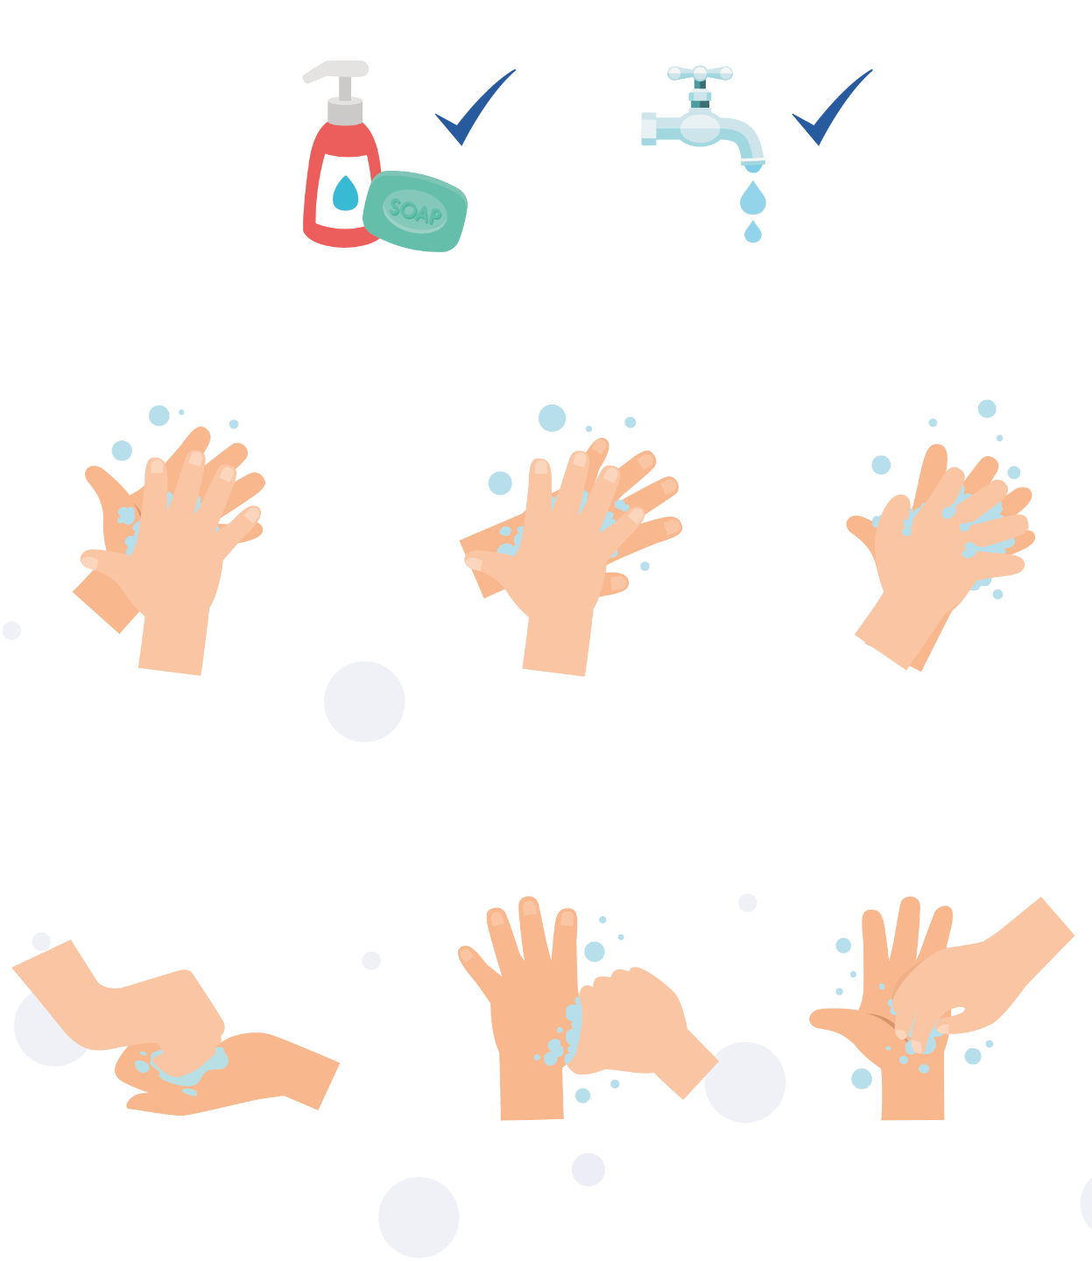

1
2
3

Palm to palm
Back of hands
Between fingers
4
5
6

Back of fingers
Thumbs
Tip of fingers
To help keep time, sing ‘Happy Birthday’ twice

SW1 - Hand Shaking Experiment Worksheet - Section A
Dirty section
Colony 1 _________________
Colony 2 _________________
Colony 3 _________________
Colony 4 _________________
Colony 5 _________________
Clean section
Colony 1 _________________
Colony 2 _________________
Colony 3 _________________
Colony 4 _________________

Hand Shaking Experiment:

Section A Results Worksheet
Observations
- Which side of the Petri dish contained the highest number of microbes?
_________________________________________________________
- Which side of the Petri dish contained more different colonies of microbes?
_________________________________________________________
- How many different colony types were there on the:
Clean ___________
Dirty ___________
Conclusions
- Some people may see more microbes on the clean side of the Petri dish than the dirty side. Why?
_____________________________________________________________________________________________________________________________________________________________________________________________________________________________________________________________________________________________
- Which colonies would you consider the friendly microbes and why?
______________________________________________________________________________________________________________________________________

SW2 - Hand Shaking Experiment Worksheet - Section B

Hand Shaking Experiment: Section B Results Worksheet

Procedure
- Carry out the experiment according to the teacher’s instructions.
- In the table below, fill in how many different types of colonies you counted on your Petri dish and draw a graph of your results.
After washing (or not washing) and shaking hands
Results | Student 1 | Student 2 | Student 3 | Student 4 | Student 5 | Student 6
No wash (control)
Quick wash
Thorough wash
Thorough wash with soap
- Which method of hand hygiene eliminated the most microbes?
____________________________________________________________
- Why would soap help eliminate more microbes than washing with water alone?
____________________________________________________________
- What are the advantages and disadvantages to using antibacterial soap when washing your hands?
Advantages:__________________________________________________
Disadvantages:_______________________________________________
- What evidence do you have that microbes can be transmitted by hands?
_____________________________________________________
- Which areas of the hand would do you think would contain the most microbes and why?
____________________________________________________________
- List 5 times when it is important to wash your hands:
a__________________ b __________________ c __________________
d _________________ e __________________

SW3 - Hand Hygiene Quiz

Quiz: Microbes
Please tick as many answers as appropriate
How can you spread microbes to others? (2 points)
- By touching them
- By looking at them
- By speaking to them on the phone
- By sneezing
Why should we use soap to wash our hands? (2 points)
- It helps remove invisible microbes too small to be seen by our eyes
- It breaks up the oil on our hands which trap microbes
- It keeps our hands moist
- It doesn’t matter if we use soap or not
Which is NOT one of the 6 steps of hand washing?
(1 point)
- Palm to palm
- The thumbs
- Arms
- In between fingers
Who might be at risk as a result of you not washing your hands properly? (1 point)
- You
- Your family
- Your friends
- All of the above
When should we wash our hands? (3 points)
- After stroking a pet
- After sneezing or coughing
- After watching TV
- After using the bathroom or changing a soiled nappy
How can you stop harmful microbes from spreading?
(2 points)
- Do nothing
- Wash hands in water
- Use hand sanitiser if soap and water are not available
- Wash your hands with running water and soap
After we sneeze into our tissue, we should: (2 points)
- Wash our hands immediately
- Dry our hands on our clothes
- Take antibiotics
- Put the tissue straight into the bin
How long should we wash our hands for? (1 point)
- 10 seconds
- 20 seconds (length of Happy birthday song twice)
- 1 minute
- 5 minutes

