

## SH1 - The Chain of Infection Poster

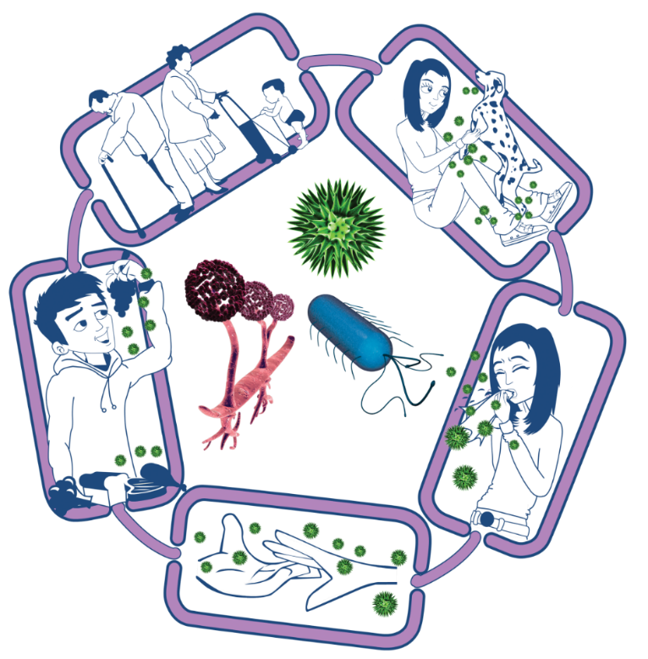

Source of infection

Someone or something carrying the harmful microbes that causes the infection. There are many different sources of infection, these can include:

• People already infected

• Pets or animals

• Contaminated food

Spread of infection

Harmful microbes need a way to be passed from a source to a person. This can be through:

• Direct touch/contact

• Sexual transmission

Harmful microbes are also spread via:

• Hands, hand contact surfaces (e.g. door handles, keyboards, toilets)

• Food contact surfaces

• Air

Way out for microbes

Harmful microbes need a way to get out of an infected person or source before they can spread to someone else. Routes include:

• Sneezing, coughing, saliva

• Bodily fluid

• Juices from raw meat and poultry

### The Chain of Infection

Way in for microbes

Harmful microbes need a

way to enter the body before they can cause an infection. This can be

through:

• The food we eat

• Inhalation of aerosols or droplets

• Open cuts or sores

• Things we put in our

mouths

People at risk from

infection

We are all at risk from

infection, but some are at greater risk:

• People on medication

e.g chemotherapy

• The very young/elderly

• People with underlying diseases e.g HIV/AIDS, diabetes