

## SH2 - Breaking the Chain of Infection Poster

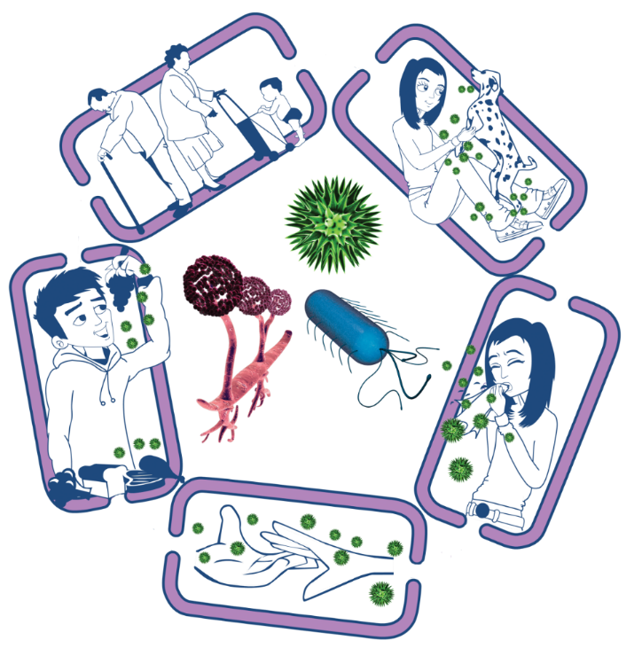

Source of infection

• Isolate infected people

• Take care with raw food

• Wash pets regularly

• Treat pets for pathogens when needed

• Dispose of nappies and soiled clothing appropriately

Way out for microbes

Prevent any:

• Coughs and sneezes

• Faeces

• Vomit

• Bodily fluid

Getting onto surfaces or hands

Spread of infection

• Wash hands thoroughly and regularly

• Cover cuts and open sores

• Take appropriate precautions during

sexual activity

### The Chain of Infection

People at risk from

infection

Everyone:

• Take appropriate vaccinations

High risk people:

• Keep away from people who are infectious

• Take extra care about cleanliness

• Take extra care when cooking and preparing food

Way in for microbes

• Cover cuts and open sores with a water proof dressing

• Cook food properly

• Take care to drink only clean water