

## SH1 - How Big is a Microbe?

Viruses

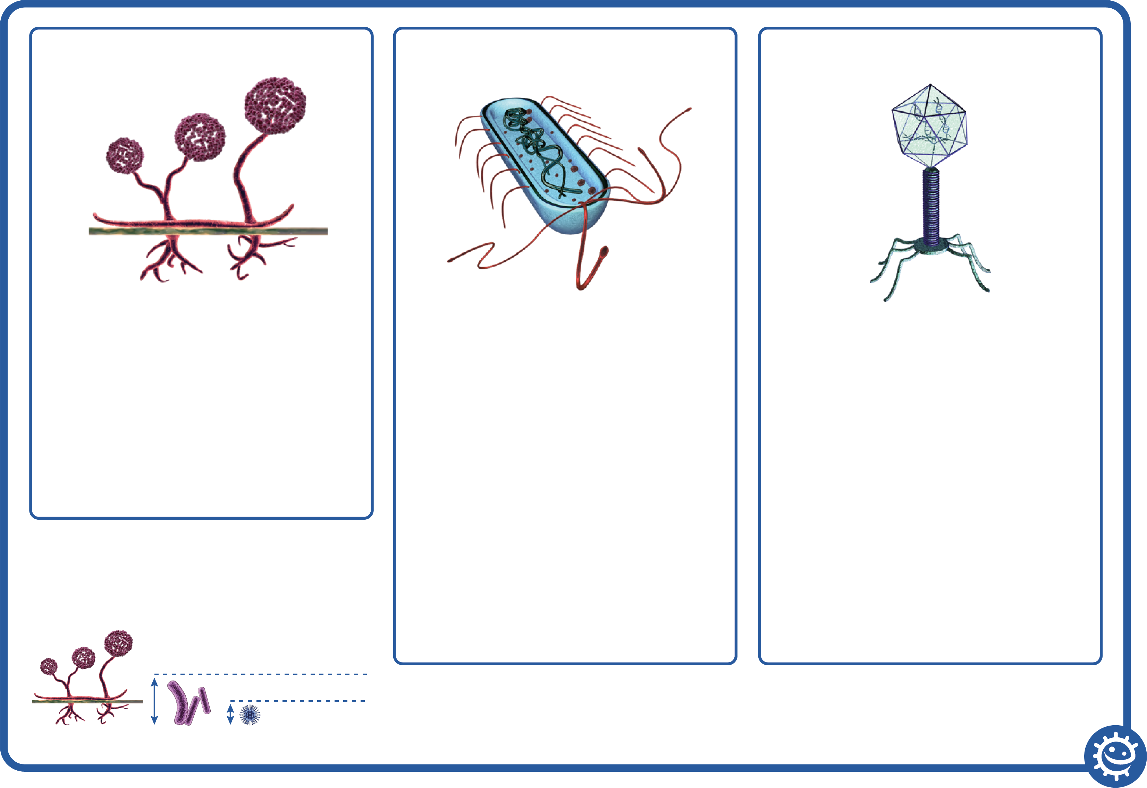

Glycoproteins

Nucleic acid

Capsid

Viruses are NOT free living – they MUST live inside another living cell/organism

Capsid

Double lipid layer holding the cells

genetic material.

Glycoproteins

These serve 2 purposes:

1. Anchor the virus to the host cell.
2. Transport genetic material from the  
   virus to the host cell.

Nucleic acid

Either DNA or RNA material, but viruses rarely contain both. Most viruses contain RNA material.

Bacteria



Chromosome

Cytoplasm

Cell membrane

Cell wall

Bacteria are free living and are found everywhere

Chromosome:

Genetic material (DNA) of the cell.

Cell wall:

The cell wall is made of peptidoglycan and maintains the overall shape of a bacterial cell.

Cell membrane:

Lining the inside of the cell wall providing a boundary for the contents of the cell and a barrier to substances entering and leaving.

Cytoplasm:

Jelly like substance inside of the cell

holding the contents.

Fungi



Sporangi-ophore

Sporangia

Rhizoids

Sporangia:

Spore producing body.

Sporangiophore:

Filamentous stalk on which the

sporangium forms.

Rhizoids:

The sub-surface hyphae are specialized for food absorption.

Microbe size



Viruses 1x

Fungi 100x

Bacteria 20x